 |  | E  TG/267/1  ORIGINAL: English  DATE: 2011-10-20
INTERNATIONAL UNION FOR THE PROTECTION OF NEW VARIETIES OF PLANTS
GENEVA

BOUGAINVILLEA

UPOV Code: BOUGA

Bougainvillea Comm. ex Juss.

GUIDELINES

FOR THE CONDUCT OF TESTS

FOR DISTINCTNESS, UNIFORMITY AND STABILITY

Alternative Names:*

Botanical name | English | French | German | Spanish
Bougainvillea Comm. Ex Juss., Bougainvillea Comm. | Bougainvillea | Bougainvillée, Bougainvillier | Bougainvillee | Bugambilia, Buganvilla

The purpose of these guidelines (“Test Guidelines”) is to elaborate the principles contained in the General Introduction (document TG/1/3), and its associated TGP documents, into detailed practical guidance for the harmonized examination of distinctness, uniformity and stability (DUS) and, in particular, to identify appropriate characteristics for the examination of DUS and production of harmonized variety descriptions.

ASSOCIATED DOCUMENTS

These Test Guidelines should be read in conjunction with the General Introduction and its associated TGP documents.
TABLE OF CONTENTS PAGE

1. Subject of these Test Guidelines 3
2. Material Required 3
3. Method of Examination 3
3.1 Number of Growing Cycles 3
3.2 Testing Place 3
3.3 Conditions for Conducting the Examination 3
3.4 Test Design 4
3.5 Additional Tests 4
4. Assessment of Distinctness, Uniformity and Stability 4
4.1 Distinctness 4
4.2 Uniformity 5
4.3 Stability 5
5. Grouping of Varieties and Organization of the Growing Trial 6
6. Introduction to the Table of Characteristics 6
6.1 Categories of Characteristics 6
6.2 States of Expression and Corresponding Notes 7
6.3 Types of Expression 7
6.4 Example Varieties 7
6.5 Legend 8
7. Table of Characteristics/Tableau des caractères/Merkmalstabelle/Tabla de caracteres 9
8. Explanations on the Table of Characteristics 18
8.1 Explanations covering several characteristics 18
8.2 Explanations for individual characteristics 18
9. Literature 24
10. Technical Questionnaire 25

Subject of these Test Guidelines
These Test Guidelines apply to all varieties of Bougainvillea Comm. ex Juss.

Material Required
2.1 The competent authorities decide on the quantity and quality of the plant material required for testing the variety and when and where it is to be delivered. Applicants submitting material from a State other than that in which the testing takes place must ensure that all customs formalities and phytosanitary requirements are complied with.

2.2 The minimum quantity of plant material, to be provided by the applicant, should be:

10 plants

2.3 The plant material supplied should be visibly healthy, not lacking in vigor, nor affected by any important pest or disease.

2.4 The plant material should not have undergone any treatment which would affect the expression of the characteristics of the variety, unless the competent authorities allow or request such treatment. If it has been treated, full details of the treatment must be given.

Method of Examination

3.1 Number of Growing Cycles
The minimum duration of tests should normally be a single growing cycle

3.2 Testing Place
Tests are normally conducted at one place. In the case of tests conducted at more than one place, guidance is provided in TGP/9 “Examining Distinctness”.

3.3 Conditions for Conducting the Examination
3.3.1 The tests should be carried out under conditions ensuring satisfactory growth for the expression of the relevant characteristics of the variety and for the conduct of the examination.

    - Observation of color by eye

Because daylight varies, color determinations made against a color chart should be made either in a suitable cabinet providing artificial daylight or in the middle of the day in a room without direct sunlight. The spectral distribution of the illuminant for artificial daylight should conform with the CIE Standard of Preferred Daylight D 6500 and should fall within the tolerances set out in the British Standard 950, Part I. These determinations should be made with the plant part placed against a white background. The color chart and version used should be specified in the variety description.

3.4 Test Design
3.4.1 Each test should be designed to result in a total of at least 10 plants.

3.4.2 The design of the tests should be such that plants or parts of plants may be removed for measurement or counting without prejudice to the observations which must be made up to the end of the growing cycle.

3.5 Additional Tests
Additional tests, for examining relevant characteristics, may be established.

Assessment of Distinctness, Uniformity and Stability

4.1 Distinctness

4.1.1 General Recommendations

It is of particular importance for users of these Test Guidelines to consult the General Introduction prior to making decisions regarding distinctness. However, the following points are provided for elaboration or emphasis in these Test Guidelines.

4.1.2 Consistent Differences

The differences observed between varieties may be so clear that more than one growing cycle is not necessary. In addition, in some circumstances, the influence of the environment is not such that more than a single growing cycle is required to provide assurance that the differences observed between varieties are sufficiently consistent. One means of ensuring that a difference in a characteristic, observed in a growing trial, is sufficiently consistent is to examine the characteristic in at least two independent growing cycles.

    - Clear Differences

Determining whether a difference between two varieties is clear depends on many factors, and should consider, in particular, the type of expression of the characteristic being examined, i.e. whether it is expressed in a qualitative, quantitative, or pseudo-qualitative manner. Therefore, it is important that users of these Test Guidelines are familiar with the recommendations contained in the General Introduction prior to making decisions regarding distinctness.

4.1.4 Number of Plants / Parts of Plants to be Examined
Unless otherwise indicated, for the purposes of distinctness, all observations on single plants should be made on 9 plants or parts taken from each of 9 plants and any other observations made on all plants in the test, disregarding any off-type plants.

4.1.5 Method of Observation
The recommended method of observing the characteristic for the purposes of distinctness is indicated by the following key in the second column of the Table of Characteristics (see document TGP/9 “Examining Distinctness”, Section 4 “Observation of characteristics”):

MG: single measurement of a group of plants or parts of plants
MS: measurement of a number of individual plants or parts of plants
VG: visual assessment by a single observation of a group of plants or parts of plants
VS: visual assessment by observation of individual plants or parts of plants

Type of observation: visual (V) or measurement (M)

“Visual” observation (V) is an observation made on the basis of the expert’s judgment. For the purposes of this document, “visual” observation refers to the sensory observations of the experts and, therefore, also includes smell, taste and touch. Visual observation includes observations where the expert uses reference points (e.g. diagrams, example varieties, side-by-side comparison) or non-linear charts (e.g. color charts). Measurement (M) is an objective observation against a calibrated, linear scale e.g. using a ruler, weighing scales, colorimeter, dates, counts, etc.

Type of record: for a group of plants (G) or for single, individual plants (S)

For the purposes of distinctness, observations may be recorded as a single record for a group of plants or parts of plants (G), or may be recorded as records for a number of single, individual plants or parts of plants (S). In most cases, “G” provides a single record per variety and it is not possible or necessary to apply statistical methods in a plant-by-plant analysis for the assessment of distinctness.

In cases where more than one method of observing the characteristic is indicated in the Table of Characteristics (e.g. VG/MG), guidance on selecting an appropriate method is provided in document TGP/9, Section 4.2.

4.2 Uniformity
4.2.1 It is of particular importance for users of these Test Guidelines to consult the General Introduction prior to making decisions regarding uniformity. However, the following points are provided for elaboration or emphasis in these Test Guidelines:

4.2.2 For the assessment of uniformity, a population standard of 1% and an acceptance probability of at least 95% should be applied. In the case of a sample size of 10 plants, 1 off-type is allowed.

4.3 Stability
4.3.1 In practice, it is not usual to perform tests of stability that produce results as certain as those of the testing of distinctness and uniformity. However, experience has demonstrated that, for many types of variety, when a variety has been shown to be uniform, it can also be considered to be stable.
4.3.2 Where appropriate, or in cases of doubt, stability may be tested, either by growing a further generation, or by testing a new plant stock to ensure that it exhibits the same characteristics as those shown by the previous material supplied.

Grouping of Varieties and Organization of the Growing Trial
5.1 The selection of varieties of common knowledge to be grown in the trial with the candidate varieties and the way in which these varieties are divided into groups to facilitate the assessment of distinctness are aided by the use of grouping characteristics.

5.2 Grouping characteristics are those in which the documented states of expression, even where produced at different locations, can be used, either individually or in combination with other such characteristics: (a) to select varieties of common knowledge that can be excluded from the growing trial used for examination of distinctness; and (b) to organize the growing trial so that similar varieties are grouped together.

5.3 The following have been agreed as useful grouping characteristics:

(a) Leaf blade: secondary color (characteristic 12)
(b) Inflorescence: type of bract (characteristic 22)
(c) Young bract: main color of inner side (calyx lobe open) (characteristic 30) with the following groups:
Group 1: white
Group 2: yellow
Group 3: orange
Group 4: red
Group 5: pink
Group 6: red purple
Group 7: purple
Group 8: violet

5.4 Guidance for the use of grouping characteristics, in the process of examining distinctness, is provided through the General Introduction and document TGP/9 “Examining Distinctness”.

Introduction to the Table of Characteristics

6.1 Categories of Characteristics
6.1.1 Standard Test Guidelines Characteristics

Standard Test Guidelines characteristics are those which are approved by UPOV for examination of DUS and from which members of the Union can select those suitable for their particular circumstances.

6.1.2 Asterisked Characteristics

Asterisked characteristics (denoted by *) are those included in the Test Guidelines which are important for the international harmonization of variety descriptions and should always be examined for DUS and included in the variety description by all members of the Union, except when the state of expression of a preceding characteristic or regional environmental conditions render this inappropriate.

6.2 States of Expression and Corresponding Notes
6.2.1 States of expression are given for each characteristic to define the characteristic and to harmonize descriptions. Each state of expression is allocated a corresponding numerical note for ease of recording of data and for the production and exchange of the description.

6.2.2 In the case of qualitative and pseudo-qualitative characteristics (see Chapter 6.3), all relevant states of expression are presented in the characteristic. However, in the case of quantitative characteristics with 5 or more states, an abbreviated scale may be used to minimize the size of the Table of Characteristics. For example, in the case of a quantitative characteristic with 9 states, the presentation of states of expression in the Test Guidelines may be abbreviated as follows:

State | Note
small | 3
medium | 5
large | 7

However, it should be noted that all of the following 9 states of expression exist to describe varieties and should be used as appropriate:

State | Note
very small | 1
very small to small | 2
small | 3
small to medium | 4
medium | 5
medium to large | 6
large | 7
large to very large | 8
very large | 9

6.2.3 Further explanation of the presentation of states of expression and notes is provided in document TGP/7 “Development of Test Guidelines”.

6.3 Types of Expression
An explanation of the types of expression of characteristics (qualitative, quantitative and pseudo-qualitative) is provided in the General Introduction.

6.4 Example Varieties
Where appropriate, example varieties are provided to clarify the states of expression of each characteristic.

6.5 Legend
(*) Asterisked characteristic – see Chapter 6.1.2

QL Qualitative characteristic – see Chapter 6.3
QN Quantitative characteristic – see Chapter 6.3
PQ Pseudo-qualitative characteristic – see Chapter 6.3

MG, MS, VG, VS – see Chapter 4.1.5

(a)-(c) See Explanations on the Table of Characteristics in Chapter 8.1
(+) See Explanations on the Table of Characteristics in Chapter 8.2

Table of Characteristics/Tableau des caractères/Merkmalstabelle/Tabla de caracteres
 |  | English | français | deutsch | español | Example Varieties/  Exemples/  Beispielssorten/  Variedades ejemplo | Note/  Nota
1. | VG | Plant: growth habit | Plante : port | Pflanze: Wuchsform | Planta: hábito de crecimiento
PQ |  | upright | dressé | aufrecht | erguido | Pixie Queen | 1
 |  | semi-upright | semi-dressé | halbaufrecht | semierguido |  | 2
 |  | spreading | étalé | breitwüchsig | extendido | Poultoni, Vera Pink | 3
2. | VG | Young shoot: color | Jeune rameau : couleur | Junger Trieb: Farbe | Retoño: color
PQ | (a) | light green | vert clair | hellgrün | verde claro | Alexandra | 1
 |  | medium green | vert moyen | mittelgrün | verde mediano |  | 2
 |  | reddish green | vert rougeâtre | rötlichgrün | verde rojizo | Barbera Karst | 3
 |  | reddish | rougeâtre | rötlich | rojizo | Vera Deep Purple | 4
3.  (*) | VG/  MS | Plant: length of internodes | Plante : longueur des entre-nœuds | Pflanze: Länge der Internodien | Planta: longitud de los intranudos
QN | (b) | short | courts | kurz | corta |  | 3
 |  | medium | moyens | mittel | mediana | Vera Deep Purple | 5
 |  | long | longs | lang | larga | Killie Campbell | 7
4. | VG | Stem: thorns | Tige : épines | Trieb: Dornen | Tallo: espinas
QL | (b) | absent | absentes | fehlend | ausentes | Poultoni | 1
 |  | present | présentes | vorhanden | presentes |  | 9
5.  (*)  (+) | VG | Thorn: length | Épine : longueur | Dorn: Länge | Espina: longitud
QN | (b) | short | courte | kurz | corta | Pixie Queen | 1
 |  | medium | moyenne | mittel | mediana | Alexandra | 2
 |  | long | longue | lang | larga | Rijnbo705 | 3
6.  (*) | VG | Thorn: curvature | Épine : courbure | Dorn: Biegung | Espina: curvatura
QN | (b) | absent or weak | absente ou faible | fehlend oder gering | ausente o débil | Killie Campbell | 1
 |  | medium | moyenne | mittel | mediana |  | 2
 |  | strong | prononcée | stark | larga | Vera Deep Purple | 3
7.  (*) | MG/MS | Leaf blade: length | Limbe : longueur | Blattspreite: Länge | Limbo: longitud
QN | (c) | short | court | kurz | corta | Tosca | 3
 |  | medium | moyen | mittel | mediana | Wabag | 5
 |  | long | long | lang | larga | Vera Deep Purple | 7
8.  (*) | MG/MS | Leaf blade: width | Limbe : largeur | Blattspreite: Breite | Limbo: anchura
QN | (c) | narrow | étroit | schmal | estrecha | Pixie Queen | 3
 |  | medium | moyen | mittel | mediana | Vera Deep Purple | 5
 |  | broad | large | breit | ancha | Killie Campbell | 7
9.  (*)  (+) | VG | Leaf blade: shape | Limbe : forme | Blattspreite: Form | Limbo: forma
PQ | (c) | lanceolate | lancéolée | lanzettlich | lanceolada |  | 1
 |  | medium ovate | ovale moyenne | mittel eiförmig | oval mediana | Alexandra | 2
 |  | broad ovate | ovale large | breit eiförmig | oval ancha | Barbera Karst | 3
 |  | elliptic | elliptique | elliptisch | elíptica | Elisabeth | 4
 |  | circular | arrondie | kreisförmig | circular | Sea Foam | 5
10.  (+) | VG | Leaf blade: shape of base | Limbe : forme de la base | Blattspreite: Form der Basis | Limbo: forma de la base
PQ | (c) | attenuate | atténuée | verjüngt | atenuada | Vera Deep Purple | 1
 |  | acute | pointue | spitz | aguda |  | 2
 |  | obtuse | obtuse | stumpf | obtusa | Nancy Gardner | 3
11.  (+) | VG | Leaf blade: main color | Limbe : couleur principale | Blattspreite: Hauptfarbe | Limbo: color principal
PQ | (c) | yellowish white | blanc jaunâtre | gelblichweiß | blanco amarillento |  | 1
 |  | yellow | jaune | gelb | amarillo |  | 2
 |  | yellowish green | vert jaunâtre | gelblichgrün | verde amarillento | Pixie Queen | 3
 |  | light green | vert clair | hellgrün | verde claro | Mini Thai Variegated | 4
 |  | medium green | vert moyen | mittelgrün | verde mediano |  | 5
 |  | dark green | vert foncé | dunkelgrün | verde oscuro |  | 6
 |  | very dark green | vert très foncé | sehr dunkelgrün | verde muy oscuro |  | 7
 |  | grey green | vert-gris | graugrün | verde grisáceo |  | 8
12.  (*)  (+) | VG | Leaf blade: secondary color | Limbe : couleur secondaire | Blattspreite: Sekundärfarbe | Limbo: color secundario
PQ | (c) | none | aucune | keine | ninguno |  | 1
 |  | white | blanche | weiß | blanco |  | 2
 |  | yellowish white | blanc jaunâtre | gelblichweiß | blanco amarillento |  | 3
 |  | yellow | jaune | gelb | amarillo | Mini Thai Variegated | 4
 |  | light green | vert clair | hellgrün | verde claro |  | 5
 |  | medium green | vert moyen | mittelgrün | verde mediano | Pixie Queen | 6
 |  | dark green | vert foncé | dunkelgrün | verde oscuro |  | 7
 |  | very dark green | vert très foncé | sehr dunkelgrün | verde muy oscuro |  | 8
 |  | grey green | vert-gris | graugrün | verde grisáceo |  | 9
13.  (+) | VG | Leaf blade: distribution of secondary color | Limbe : répartition de la couleur secondaire | Blattspreite: Verteilung der Sekundärfarbe | Limbo: distribución del color secundario
 | (c) | absent | aucune | fehlend | ausente |  | 1
 |  | narrow marginal | marginale étroite | schmaler Rand | marginal estrecho | Zuki | 2
 |  | broad marginal | marginale large | breiter Rand | marginal ancho |  | 3
 |  | around mid rib | autour de la nervure médiane | um die Mittelrippe herum | alrededor del nervio central | Pixie Queen | 4
 |  | speckled | tachetée | gefleckt | en motas | Mini Thai Variegated | 5
 |  | irregular | irrégulière | unregelmäßig | irregular |  | 6
14.  (+) | VG | Leaf blade: tertiary color | Limbe : couleur tertiaire | Blattspreite: Tertiärfarbe | Limbo: color terciario
PQ | (c) | none | aucune | keine | ninguno |  | 1
 |  | white | blanche | weiß | blanco |  | 2
 |  | yellowish white | blanc jaunâtre | gelblichweiß | blanco amarillento |  | 3
 |  | yellow | jaune | gelb | amarillo |  | 4
 |  | light green | vert clair | hellgrün | verde claro | Pixie Queen | 5
 |  | medium green | vert moyen | mittelgrün | verde mediano |  | 6
 |  | dark green | vert foncé | dunkelgrün | verde oscuro |  | 7
 |  | very dark green | vert très foncé | sehr dunkelgrün | verde muy oscuro |  | 8
 |  | grey green | vert-gris | graugrün | verde grisáceo |  | 9
15. | VG | Leaf blade: undulation of margin | Limbe : ondulation du bord | Blattspreite: Randwellung | Limbo: ondulación del borde
QN | (c) | absent or weak | absente ou faible | fehlend oder gering | ausente o débil |  | 1
 |  | medium | moyenne | mittel | mediana |  | 2
 |  | strong | forte | stark | fuerte |  | 3
16.  (*)  (+) | MG/MS | Petiole: length | Pétiole : longueur | Blattstiel: Länge | Peciolo: longitud
QN | (c) | short | court | kurz | corta | Mini Thai | 1
 |  | medium | moyen | mittel | mediana | Vera Deep Purple | 2
 |  | long | long | lang | larga | Killie Campbell | 3
17.  (+) | MG/MS | Peduncle: length | Pédoncule : longueur | Blütenstiel: Länge | Pedúnculo: longitud
QN |  | short | court | kurz | corta | Vera Deep Purple | 3
 |  | medium | moyen | mittel | mediana | Rijnbo705 | 5
 |  | long | long | lang | larga | Barbera Karst | 7
18.  (+) | VG | Inflorescence: arrangement of bract clusters | Inflorescence : disposition des groupes de bractées | Blütenstand: Anordnung der Hochblattbüschel | Inflorescencia: disposición de los racimos de brácteas
QL |  | terminal | terminale | terminal | terminal |  | 1
 |  | axillary | axillaire | axillar | axilar |  | 2
 |  | axillary and terminal | axillaire et terminale | axillar und terminal | axilar y terminal |  | 3
19.  (+) | VG/  MG | Inflorescence: number of bract clusters | Inflorescence : nombre de groupes de bractées | Blütenstand: Anzahl der Hochblattbüschel | Inflorescencia: número de racimos de brácteas
QN |  | few | petit | gering | bajo |  | 3
 |  | medium | moyen | mittel | mediano |  | 5
 |  | many | élevé | hoch | alto |  | 7
20.  (+) | VG | Inflorescence: density of bract clusters | Inflorescence : densité des groupes de bractées | Blütenstand: Dichte der Hochblattbüschel | Inflorescencia: densidad de los racimos de brácteas
QN |  | sparse | faible | locker | escasa |  | 3
 |  | medium | moyenne | mittel | mediana |  | 5
 |  | dense | elevée | dicht | densa |  | 7
21.  (+) | VG | Inflorescence: presence of flowers | Inflorescence : présence de fleurs | Blütenstand: Vorhandensein von Blüten | Inflorescencia: presencia de flores
QL |  | absent | absente | fehlend | ausentes | Dania | 1
 |  | present | présente | vorhanden | presentes | Alexandra,  Vera Deep Purple | 9
22.  (*)  (+) | VG | Inflorescence: type of bract | Inflorescence : type de bractée | Blütenstand: Typ des Hochblatts | Inflorescencia: tipo de bráctea
QL |  | single | simple | einfach | simple | Alexandra | 1
 |  | double | double | gefüllt | doble | Dania | 2
23. | MG/MS | Bract: length | Bractée : longueur | Hochblatt: Länge | Bráctea: longitud
QN |  | short | courte | kurz | corta | Mini Thai | 3
 |  | medium | moyenne | mittel | mediana |  | 5
 |  | long | longue | lang | larga | Killie Campbell | 7
24. | MG/MS | Bract: width | Bractée : largeur | Hochblatt: Breite | Bráctea: anchura
QN |  | narrow | étroite | schmal | estrecha | Mini Thai | 3
 |  | medium | moyenne | mittel | mediana | Vera Deep Purple | 5
 |  | broad | large | breit | ancha | Killie Campbell | 7
25.  (*)  (+) | VG | Bract: shape | Bractée : forme | Hochblatt: Form | Bráctea: forma
PQ |  | narrow ovate | ovale étroite | schmal eiförmig | oval estrecha | Elisabeth | 1
 |  | medium ovate | ovale moyenne | mittel eiförmig | oval mediana | Alexandra | 2
 |  | broad ovate | ovale large | breit eiförmig | oval ancha | Vera Deep Purple | 3
 |  | circular | circulaire | kreisförmig | circular | Afterglow | 4
26.  (*)  (+) | VG | Bract: shape of base | Bractée : forme de la base | Hochblatt: Form der Basis | Bráctea: forma de la base
PQ |  | acute | pointue | spitz | aguda | Easter Parade | 1
 |  | obtuse | obtuse | stumpf | obtusa | Pixie Queen | 2
 |  | cordate | cordiforme | herzförmig | cordiforme | Siggi | 3
27. | VG | Only varieties with inflorescence type of bract: single: Calyx lobes: color of upper side | Seulement les variétés avec un type de bractée de l’inflorescence : simple : lobes du calice : couleur de la face supérieure | Nur Sorten mit Blütenstand: Typ des Hochblatts: einfach: Kelchlappen: Farbe der Oberseite | Únicamente variedades con inflorescencia tipo de bráctea: simple: lóbulos del cáliz: color de la cara superior
PQ |  | RHS Colour Chart (indicate reference number) | Code RHS des couleurs (indiquer le numéro de référence) | RHS-Farbkarte (Nummer angeben) | Carta de colores RHS (indíquese el número de referencia)
28.  (*)  (+) | VG | Small young bract: main color of outer side | Petite bractée jeune : couleur principale de la face externe | Kleines junges Hochblatt: Hauptfarbe der Außenseite | Bractéola joven: color principal de la cara exterior
PQ |  | RHS Colour Chart (indicate reference number) | Code RHS des couleurs (indiquer le numéro de référence) | RHS-Farbkarte (Nummer angeben) | Carta de colores RHS (indíquese el número de referencia)
29.  (*)  (+) | VG | Young bract: main color of inner side (calyx lobe not open) | Jeune bractée : couleur principale de la face interne (lobe du calice non ouvert) | Junges Hochblatt: Hauptfarbe der Innenseite (Kelchlappen nicht geöffnet) | Bráctea joven: color principal de la cara interior (lóbulo del cáliz no abierto)
PQ |  | RHS Colour Chart (indicate reference number) | Code RHS des couleurs (indiquer le numéro de référence) | RHS-Farbkarte (Nummer angeben) | Carta de colores RHS (indíquese el número de referencia)
30.  (*)  (+) | VG | Young bract: main color of inner side (calyx lobe open) | Jeune bractée : couleur principale de la face interne (lobe du calice ouvert) | Junges Hochblatt: Hauptfarbe der Innenseite (Kelchlappen geöffnet) | Bráctea joven: color principal de la cara interior (lóbulo del cáliz abierto)
PQ |  | RHS Colour Chart (indicate reference number) | Code RHS des couleurs (indiquer le numéro de référence) | RHS-Farbkarte (Nummer angeben) | Carta de colores RHS (indíquese el número de referencia)
31. | VG | Only varieties with inflorescence type of bract: double: Young outer bract: main color of inner side | Seulement les variétés avec un type de bractée de l’inflorescence : double : jeune bractée externe : couleur principale de la face interne | Nur Sorten mit Blütenstand: Typ des Hochblatts: gefüllt: Junges äußeres Hochblatt: Hauptfarbe der Innenseite | Únicamente variedades con inflorescencia tipo de bráctea: doble: bráctea joven exterior: color principal de la cara interior
PQ |  | RHS Colour Chart (indicate reference number) | Code RHS des couleurs (indiquer le numéro de référence) | RHS-Farbkarte (Nummer angeben) | Carta de colores RHS (indíquese el número de referencia)
32. | VG | Only varieties with inflorescence type of bract: double: Young inner bract: main color of inner side | Seulement les variétés avec un type de bractée de l’inflorescence : double : jeune bractée interne : couleur principale de la face interne | Nur Sorten mit Blütenstand: Typ des Hochblatts: gefüllt: Junges inneres Hochblatt: Hauptfarbe der Innenseite | Únicamente variedades con inflorescencia tipo de bráctea: doble: bráctea joven interior: color principal de la cara interior
PQ |  | RHS Colour Chart (indicate reference number) | Code RHS des couleurs (indiquer le numéro de référence) | RHS-Farbkarte (Nummer angeben) | Carta de colores RHS (indíquese el número de referencia)
33.  (+) | VG | Young bract: secondary color of inner side (calyx lobe open) | Jeune bractée : couleur secondaire de la face interne (lobe du calice ouvert) | Junges Hochblatt: Sekundärfarbe der Innenseite (Kelchlappen geöffnet) | Bráctea joven: color secundario de la cara interior (lóbulo del cáliz abierto)
PQ |  | RHS Colour Chart (indicate reference number) | Code RHS des couleurs (indiquer le numéro de référence) | RHS-Farbkarte (Nummer angeben) | Carta de colores RHS (indíquese el número de referencia)
34.  (+) | VG | Young bract: tertiary color of inner side (calyx lobe open) | Jeune bractée : couleur tertiaire de la face interne (lobe du calice ouvert) | Junges Hochblatt: Tertiärfarbe der Innenseite (Kelchlappen geöffnet) | Bráctea joven: color terciario de la cara interior (lóbulo del cáliz abierto)
PQ |  | RHS Colour Chart (indicate reference number) | Code RHS des couleurs (indiquer le numéro de référence) | RHS-Farbkarte (Nummer angeben) | Carta de colores RHS (indíquese el número de referencia)
35.  (+) | VG | Bract: main color of inner side (calyx lobe wilted) | Bractée : couleur principale de la face interne (lobe du calice fané) | Hochblatt: Hauptfarbe der Innenseite (Kelchlappen verwelkt) | Bráctea: color principal de la cara interior (lóbulo del cáliz marchito)
PQ |  | RHS Colour Chart (indicate reference number) | Code RHS des couleurs (indiquer le numéro de référence) | RHS-Farbkarte (Nummer angeben) | Carta de colores RHS (indíquese el número de referencia)

Explanations on the Table of Characteristics

8.1 Explanations covering several characteristics
The optimum stage of development for the assessment of the characteristics is at the time of opening of one flower in three inflorescences. In the case of double bract varieties, observations should be made when a third of the bracts are fully developed and open.

Characteristics containing the following key in the second column of the Table of Characteristics should be examined as indicated below:

- observations should be made on the upper third of the main shoot.
- observations should be made on the middle third of the main shoot.
- observations should be made on a developed leaf from the middle third of the main shoot.

Explanations for individual characteristics
Ad. 5: Thorn: length

The natural length of thorn should be observed.

Ad. 9: Leaf blade: shape

 |  | ← broadest part →
 |  | below middle | at middle
(broad compressed) ← width (ratio length/width) → narrow (elongated) |  | 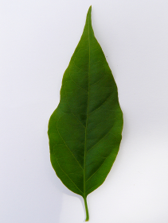 | 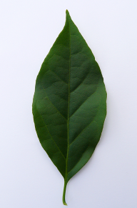
1
lanceolate
 |  | 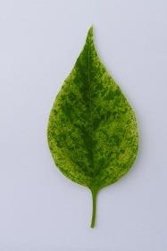
 |  | 2  medium ovate | 4  elliptic
 |  | 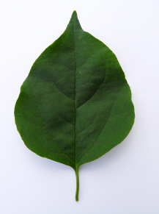 | 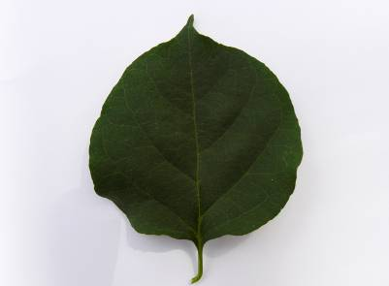
 |  | 3  broad ovate | 5  circular

Ad. 10: Leaf blade: shape of base

1 | 2 | 3
attenuate | acute | obtuse

Ad. 13: Leaf blade: distribution of secondary color
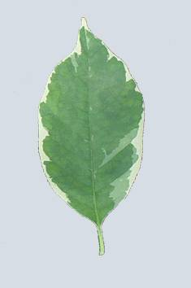 | 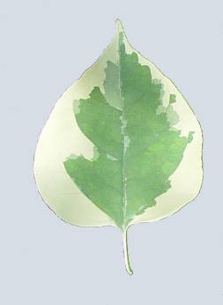 | 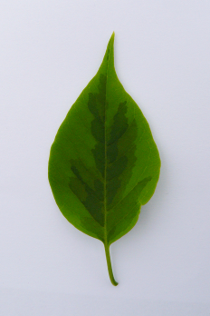 | 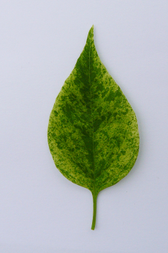 | 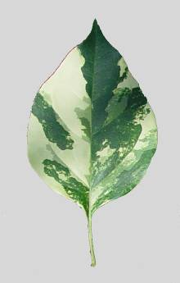
2 | 3 | 4 | 5 | 6
narrow marginal | broad marginal | around the midrib | speckled | irregular

Ad. 11: Leaf blade: main color
Ad. 12: Leaf blade: secondary color
Ad. 14: Leaf blade: tertiary color

The main color is the color with the largest surface area. The secondary color is the color with the second largest surface area. If the area of the colors is nearly half and half, the darker color is the main color. The tertiary color is the color with the third largest surface area. The main color may be the only color.

Ad. 16: Petiole: length
Ad. 17: Peduncle: length

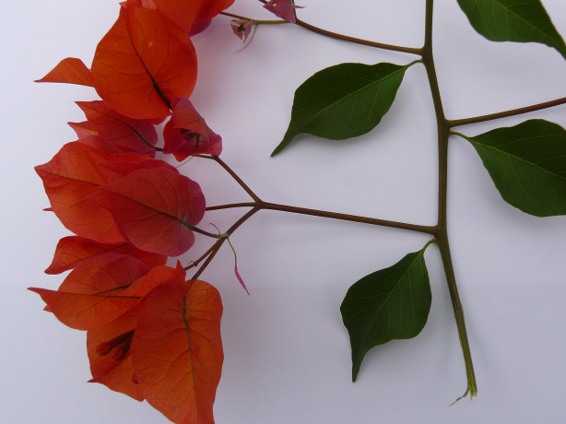 | Petiole: length  Peduncle: length

Ad. 18: Inflorescence: arrangement of bract clusters

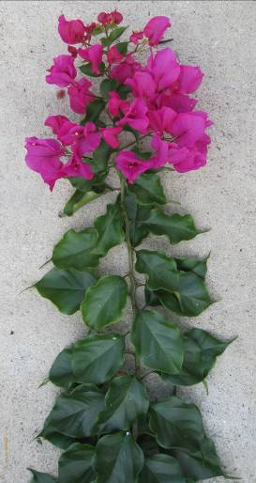 | 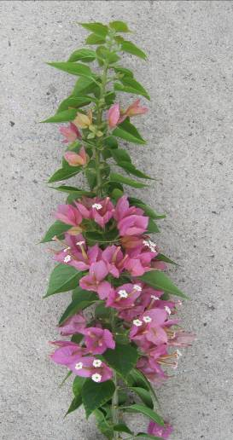 | 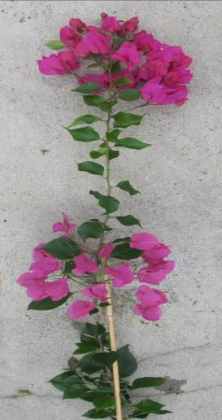
1 | 2 | 3
terminal | axillary | axillary and terminal

Ad. 18: Inflorescence: arrangement of bract clusters
Ad. 19: Inflorescence: number of bract clusters
Ad. 20: Inflorescence: density of bract clusters
Ad. 21: Inflorescence: presence of flowers
Ad. 22: Inflorescence: type of bract

The part of the shoot with colored bracts is considered to be an inflorescence, irrespective of whether flowers are present.

Ad. 22: Inflorescence: type of bract

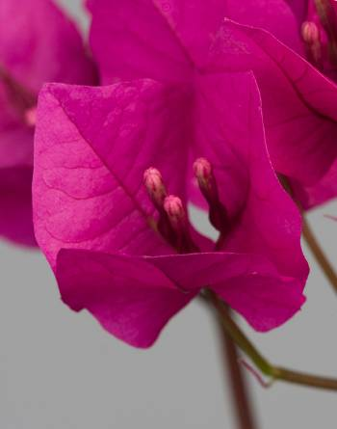 | 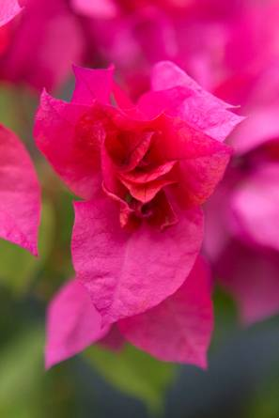
1 | 2
single | double

Ad. 25: Bract: shape

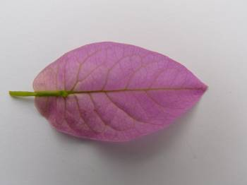 | 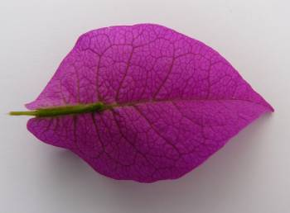 | 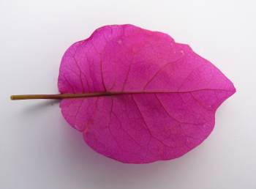 | 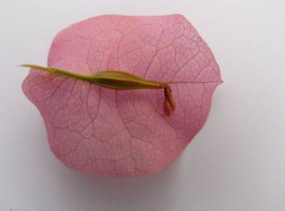
1 | 2 | 3 | 4
narrow ovate | medium ovate | broad ovate | circular

Ad. 26: Bract shape of base

 | 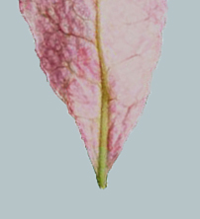 |  | 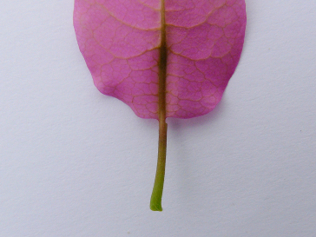 |  | 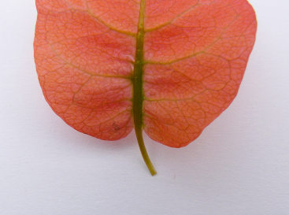
1 |  | 2 |  | 3
acute |  | obtuse |  | cordate

Ad. 28: Small young bract: main color of outer side
Ad. 29: Young bract: main color of inner side (calyx lobe not open)
Ad. 30: Young bract: main color of inner side (calyx lobe open)
Ad. 33: Young bract: secondary color of inner side (calyx lobe open)
Ad. 34: Young bract: tertiary color of inner side (calyx lobe open)

The main color is the color with the largest surface area. The secondary color is the color with the second largest surface area. If the area of the colors is nearly half and half, the darker color is the main color. The tertiary color is the color with the third largest surface area.

Ad. 28: Small young bract: main color of outer side
Ad. 29: Young bract: main color of inner side (calyx lobe not open)
Ad. 30: Young bract: main color of inner side (calyx lobe open)
Ad. 35: Bract: main color of inner side (calyx lobe wilted)

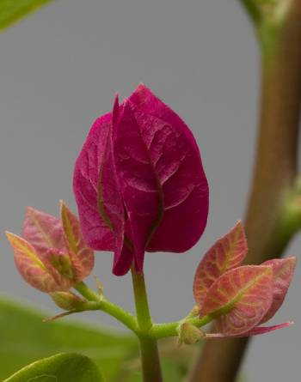
Small young bract Young bract – calyx lobe not open
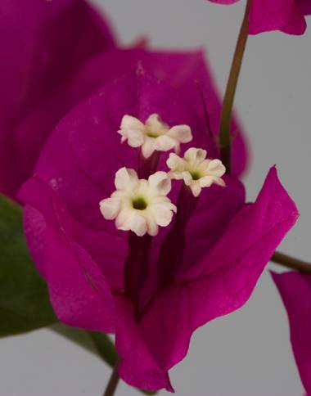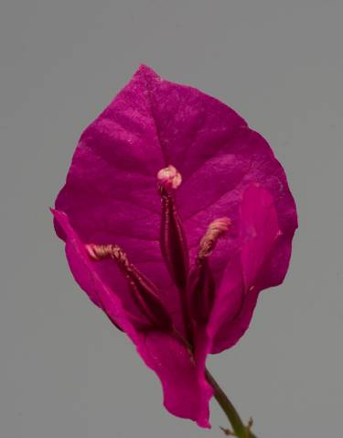
Young bract – calyx lobe open Bract – calyx lobe wilted

Literature

Iredell, J., 1990: The Bougainvillea Growers Handbook. Simon & Schuster, Brookvale, New South Wales, AU, 111 pp.
Iredell, J., 1994: Growing Bougainvilleas. Simon & Schuster, East Roseville, New South Wales, AU, 96 pp.

Technical Questionnaire
TECHNICAL QUESTIONNAIRE |  |  |  | Page {x} of {y} |  | Reference Number:
 |  |  |  |  |  | Application date:
 |  |  |  |  |  | (not to be filled in by the applicant)
TECHNICAL QUESTIONNAIRE
to be completed in connection with an application for plant breeders’ rights

1. Subject of the Technical Questionnaire
1.1 Botanical name |  |  | Bougainvillea Comm. ex Juss.
1.2 Common name |  |  | Bougainvillea
2. Applicant
Name
Address
Telephone No.
Fax No.
E-mail address
Breeder (if different from applicant)
3. Proposed denomination and breeder’s reference
Proposed denomination
(if available)

Breeder’s reference
#4. Information on the breeding scheme and propagation of the variety

4.1 Breeding scheme

Variety resulting from:

4.1.1 Crossing

(a) controlled cross [ ]
(please state parent varieties)

(…………………..……………..…) x (……………..…………………..…)
female parent male parent

(b) partially known cross [ ]
(please state known parent variety(ies))

(…………………..……………..…) x (……………..…………………..…)
female parent male parent

(c) unknown cross [ ]

4.1.2 Mutation [ ]
(please state parent variety)

4.1.3 Discovery and development [ ]
(please state where and when discovered and how developed)

4.1.4 Other [ ]
(please provide details)

4.2 Method of propagating the variety

4.2.1 Vegetative propagation

(a) cuttings [ ]

(b) in vitro propagation [ ]

(c) other (state method) [ ]

4.2.2 Seed [ ]

4.2.3 Other [ ]

(please provide details)

5. Characteristics of the variety to be indicated (the number in brackets refers to the corresponding characteristic in Test Guidelines; please mark the note which best corresponds).
 | Characteristics |  |  |  |  |  | Example Varieties |  |  | Note
5.1  (12) | Leaf blade: secondary color
 | none |  |  |  |  |  |  |  |  | 1[ ]
 | white |  |  |  |  |  |  |  |  | 2[ ]
 | yellowish white |  |  |  |  |  |  |  |  | 3[ ]
 | yellow |  |  |  |  |  | Mini Thai Variegated |  |  | 4[ ]
 | light green |  |  |  |  |  |  |  |  | 5[ ]
 | medium green |  |  |  |  |  | Pixie Queen |  |  | 6[ ]
 | dark green |  |  |  |  |  |  |  |  | 7[ ]
 | very dark green |  |  |  |  |  |  |  |  | 8[ ]
 | grey green |  |  |  |  |  |  |  |  | 9[ ]
5.2  (22) | Inflorescence: type of bract
 | single |  |  |  |  |  | Alexandra |  |  | 1[ ]
 | double |  |  |  |  |  | Dania |  |  | 2[ ]
5.3i  (30) | Young bract: main color of inner side (calyx lobe open)
 | RHS Colour Chart (indicate reference number)
5.3ii  (30) | Young bract: main color of inner side (calyx lobe open)
 | white |  |  |  |  |  |  |  |  | 1[ ]
 | yellow |  |  |  |  |  |  |  |  | 2[ ]
 | orange |  |  |  |  |  |  |  |  | 3[ ]
 | red |  |  |  |  |  |  |  |  | 4[ ]
 | pink |  |  |  |  |  |  |  |  | 5[ ]
 | red purple |  |  |  |  |  |  |  |  | 6[ ]
 | purple |  |  |  |  |  |  |  |  | 7[ ]
 | violet |  |  |  |  |  |  |  |  | 8[ ]
6. Similar varieties and differences from these varieties

Please use the following table and box for comments to provide information on how your candidate variety differs from the variety (or varieties) which, to the best of your knowledge, is (or are) most similar. This information may help the examination authority to conduct its examination of distinctness in a more efficient way.

Denomination(s) of variety(ies) similar to your candidate variety |  | Characteristic(s) in which your candidate variety differs from the similar variety(ies) |  |  | Describe the expression of the characteristic(s) for the similar variety(ies) |  |  | Describe the expression of the characteristic(s) for your candidate variety
Example |  | Leaf blade: secondary color |  |  | none |  |  | white
Comments:

#7. Additional information which may help in the examination of the variety

7.1 In addition to the information provided in sections 5 and 6, are there any additional characteristics which may help to distinguish the variety?

Yes [ ] No [ ]

(If yes, please provide details)

7.2 Are there any special conditions for growing the variety or conducting the examination?

Yes [ ] No [ ]

(If yes, please provide details)

7.3 Other information

A representative color image of the variety should accompany the Technical Questionnaire

8. Authorization for release

(a) Does the variety require prior authorization for release under legislation concerning the protection of the environment, human and animal health?

Yes [ ] No [ ]

(b) Has such authorization been obtained?

Yes [ ] No [ ]

If the answer to (b) is yes, please attach a copy of the authorization.

9. Information on plant material to be examined or submitted for examination.

9.1 The expression of a characteristic or several characteristics of a variety may be affected by factors, such as pests and disease, chemical treatment (e.g. growth retardants or pesticides), effects of tissue culture, different rootstocks, scions taken from different growth phases of a tree, etc.

9.2 The plant material should not have undergone any treatment which would affect the expression of the characteristics of the variety, unless the competent authorities allow or request such treatment. If the plant material has undergone such treatment, full details of the treatment must be given. In this respect, please indicate below, to the best of your knowledge, if the plant material to be examined has been subjected to:

(a) Microorganisms (e.g. virus, bacteria, phytoplasma) Yes [ ] No [ ]

(b) Chemical treatment (e.g. growth retardant, pesticide) Yes [ ] No [ ]

(c) Tissue culture Yes [ ] No [ ]

(d) Other factors Yes [ ] No [ ]

Please provide details for where you have indicated “yes”.

……………………………………………………………

10. I hereby declare that, to the best of my knowledge, the information provided in this form is correct:

Applicant’s name

Signature Date

[End of document]

These names were correct at the time of the introduction of these Test Guidelines but may be revised or updated. [Readers are advised to consult the UPOV Code, which can be found on the UPOV Website (www.upov.int), for the latest information.]
# Authorities may allow certain of this information to be provided in a confidential section of the Technical Questionnaire.
# Authorities may allow certain of this information to be provided in a confidential section of the Technical Questionnaire.

