 |  | E  TG/266/1 Rev. Corr.  ORIGINAL: English  DATE: 2011-10-20 + 2013-03-20  + 2014-04-09
INTERNATIONAL UNION FOR THE PROTECTION OF NEW VARIETIES OF PLANTS
GENEVA

 | AFRICAN LILY  UPOV Code: AGAPA  Agapanthus L’Hér. | *

GUIDELINES

FOR THE CONDUCT OF TESTS

FOR DISTINCTNESS, UNIFORMITY AND STABILITY

Alternative Names:*

Botanical name | English | French | German | Spanish
Agapanthus L’Hér. | African lily, Agapanthus, Blue lily, Lily of the Nile | Agapanthe,  Fleur d’amour | Agapanthus, Schmucklilie | Agapando, Agapanto,  Estrella de mar

The purpose of these guidelines (“Test Guidelines”) is to elaborate the principles contained in the General Introduction (document TG/1/3), and its associated TGP documents, into detailed practical guidance for the harmonized examination of distinctness, uniformity and stability (DUS) and, in particular, to identify appropriate characteristics for the examination of DUS and production of harmonized variety descriptions.

ASSOCIATED DOCUMENTS

These Test Guidelines should be read in conjunction with the General Introduction and its associated TGP documents.

TABLE OF CONTENTS PAGE

TOC \o "1-2" 1. Subject of these Test Guidelines PAGEREF _Toc278985481 \h 3
2. Material Required PAGEREF _Toc278985482 \h 3
3. Method of Examination PAGEREF _Toc278985483 \h
3.1 Number of Growing Cycles 3
3.2 Testing Place 3
3.3 Conditions for Conducting the Examination 3
3.4 Test Design 4
3.5 Additional Tests 4
4. Assessment of Distinctness, Uniformity and Stability 4
4.1 Distinctness 4
4.2 Uniformity 5
4.3 Stability 5
5. Grouping of Varieties and Organization of the Growing Trial 6
6. Introduction to the Table of Characteristics 6
6.1 Categories of Characteristics 6
6.2 States of Expression and Corresponding Notes 7
6.3 Types of Expression 7
6.4 Example Varieties 8
6.5 Legend 8
7. Table of Characteristics/Tableau des caractères/Merkmalstabelle/Tabla de caracteres 9
8. Explanations on the Table of Characteristics 19
8.1 Explanations covering several characteristics 19
8.2 Explanations for individual characteristics 20
9. Literature 26
10. Technical Questionnaire 27
AUTONUM  (*)  (+) | VG | Plant: type |  |  | Plante : type |  | Pflanze: Typ |  | Planta: tipo
QL |  | deciduous |  |  | caduc |  | laubabwerfend |  | caduca |  |  | Deep Blue |  | 1
 |  | evergreen |  |  | persistant |  | immergrün |  | perenne |  |  | Cloudy Skies |  | 2
(*) | VG | Plant: density of foliage |  |  | Plante : densité du feuillage |  | Pflanze: Dichte des Laubes |  | Planta: densidad del follaje
QN | (a) | sparse |  |  | faible |  | locker |  | escasa |  |  | Baby Pete |  | 3
 |  | medium |  |  | moyenne |  | mittel |  | media |  |  | Snow Cloud |  | 5
 |  | dense |  |  | elevée |  | dicht |  | densa |  |  | Snowstorm |  | 7
AUTONUM AUTONUM | VG/MS | Leaf: length |  |  | Feuille : longueur |  | Blatt: Länge |  | Hoja: longitud
QN | (a) | short |  |  | courte |  | kurz |  | corta |  |  | Tinkerbell |  | 3
 | (b) | medium |  |  | moyenne |  | mittel |  | media |  |  | Everblue |  | 5
 |  | long |  |  | longue |  | lang |  | larga |  |  | Deep Blue |  | 7
VG | Style: color | Style : couleur |  |  | Griffel: Farbe |  | Estilo: color
PQ | (g) | white |  |  | blanc |  | weiß |  | blanco |  |  | Blue Moon |  | 1
 |  | violet |  |  | violet |  | violett |  | violeta |  |  | Wiley J |  | 2
 |  | violet blue |  |  | bleu violacé |  | violettblau |  | azul violeta |  |  | Glen Avon |  | 3
AUTONUM  (*)  (+) | MG/VG | Time of beginning of flowering |  |  | Époque de début de floraison |  | Zeitpunkt des Blühbeginns |  | Época del comienzo de la floración
QN |  | early |  |  | précoce |  | früh |  | temprana |  |  | ATlblu |  | 3
 |  | medium |  |  | moyenne |  | mittel |  | intermedia |  |  | Blue Velvet |  | 5
 |  | late |  |  | tardive |  | spät |  | tardía |  |  | New Blue |  | 7

Explanations on the Table of Characteristics

8.1 Explanations covering several characteristics
Unless otherwise indicated, all characteristics should be observed at the time when at least 50% of all flowers have opened.

Characteristics containing the following key in the second column of the Table of Characteristics should be examined as indicated below:

(a) To be observed when the first flower bud starts to protrude from the inflorescence bract.
(b) Observations should be made on fully developed leaves.
(c) Observations on leaf variegation should be made on young leaves.
(d) The main color is the color of the largest surface area. In cases where it is difficult to determine the largest surface area, the darkest color is considered to be the main color. The secondary color is the color of the second largest surface area.
(e) To be observed in the middle third of the peduncle.
(f) Observations should be made when the flower bud is fully expanded, just prior to reflexing of the tepals.
(g) Observations should be made on fresh fully open flowers.
Diagram of flower parts:

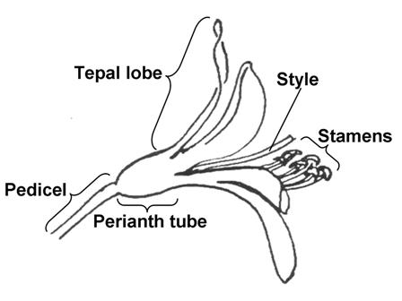

8.2 Explanations for individual characteristics
Ad. 1: Plant: type

Observations should be made during winter and spring.

Ad. 3: Plant: number of leaves per shoot

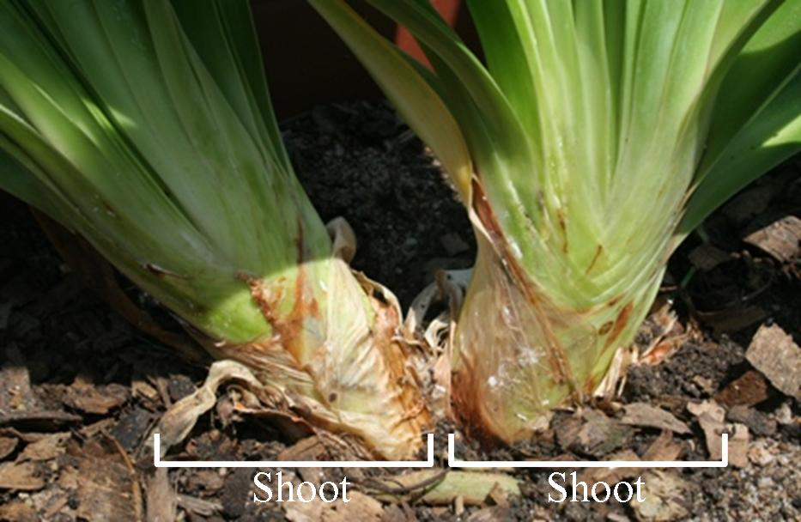

Ad. 8: Leaf: disappearance of variegation with development

Observations should be made by comparing variegation of young leaves with variegation of mature leaves. Disappearance of variegation is present when mature leaves have less variegation than young leaves.

Ad. 11: Leaf: anthocyanin coloration at base

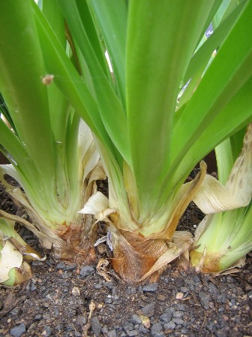 | 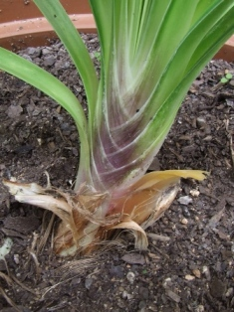
1 | 9
absent | present

Ad. 12: Inflorescence bract: length of tip relative to total length of bract

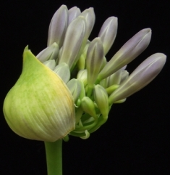 | 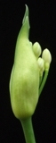 | 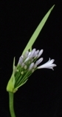 | 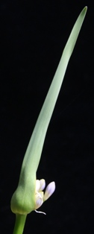 | 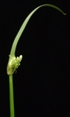
1 | 3 | 5 | 7 | 9
very short | short | medium | long | very long

Ad. 14: Inflorescence bract: opening

To be observed when most of the flower buds have protruded.

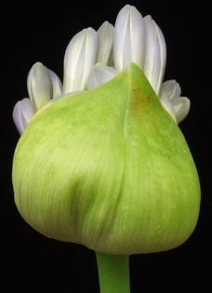 | 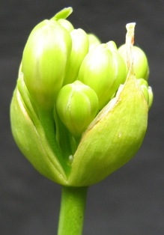
1 | 2
one side | both sides

Ad. 17: Peduncle: shape in cross section

EMBED PBrush  | EMBED PBrush  | 
1 | 2 | 3
medium elliptic | broad elliptic | circular

Ad. 19: Inflorescence: number of flowers

The total number of flowers should be assessed, including flower buds, open flowers, and faded flowers.

Ad. 20: Inflorescence: diameter
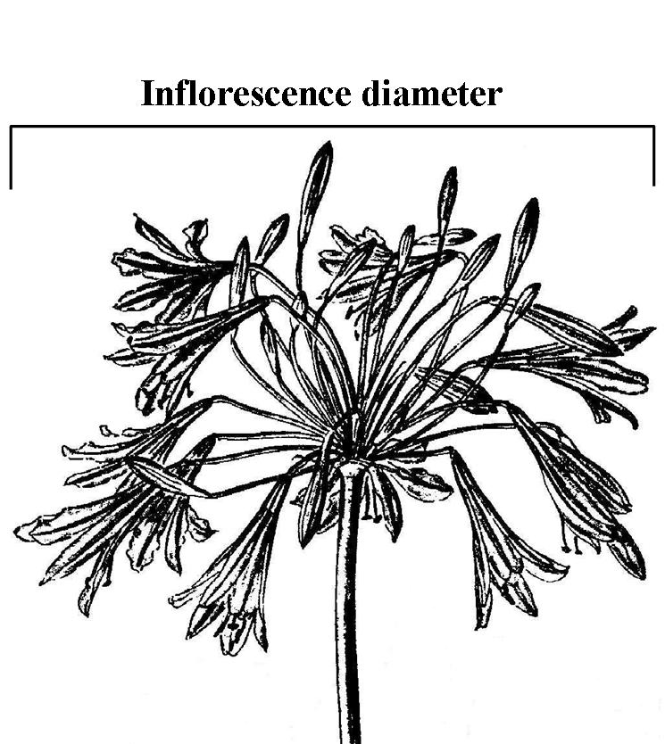

Ad. 21: Inflorescence: shape in lateral view

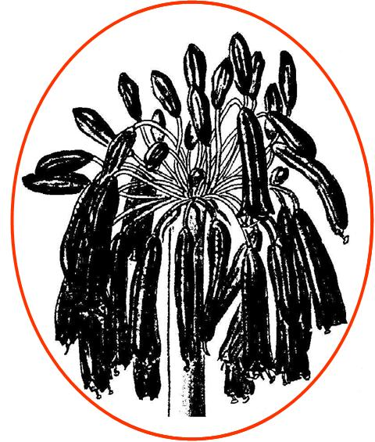 | 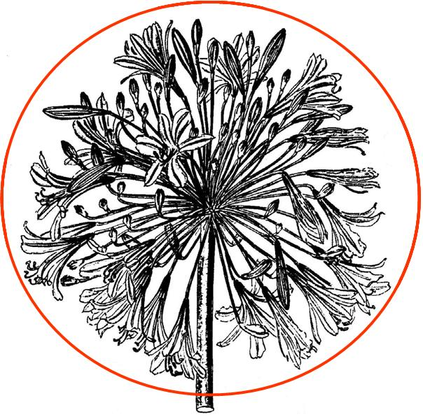 | 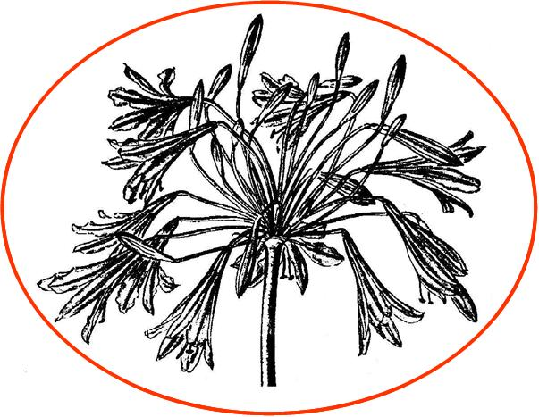 | 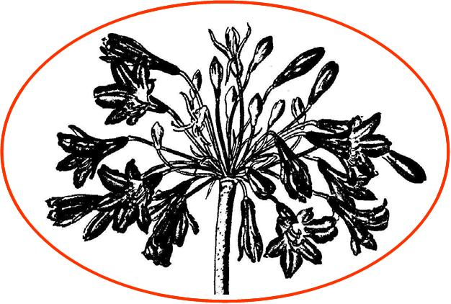
1 | 2 | 3 | 4
elliptic | circular | narrow oblate | broad oblate

Ad. 27: Pedicel: distribution of anthocyanin coloration

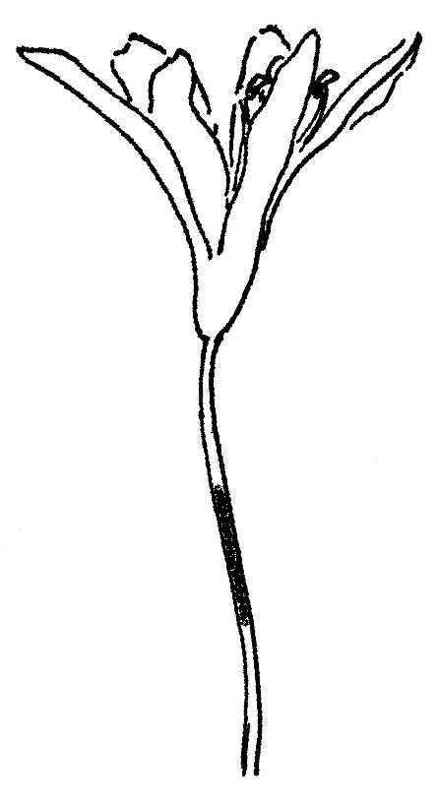 | 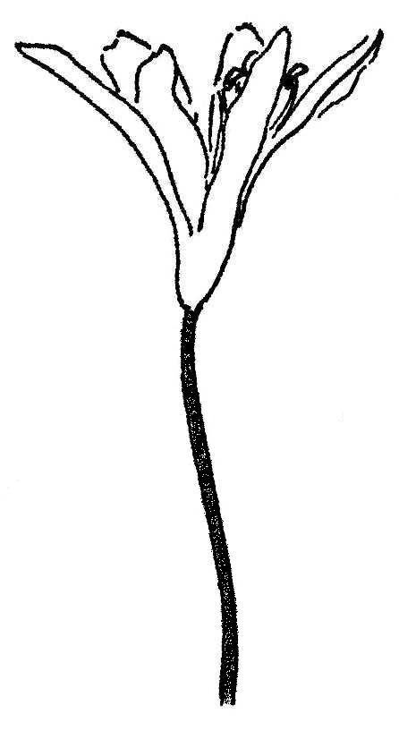 | 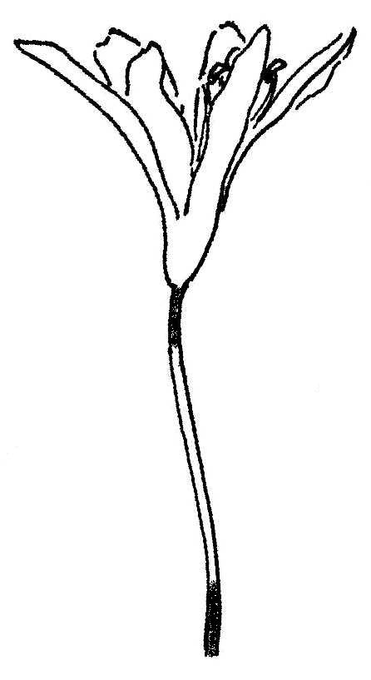
1 | 2 | 3
only on middle third | entire | only on upper and lower third

Ad. 28: Flower: shape

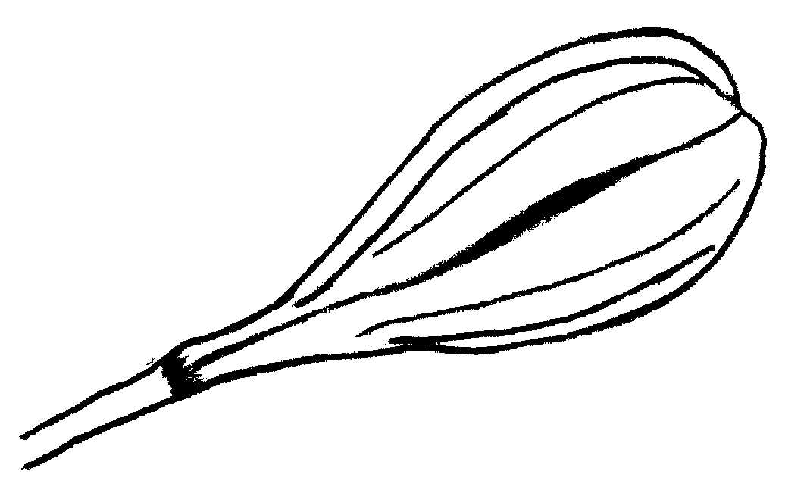 | 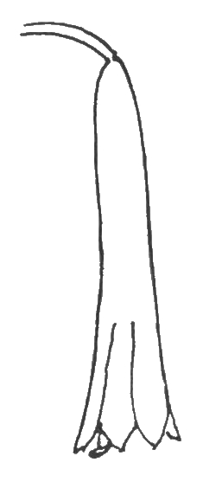 | 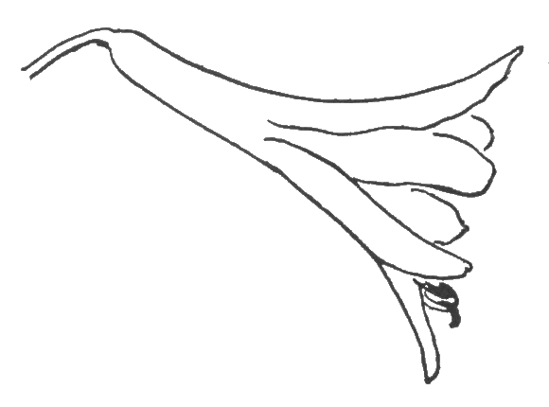 | 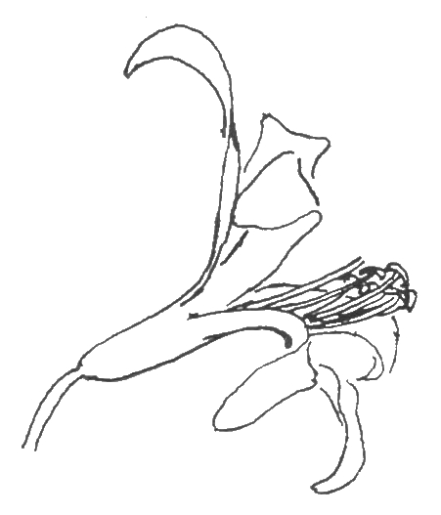
1 | 2 | 3 | 4
globose | tubular | funnel | campanulate

Ad. 29: Flower: type

Single type flowers have six tepals.
Semi-double type flowers have more than six tepals.

Ad. 30: Perianth: length

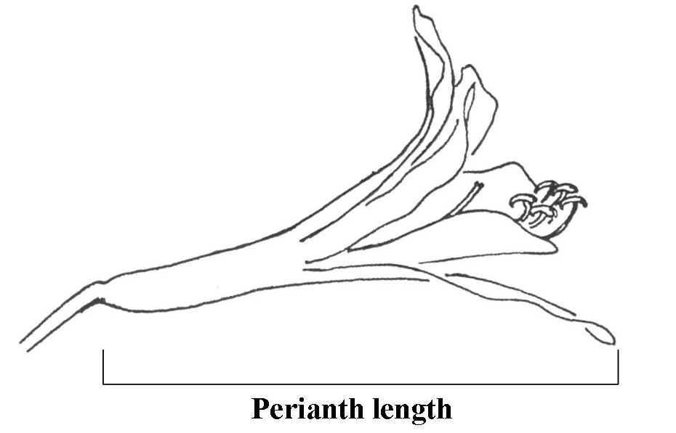

Ad. 31: Perianth: diameter

The maximum natural diameter should be assessed.

Ad. 32: Perianth: overlapping of tepal lobes

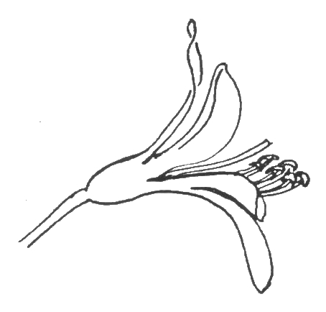 | 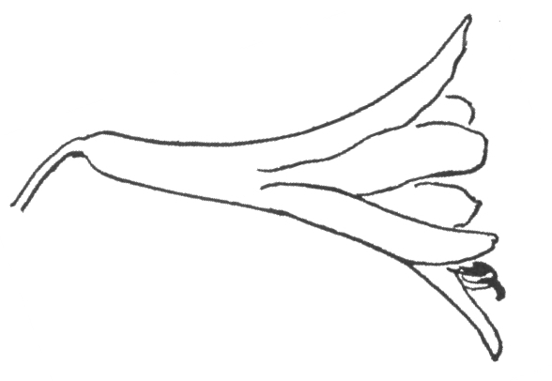
1 | 2 | 3
absent | incomplete | complete

Ad. 32: Perianth: overlapping of tepal lobes
Ad. 33: Perianth tube: length

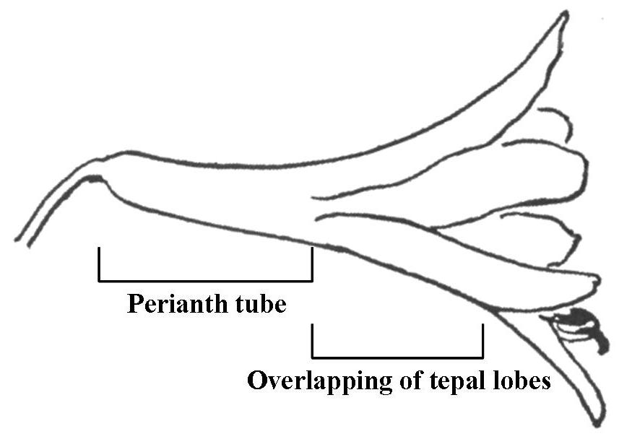

Ad. 35: Tepal lobe: ratio length/width

The tepal lobe is the part of the tepal that does not form part of the perianth tube.

Ad. 40: Flower: tepal-like staminodes and pistillodes

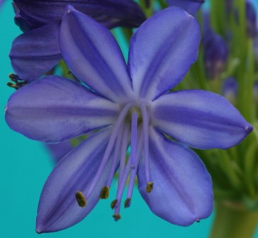 | 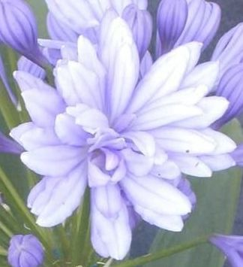
1 | 9
absent | present

Ad. 41: Flower: extrusion of stamens

The extrusion of stamens is observed as the protrusion of the stamens in relation to the apex of the tepal lobes.

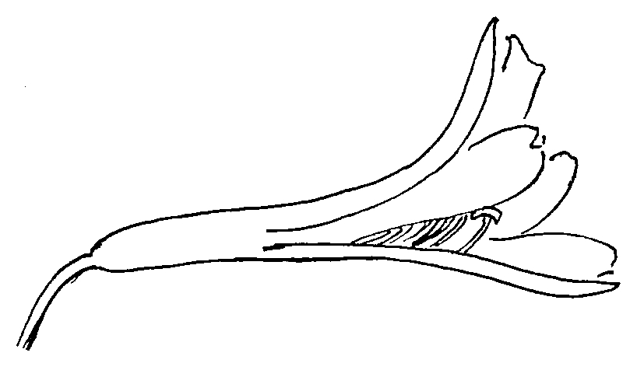
1 | 2 | 3
absent or weak | medium | strong

Ad. 43: Anther: color

The color of the anthers should be observed just before dehiscence.

Ad. 45: Time of beginning of flowering

Time of beginning of flowering is when 50% of plants have at least one flower fully open.

Literature
Duncan, G.D., 1998: Kirstenbosch Gardening Series: Grow Agapanthus: a guide to the species, cultivation and propagation of the genus Agapanthus. National Botanical Institute, Kirstenbosch, Cape Town, ZA, 32 pp.

Germishuizen, G., Meyer, N.L., Steenkamp, Y., Keith, M., 2006: A checklist of South African plants. Southern African Botanical Diversity Network Report No. 41, SABONET, Pretoria, ZA

Hattatt, L., 2001: Encyclopedia of garden plants and flowers. Parragon, Bath, UK, 256 pp.

Leighton, F.M., 1965: The genus Agapanthus L’Heritier. Journal of South African Botany, Supplementary Volume No. IV, ZA, 50 pp.

Perry, F. (ed.), 1980: The Macdonald encyclopedia of plants & flowers. Macdonald General Books, London, UK

Snoeijer, W., 2004: Agapanthus: a revision of the genus. Timber Press, Inc., Portland, Oregon, US, 320 pp.

Zonneveld, B.J.M., Duncan, G.D., 2003: Taxonomic implications of genome size and pollen colour and vitality for species of Agapanthus L’Heritier (Agapanthaceae). Plant Syst. Evol. 241: 115-123

Technical Questionnaire

TECHNICAL QUESTIONNAIRE
Page {x} of {y}
Reference Number:
Application date:(not to be filled in by the applicant)
TECHNICAL QUESTIONNAIRE
to be completed in connection with an application for plant breeders’ rights
1. Subject of the Technical Questionnaire1.1 Genus1.1.1 Botanical nameAgapanthus L’Hér.1.1.2 Common nameAfrican lily; AgapanthusSpecies / Group
(please complete)2. ApplicantNameAddress
Telephone No.Fax No.E-mail addressBreeder (if different from applicant)3. Proposed denomination and breeder’s referenceProposed denomination (if available)
Breeder’s reference
#4. Information on the breeding scheme and propagation of the variety

4.1 Breeding scheme

Variety resulting from:

4.1.1 Crossing

(a) controlled cross [ ]
(please state parent varieties)

(…………………..……………..…) x (……………..…………………..…)
female parent male parent

(b) partially known cross [ ]
(please state known parent variety(ies))

(…………………..……………..…) x (……………..…………………..…)
female parent male parent

(c) unknown cross [ ]

4.1.2 Mutation [ ]
(please state parent variety)

4.1.3 Discovery and development [ ]
(please state where and when discovered and how developed)

4.1.4 Other [ ]
(please provide details)

4.2 Method of propagating the variety

4.2.1 Vegetative propagation

(a) cuttings [ ]

(b) in vitro propagation [ ]

(c) other (state method) [ ]

4.2.2 Other [ ]
(please provide details)

5. Characteristics of the variety to be indicated (the number in brackets refers to the corresponding characteristic in Test Guidelines; please mark the note which best corresponds).
CharacteristicsExample VarietiesNote5.1
(1)Plant: typedeciduousDeep Blue1[ ]evergreenCloudy Skies2[ ]5.2
(7)Leaf: variegationabsentBlue Velvet1[ ]presentTinkerbell9[ ]5.3
(14)Inflorescence bract: openingone sideWiley J1[ ]both sidesDouble Diamond2[ ]5.4
(19)Inflorescence: number of flowersvery fewPeter Pan1[ ]very few to few2[ ]fewBright Eyes3[ ]few to medium4[ ]mediumBlue Velvet5[ ]medium to many6[ ]manyMagnifico7[ ]many to very many8[ ]very manyMaximus9[ ]CharacteristicsExample VarietiesNote5.5(i)
(22) Flower bud: main colorRHS Colour Chart(indicate reference number)5.5(ii)
(22)Flower bud: main colorwhiteDouble Diamond1[ ]yellow green2[ ]violetAmethyst3[ ]violet blueBlue Velvet4[ ]blue5[ ]5.6
(29)Flower: typesingleBlue Velvet1[ ]semi-doubleDouble Diamond2[ ]5.7
(43)Anther: colorwhiteLavender Haze1[ ]greenBlue Brush2[ ]blue greenGlen Avon3[ ]light yellowOssato Snow4[ ]medium yellowPolar Ice5[ ]purpleCorinne6[ ]brownUmbellatus Albus7[ ]blue greySarah8[ ]blackAberdeen9[ ]
6. Similar varieties and differences from these varieties

Please use the following table and box for comments to provide information on how your candidate variety differs from the variety (or varieties) which, to the best of your knowledge, is (or are) most similar. This information may help the examination authority to conduct its examination of distinctness in a more efficient way.
Denomination(s) of variety(ies) similar to your candidate varietyCharacteristic(s) in which your candidate variety differs from the similar variety(ies)Describe the expression of the characteristic(s) for the similar variety(ies)Describe the expression of the characteristic(s) for your candidate varietyExamplePlant: typedeciduousevergreenComments:

#7. Additional information which may help in the examination of the variety

7.1 In addition to the information provided in sections 5 and 6, are there any additional characteristics which may help to distinguish the variety?

Yes [ ] No [ ]

(If yes, please provide details)

7.2 Are there any special conditions for growing the variety or conducting the examination?

Yes [ ] No [ ]

(If yes, please provide details)

7.3 Other information

A representative color image of the variety should accompany the
Technical Questionnaire.

8. Authorization for release

(a) Does the variety require prior authorization for release under legislation concerning the protection of the environment, human and animal health?

Yes [ ] No [ ]

(b) Has such authorization been obtained?

Yes [ ] No [ ]

If the answer to (b) is yes, please attach a copy of the authorization.

9. Information on plant material to be examined or submitted for examination.

9.1 The expression of a characteristic or several characteristics of a variety may be affected by factors, such as pests and disease, chemical treatment (e.g. growth retardants or pesticides), effects of tissue culture, different rootstocks, scions taken from different growth phases of a tree, etc.

9.2 The plant material should not have undergone any treatment which would affect the expression of the characteristics of the variety, unless the competent authorities allow or request such treatment. If the plant material has undergone such treatment, full details of the treatment must be given. In this respect, please indicate below, to the best of your knowledge, if the plant material to be examined has been subjected to:

(a) Microorganisms (e.g. virus, bacteria, phytoplasma) Yes [ ] No [ ]

(b) Chemical treatment (e.g. growth retardant, pesticide) Yes [ ] No [ ]

(c) Tissue culture Yes [ ] No [ ]

(d) Other factors Yes [ ] No [ ]

Please provide details for where you have indicated “yes”.

……………………………………………………………

10. I hereby declare that, to the best of my knowledge, the information provided in this form is correct:

Applicant’s name

Signature Date

[End of document]

AUTONUM 1 AUTONUM 2 AUTONUM 3 AUTONUM 4 AUTONUM 5 AUTONUM 6 AUTONUM 7 AUTONUM 8 AUTONUM 9 AUTONUM 10 AUTONUM 11 AUTONUM 12 AUTONUM 13 AUTONUM 14 AUTONUM 15 AUTONUM 16 AUTONUM 17 AUTONUM 18 AUTONUM 19 AUTONUM 20 AUTONUM 21 AUTONUM 22 AUTONUM 23 AUTONUM 24 AUTONUM 25 AUTONUM 26 AUTONUM 27 AUTONUM 28 AUTONUM 29 AUTONUM 30 AUTONUM 31 AUTONUM 32 AUTONUM 33 AUTONUM 34 AUTONUM 35 AUTONUM 36 AUTONUM 37 AUTONUM 38 AUTONUM 39 AUTONUM
(*)

