 |  | E  TG/227/1  ORIGINAL: English  DATE: 2006-04-05
INTERNATIONAL UNION FOR THE PROTECTION OF NEW VARIETIES OF PLANTS
GENEVA

 | HOP  UPOV Code: HUMUL_LUP  Humulus lupulus L. | *

GUIDELINES

FOR THE CONDUCT OF TESTS

FOR DISTINCTNESS, UNIFORMITY AND STABILITY

Alternative Names:*

Botanical name | English | French | German | Spanish
Humulus lupulus L. | Hop | Houblon | Hopfen | Lúpulo

The purpose of these guidelines (“Test Guidelines”) is to elaborate the principles contained in the General Introduction (document TG/1/3), and its associated TGP documents, into detailed practical guidance for the harmonized examination of distinctness, uniformity and stability (DUS) and, in particular, to identify appropriate characteristics for the examination of DUS and production of harmonized variety descriptions.

ASSOCIATED DOCUMENTS
These Test Guidelines should be read in conjunction with the General Introduction and its associated TGP documents.
TABLE OF CONTENTS PAGE

1. Subject of these Test Guidelines 3
2. Material Required 3
3. Method of Examination 3
3.1 Number of Growing Cycles 3
3.2 Testing Place 3
3.3 Conditions for Conducting the Examination 3
3.4 Test Design 4
3.5 Number of Plants / Parts of Plants to be Examined 4
3.6 Additional Tests 4
4. Assessment of Distinctness, Uniformity and Stability 4
4.1 Distinctness 4
4.2 Uniformity 5
4.3 Stability 5
5. Grouping of Varieties and Organization of the Growing Trial 5
6. Introduction to the Table of Characteristics 6
6.1 Categories of Characteristics 6
6.2 States of Expression and Corresponding Notes 6
6.3 Types of Expression 6
6.4 Example Varieties 6
6.5 Legend 6
7. Table of Characteristics/Tableau des caractères/Merkmalstabelle/Tabla de caracteres 7
8. Explanations on the Table of Characteristics 13
8.1 Explanations covering several characteristics 13
8.2 Explanations for individual characteristics 13
8.3. Phenological growth stages and BBCH-identification keys of Humulus lupulus L.
(Rossbauer et al., 1995) 16
9. Literature 17
10. Technical Questionnaire 18

Subject of these Test Guidelines
These Test Guidelines apply to all varieties of Humulus lupulus L.

Material Required
2.1 The competent authorities decide on the quantity and quality of the plant material required for testing the variety and when and where it is to be delivered. Applicants submitting material from a State other than that in which the testing takes place must ensure that all customs formalities and phytosanitary requirements are complied with.

2.2 The material is to be supplied in the form of dormant roots.

2.3 The minimum quantity of plant material, to be supplied by the applicant, should be:

10 dormant roots.

2.4 The plant material supplied should be visibly healthy, not lacking in vigor, nor affected by any important pest or disease.

2.5 The plant material should not have undergone any treatment which would affect the expression of the characteristics of the variety, unless the competent authorities allow or request such treatment. If it has been treated, full details of the treatment must be given.

Method of Examination

3.1 Number of Growing Cycles
The minimum duration of tests should normally be two independent growing cycles.

3.2 Testing Place
Tests are normally conducted at one place. In the case of tests conducted at more than one place, guidance is provided in TGP/9 “Examining Distinctness”.

3.3 Conditions for Conducting the Examination
The tests should be carried out under conditions ensuring satisfactory growth for the expression of the relevant characteristics of the variety and for the conduct of the examination.

3.3.1 Stage of development for the assessment
The optimum stage of development for the assessment of each characteristic is indicated by a number in the second column of the Table of Characteristics. The stages of development denoted by each number are described at the end of Chapter 8.

3.3.2 Type of observation
The recommended method of observing the characteristic is indicated by the following key in the second column of the Table of Characteristics:

MG: single measurement of a group of plants or parts of plants
VG: visual assessment by a single observation of a group of plants or parts of plants

3.4 Test Design
    - Each test should be designed to result in a total of at least 10 plants.

3.4.2 The design of the tests should be such that plants or parts of plants may be removed for measurement or counting without prejudice to the observations which must be made up to the end of the growing cycle.

3.5 Number of Plants / Parts of Plants to be Examined
Unless otherwise indicated, all observations should be made on 10 plants or parts taken from each of 10 plants.

3.6 Additional Tests
Additional tests, for examining relevant characteristics, may be established.

Assessment of Distinctness, Uniformity and Stability

4.1 Distinctness
4.1.1 General Recommendations
It is of particular importance for users of these Test Guidelines to consult the General Introduction prior to making decisions regarding distinctness. However, the following points are provided for elaboration or emphasis in these Test Guidelines.

4.1.2 Consistent Differences
The differences observed between varieties may be so clear that more than one growing cycle is not necessary. In addition, in some circumstances, the influence of the environment is not such that more than a single growing cycle is required to provide assurance that the differences observed between varieties are sufficiently consistent. One means of ensuring that a difference in a characteristic, observed in a growing trial, is sufficiently consistent is to examine the characteristic in at least two independent growing cycles.

4.1.3 Clear Differences
Determining whether a difference between two varieties is clear depends on many factors, and should consider, in particular, the type of expression of the characteristic being examined, i.e. whether it is expressed in a qualitative, quantitative, or pseudo-qualitative manner. Therefore, it is important that users of these Test Guidelines are familiar with the recommendations contained in the General Introduction prior to making decisions regarding distinctness.

4.2 Uniformity
4.2.1 It is of particular importance for users of these Test Guidelines to consult the General Introduction prior to making decisions regarding uniformity. However, the following points are provided for elaboration or emphasis in these Test Guidelines:

4.2.2 For the assessment of uniformity, a population standard of 1% and an acceptance probability of at least 95% should be applied. In the case of a sample size of 10 plants, 1 off-type is allowed.

4.3 Stability
4.3.1 In practice, it is not usual to perform tests of stability that produce results as certain as those of the testing of distinctness and uniformity. However, experience has demonstrated that, for many types of variety, when a variety has been shown to be uniform, it can also be considered to be stable.

4.3.2 Where appropriate, or in cases of doubt, stability may be tested, either by growing a further generation, or by testing a new plant stock to ensure that it exhibits the same characteristics as those shown by the previous material supplied.

Grouping of Varieties and Organization of the Growing Trial
5.1 The selection of varieties of common knowledge to be grown in the trial with the candidate varieties and the way in which these varieties are divided into groups to facilitate the assessment of distinctness are aided by the use of grouping characteristics.

5.2 Grouping characteristics are those in which the documented states of expression, even where produced at different locations, can be used, either individually or in combination with other such characteristics: (a) to select varieties of common knowledge that can be excluded from the growing trial used for examination of distinctness; and (b) to organize the growing trial so that similar varieties are grouped together.

5.3 The following have been agreed as useful grouping characteristics:

- Main shoot: anthocyanin coloration (characteristic 1)
- Plant: growth type (characteristic 7)
- Time of picking maturity of cones (characteristic 16)
- Cone: degree of opening of bracts (characteristic 19)

5.4 Guidance for the use of grouping characteristics, in the process of examining distinctness, is provided through the General Introduction.

Introduction to the Table of Characteristics

6.1 Categories of Characteristics
6.1.1 Standard Test Guidelines Characteristics
Standard Test Guidelines characteristics are those which are approved by UPOV for examination of DUS and from which members of the Union can select those suitable for their particular circumstances.

6.1.2 Asterisked Characteristics
Asterisked characteristics (denoted by *) are those included in the Test Guidelines which are important for the international harmonization of variety descriptions and should always be examined for DUS and included in the variety description by all members of the Union, except when the state of expression of a preceding characteristic or regional environmental conditions render this inappropriate.

6.2 States of Expression and Corresponding Notes
States of expression are given for each characteristic to define the characteristic and to harmonize descriptions. Each state of expression is allocated a corresponding numerical note for ease of recording of data and for the production and exchange of the description.

6.3 Types of Expression
An explanation of the types of expression of characteristics (qualitative, quantitative and pseudo-qualitative) is provided in the General Introduction.

6.4 Example Varieties
Where appropriate, example varieties are provided to clarify the states of expression of each characteristic.

6.5 Legend
(*) Asterisked characteristic – see Chapter 6.1.2

QL Qualitative characteristic – see Chapter 6.3
QN Quantitative characteristic – see Chapter 6.3
PQ Pseudo-qualitative characteristic – see Chapter 6.3

MG, VG: See Chapter 3.3.2

(a)-(c) See Explanations on the Table of Characteristics in Chapter 8.1

(+) See Explanations on the Table of Characteristics in Chapter 8.2

37-89: See Explanations on the Table of Characteristics in Chapter 8.3

Table of Characteristics/Tableau des caractères/Merkmalstabelle/Tabla de caracteres
 |  | English | français |  | deutsch | español |  | Example Varieties/  Exemples/  Beispielssorten/  Variedades ejemplo |  |  | Note/  Nota
1.  (*) | 37-38  VG | Main shoot: anthocyanin coloration | Tige principale: pigmentation anthocyanique |  | Haupttrieb: Anthocyanfärbung | Rama principal: pigmentación antociánica
QN | (a) | absent or very weak | absente ou très faible |  | fehlend oder sehr gering | ausente o muy débil |  | Late Cluster |  |  | 1
 |  | weak | faible |  | gering | débil |  | Willamette |  |  | 3
 |  | medium | moyenne |  | mittel | media |  | Spalter |  |  | 5
 |  | strong | forte |  | stark | fuerte |  | Northern Brewer |  |  | 7
 |  | very strong | très forte |  | sehr stark | muy fuerte |  | Wye Challenger |  |  | 9
2.  (*) | 37-38  VG | Leaf: size of blade | Feuille: taille du limbe |  | Blatt: Größe der Spreite | Hoja: tamaño del limbo
QN | (a) | small | petit |  | klein | pequeño |  | First Gold |  |  | 3
 | (b) | medium | moyen |  | mittel | medio |  | Northern Brewer |  |  | 5
 |  | large | grand |  | groß | grande |  | Nugget |  |  | 7
3.  (*) | 37-38  VG | Leaf: blistering of upper side of blade | Feuille: cloqûre de la face supérieure du limbe |  | Blatt: Blasigkeit der Oberseite der Spreite | Hoja: abullonado del haz del limbo
QN | (a)  (b) | absent or very weak | absente ou très faible |  | fehlend oder sehr gering | ausente o muy débil |  |  |  |  | 1
 |  | weak | faible |  | gering | débil |  | Columbus |  |  | 3
 |  | medium | moyenne |  | mittel | medio |  | Perle |  |  | 5
 |  | strong | forte |  | stark | fuerte |  |  |  |  | 7
4. | 37-38  VG | Leaf: color of upper side of blade | Feuille: couleur de la face supérieure du limbe |  | Blatt: Farbe der Oberseite der Spreite | Hoja: color del haz del limbo
PQ | (a) | yellow | jaune |  | gelb | amarillo |  | Diva |  |  | 1
 | (b) | yellow green | vertjaune |  | gelbgrün | verde amarillento |  | Comet |  |  | 2
 |  | green | vert |  | grün | verde |  | Brewers Gold, Wye Target |  |  | 3
5.  (*) | 37-38  VG | Only green varieties: Leaf: intensity of green color of upper side of blade | Seulement les variétés vertes: Feuille: intensité de couleur verte de la face supérieure du limbe |  | Nur grüne Sorten: Blatt: Intensität der Grünfärbung der Oberseite der Spreite | Únicamente las variedades verdes: Hoja: intensidad del color verde del haz del limbo
QN | (a) | light | clair |  | hell | claro |  | Brewers Gold |  |  | 3
 | (b) | medium | moyen |  | mittel | medio |  | Nugget |  |  | 5
 |  | dark | foncé |  | dunkel | oscuro |  | Wye Target |  |  | 7
6.  (*)  (+) | 67  MG | Time of flowering | Époque de floraison |  | Zeitpunkt der Blüte | Época de floración
QN |  | early | précoce |  | früh | precoz |  | Northern Brewer |  |  | 3
 |  | medium | moyenne |  | mittel | media |  | Wye Target |  |  | 5
 |  | late | tardive |  | spät | tardía |  | Hersbrucker Spät |  |  | 7
7.  (*) | 87-89  VG | Plant: growth type | Plante: port |  | Pflanze: Wuchstyp | Planta: porte
QL |  | dwarf | naine |  | Zwergtyp | enana |  | First Gold |  |  | 1
 |  | normal | normale |  | Normaltyp | normal |  | Hallertauer Magnum |  |  | 2
8.  (*)  (+) | 87-89  VG | Plant: shape | Plante: forme |  | Pflanze: Wuchsform | Planta: forma
PQ |  | fusiform | fusiforme |  | spindelförmig | fusiforme |  | Northern Brewer |  |  | 1
 |  | fusiform to cylindrical | fusiforme à cylindrique |  | spindelförmig bis zylindrisch | fusiforme a cilíndrica |  | Hallertauer Taurus |  |  | 2
 |  | cylindrical | cylindrique |  | zylindrisch | cilíndrica |  | Hallertauer Magnum |  |  | 3
 |  | cylindrical to club-shaped | cylindrique à claviforme |  | zylindrisch bis keulenfömig | cilíndrica a forma de garrote |  | Willamette |  |  | 4
 |  | club-shaped | claviforme |  | keulenfömig | forma de garrote |  | Spalter Select |  |  | 5
 |  | cylindrical to conic | cylindrique à conique |  | zylindrisch bis kegelförmig | cilíndrica a cónica |  | Galena |  |  | 6
 |  | conic | conique |  | kegelförmig | cónica |  | Glacier |  |  | 7
9.  (*)  (+) | 87-89  VG | Plant: volume of head | Plante: volume de la tête |  | Pflanze: Kopfvolumen | Planta: volumen del cogollo
QN |  | very low | très faible |  | sehr gering | muy bajo | First Gold |  |  | 1
 |  | low | faible |  | gering | bajo | Spalter |  |  | 3
 |  | medium | moyen |  | mittel | medio | Saphir |  |  | 5
 |  | high | élevé |  | hoch | alto | Nugget |  |  | 7
 |  | very high | très élevé |  | sehr hoch | muy alto | Spalter Select |  |  | 9
10.  (*) | 87-89  VG | Side shoot from middle third of plant: length | Pousse latérale depuis le tiers médian de la plante: longueur |  | Seitentrieb aus dem mittleren Pflanzen-drittel: Länge | Brote lateral del tercio medio de la planta: longitud
QN |  | short | courte |  | kurz | corto | First Gold |  |  | 3
 |  | medium | moyenne |  | mittel | medio | Northern Brewer |  |  | 5
 |  | long | longue |  | lang | largo | Tettnanger |  |  | 7
 |  | very long | très longue |  | sehr lang | muy largo | Late Cluster |  |  | 9
11.  (*) | 87-89  VG | Side shoot from upper third of plant: length | Pousse latérale depuis le tiers supérieur de la plante: longueur |  | Seitentrieb aus dem oberen Pflanzen-drittel: Länge | Brote lateral del tercio superior de la planta: longitud
QN |  | short | courte |  | kurz | corto | Northern Brewer |  |  | 3
 |  | medium | moyenne |  | mittel | medio | Columbus |  |  | 5
 |  | long | longue |  | lang | largo | Brewers Gold |  |  | 7
12.  (*)  (+) | 87-89  VG | Side shoot from middle third of plant: density of foliage | Pousse latérale depuis le tiers médian de la plante: densité du feuillage |  | Seitentrieb aus dem mittleren Pflanzen-drittel: Dichte der Belaubung | Brote lateral del tercio medio de la planta: densidad del follaje
QN |  | sparse | faible |  | gering | escasa |  |  |  | 3
 |  | medium | moyenne |  | mittel | media | Fuggle |  |  | 5
 |  | dense | dense |  | hoch | densa | Northern Brewer |  |  | 7
13.  (*)  (+) | 87-89  VG | Side shoot from middle third of plant: number of cones per node | Pousse latérale depuis le tiers médian de la plante: nombre de cônes par nœud |  | Seitentrieb aus dem mittleren Pflanzen-drittel: Anzahl Zapfen je Nodium | Brote lateral del tercio medio de la planta: número de conos por nudo
QN |  | few | petit |  | gering | bajo | Spalter |  |  | 3
 |  | medium | moyen |  | mittel | medio | Hallertauer Merkur |  |  | 5
 |  | many | grand |  | groß | alto | Perle |  |  | 7
14.  (*)  (+) | 87-89  VG | Side shoot from middle third of plant: total number of cones | Pousse latérale depuis le tiers médian de la plante: nombre total de cônes |  | Seitentrieb aus dem mittleren Pflanzen-drittel: Gesamtzahl der Zapfen | Brote lateral del tercio medio de la planta: número total de conos
QN |  | few | petit |  | gering | bajo | Herald |  |  | 3
 |  | medium | moyen |  | mittel | medio | Hallertauer Magnum |  |  | 5
 |  | many | grand |  | groß | alto | Brewers Gold |  |  | 7
15.  (*)  (+) | 87-89  VG | Side shoot from upper third of plant: total number of cones | Pousse latérale depuis le tiers supérieur de la plante: nombre total de cônes |  | Seitentrieb aus dem oberen Pflanzen-drittel: Gesamtzahl der Zapfen | Brote lateral del tercio superior de la planta: número total de conos
QN |  | very few | très petit |  | sehr gering | muy bajo | Herald |  |  | 1
 |  | few | petit |  | gering | bajo | Spalter |  |  | 3
 |  | medium | moyen |  | mittel | medio | Tettnanger |  |  | 5
 |  | many | grand |  | groß | alto | Aurora |  |  | 7
 |  | very many | très grand |  | sehr groß | muy alto | Hersbrucker Spät |  |  | 9
16.  (*)  (+) | 89  MG | Time of picking maturity of cones | Époque de maturité pour la cueillette des cônes |  | Zeitpunkt der Pflückreife der Zapfen | Época de madurez para la recolección de conos
QN |  | early | précoce |  | früh | precoz | Northern Brewer |  |  | 3
 |  | medium | moyenne |  | mittel | media | Hallertauer Merkur |  |  | 5
 |  | late | tardive |  | spät | tardía | Nugget |  |  | 7
17.  (*) | 89  VG | Cone: size | Cône: taille |  | Zapfen: Größe | Cono: tamaño
QN | (c) | small | petit |  | klein | pequeño | Saphir |  |  | 3
 |  | medium | moyen |  | mittel | medio | Hersbrucker Spät |  |  | 5
 |  | large | grand |  | groß | grande | Tettnanger |  |  | 7
18.  (*)  (+) | 89  VG | Cone: shape | Cône: forme |  | Zapfen: Form | Cono: forma
PQ | (c) | cylindrical | cylindrique |  | zylindrisch | cilíndrica | Wye Target |  |  | 1
 |  | narrow ovate | ovale étroit |  | schmal eiförmig | oval estrecha | Northern Brewer |  |  | 2
 |  | medium ovate | ovale moyen |  | mittel eiförmig | oval media | Nugget |  |  | 3
 |  | broad ovate | ovale large |  | breit eiförmig | oval ancha | Brewers Gold |  |  | 4
 |  | globose | globulaire |  | kugelförmig | globosa |  |  |  | 5
19.  (*) | 89  VG | Cone: degree of opening of bracts | Cône: degré d’ouverture des bractées | Zapfen: Öffnungsgrad der Deckblätter |  | Cono: grado de apertura de las brácteas
QN | (c) | closed | fermées | geschlossen |  | cerradas | Wye Target |  | 1
 |  | slightly open | légèrement ouvertes | leicht geöffnet |  | ligeramente abiertas | Perle |  | 2
 |  | clearly open | nettement ouvertes | deutlich geöffnet |  | claramente abiertas | Brewers Gold |  | 3
20.  (*) | 89  VG | Cone: intensity of green color | Cône: intensité de la couleur verte | Zapfen: Intensität der Grünfärbung |  | Cono: intensidad del color verde
QN | (c) | light | clair | hell |  | claro | Admiral |  | 3
 |  | medium | moyen | mittel |  | medio | Wye Challenger |  | 5
 |  | dark | foncé | dunkel |  | oscuro | Wye Target |  | 7
21.  (*) | 89  VG | Bract: size | Bractée: taille | Deckblatt: Größe |  | Bráctea: tamaño
QN | (c) | small | petite | klein |  | pequeño | Saphir |  | 3
 |  | medium | moyenne | mittel |  | medio | Northern Brewer |  | 5
 |  | large | grande | groß |  | grande | Herald |  | 7
22.  (*)  (+) | 89  VG | Bract: ratio width/ length | Bractée: rapport largeur/longueur | Deckblatt: Verhältnis Breite/Länge |  | Bráctea: relación anchura/longitud
QN | (c) | small | petit | klein |  | pequeña |  |  | 3
 |  | medium | moyen | mittel |  | media | Aurora |  | 5
 |  | large | grand | groß |  | grande | Wye Target |  | 7
23.  (*)  (+) | 89  VG | Bract: length of apex | Bractée: longueur du sommet | Deckblatt: Länge der Spitze |  | Bráctea: longitud del ápice
 |  | very short | très court | sehr kurz |  | muy corto |  |  | 1
QN | (c) | short | court | kurz |  | corto | Wye Target |  | 3
 |  | medium | moyen | mittel |  | medio | Perle |  | 5
 |  | long | long | lang |  | largo | Brewers Gold |  | 7
 |  | very long | très long | sehr lang |  | muy largo |  |  | 9

Explanations on the Table of Characteristics

8.1 Explanations covering several characteristics
Characteristics containing the following key in the second column of the Table of Characteristics should be examined as indicated below:

(a) Characteristics 1 to 5: Dwarf types should be observed at a comparable stage of development to that of normal types.

(b) Leaves: All observations on leaves should be made on fully developed leaves of the main shoot.

(c) Cones and bracts: All observations on cones and bracts should be made on the largest, fully developed cones from the head of plant (upper fifth of the plant)

8.2 Explanations for individual characteristics
Ad. 6: Time of flowering

Approximately 70% of flowers open on 50% of plants.

Ad. 8: Plant: shape
Ad. 9: Plant: volume of head

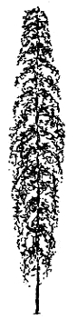  head (upper fifth of plant) | 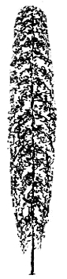 | 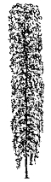 | 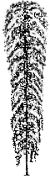 | 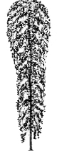 | 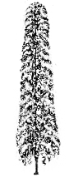 | 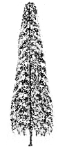
1 | 2 | 3 | 4 | 5 | 6 | 7
fusiform | fusiform to cylindrical | cylindrical | cylindrical to club-shaped | club-shaped | cylindrical to conic | conic

“Plant: volume of head” is related to “Plant: shape” but there is also clear variation of head volume within the same shape. The same volume of head can be observed in different shapes. Therefore, both characteristics should be observed.

Ad. 12: Side shoot from middle third of plant: density of foliage

Observation in the middle third of side shoots. The total appearance of leaves of the side shoots should be observed without considering number and size of leaves separately.

Ad. 13: Side shoot from middle third of plant: number of cones per node
Ad. 14: Side shoot from middle third of plant: total number of cones
Ad. 15: Side shoot from upper third of plant: total number of cones

The number of cones on side shoots can vary within plants. Therefore, side shoots from the middle and the upper third of plant should be considered separately (char. 14 and 15). In addition, a difference in the number of cones per node may be observed (char. 13). The number of cones per node should be assessed in the middle part of side shoots from the middle third of plant.

Ad 16: Time of picking maturity of cones

To be observed when almost all cones have reached the final degree of opening of bracts and have produced golden lupulin and fully developed aroma. The cones rustle when lightly pressed between fingers.

Ad. 18: Cone: shape

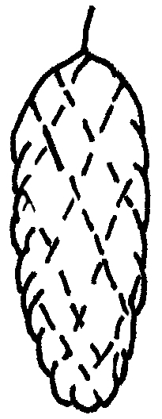 | 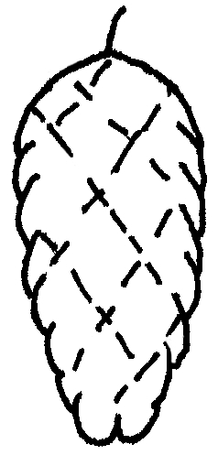 | 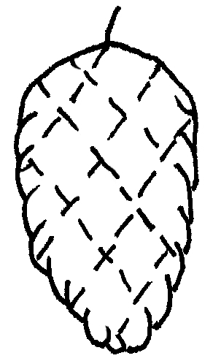 | 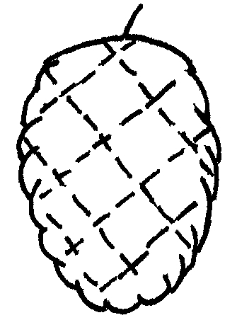 | 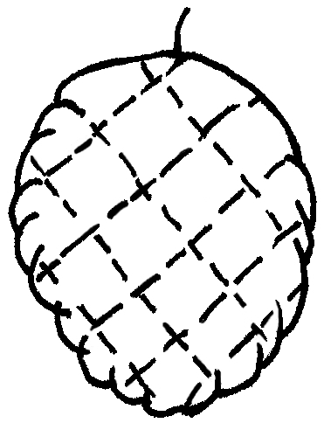
1 | 2 | 3 | 4 | 5
cylindrical | narrow ovate | medium ovate | broad ovate | globose

Ad. 22: Bract: ratio width/length

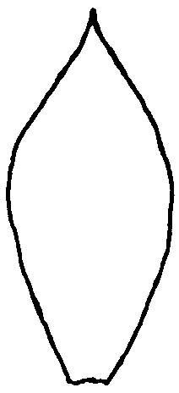 |  | 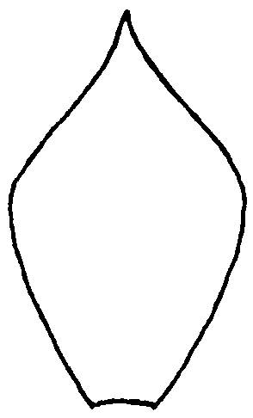 |  | 
3 | 5 |  | 7
small | medium |  | large

Ad. 23: Bract: length of apex

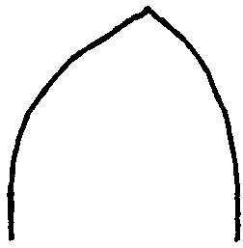 | 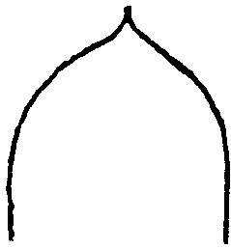 | 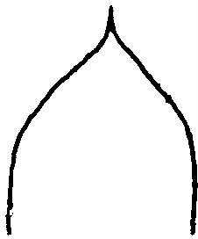 | 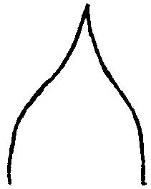 | 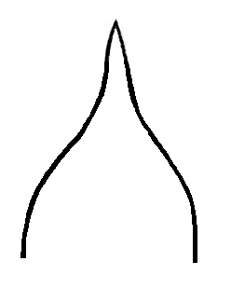
1 | 3 | 5 | 7 | 9
very short | short | medium | long | very long

8.3. Phenological growth stages and BBCH-identification keys of Hop
(Humulus lupulus L.), Rossbauer et al., 1995
Code | Description
Principal growth stage 0 | Sprouting
00 | Dormancy: Rootstock without shoots (uncut)
01 | Dormancy: Rootstock without shoots (cut)
07 | Rootstock with shoots (uncut)
08 | Beginning of shoot-growth (rootstock cut)
09 | Emergence: First shoots emerge at the soil surface
Principal growth stage 1 | Leaf development
11 | First pair of leaves unfolded
12 | Second pair of leaves unfolded (beginning of twining)  stages continuous till ...
19 | Nine and more pairs of leaves unfolded
Principal growth stage 2 | Formation of side shoots
21 | First pair of side shoots visible
22 | Second pair of side shoots visible  stages continuous till ...
29 | Nine and more pairs of side shoots visible (secondary side shoots occur)
Principal growth stage 3 | Elongation of bines
31 | Bines have reached 10 % of top wire height
32 | Bines have reached 20 % of top wire height  stages continuous till ...
38 | Plants have reached the top wire
39 | End of bine elongation
Principal growth stage 4 | -
Principal growth stage 5 | Inflorescence emergence
51 | Inflorescence buds visible
55 | Inflorescence buds enlarged
Principal growth stage 6 | Flowering
61 | Beginning of flowering: about 10 % of flowers open
65 | Full flowering: about 50 % of flowers open
69 | End of flowering
Principal growth stage 7 | Development of cones
71 | Beginning of cone development: 10 % of inflorescences are cones
75 | Cone development half way: All cones are visible, cones are soft, stigmas still present
79 | Cone development complete: Nearly all cones have reached full size
Principal growth stage 8 | Maturity of cones
81 | Beginning of maturity: 10 % of cones are compact
85 | Advanced maturity: 50 % of cones are compact
87 | 70 % of cones are compact
89 | Cones ripe for picking: cones closed; lupulin golden; aroma potential fully developed
Principal growth stage 9 | Senescence, entry into dormancy
92 | Overripeness: Cones yellow-brown discoloured, aroma deterioration
97 | Dormancy: leaves and stems dead

Literature
Meier, U. (Editor), 1997: Growth Stages of Mono- and Dicotyledonous Plants. BBCH-Monograph. Blackwell Wissenschafts-Verlag, Berlin, Wien.

Technical Questionnaire
TECHNICAL QUESTIONNAIRE |  |  |  | Page {x} of {y} |  | Reference Number:
 |  |  |  |  |  | Application date:
 |  |  |  |  |  | (not to be filled in by the applicant)
TECHNICAL QUESTIONNAIRE
to be completed in connection with an application for plant breeders’ rights

1. Subject of the Technical Questionnaire
1.1 Botanical name |  |  | Humulus lupulus L.
1.2 Common Name |  |  | Hop
2. Applicant
Name
Address
Telephone No.
Fax No.
E-mail address
Breeder (if different from applicant)
3. Proposed denomination and breeder’s reference
Proposed denomination
(if available)

Breeder’s reference
#4. Information on the breeding scheme and propagation of the variety

4.1 Breeding scheme

Variety resulting from:

    - Crossing

(a) controlled cross [ ]
(please state parent varieties)

(b) partially known cross [ ]
(please state known parent variety(ies))

(c) unknown cross [ ]

4.1.2 Mutation [ ]
(please state parent variety)

4.1.3 Discovery and development [ ]
(please state where and when discovered and how developed)

4.1.4 Other [ ]
(please provide details)

4.2 Method of propagating the variety

5. Characteristics of the variety to be indicated (the number in brackets refers to the corresponding characteristic in Test Guidelines; please mark the note which best corresponds).

 | Characteristics |  |  |  |  |  | Example Varieties |  | Note
5.1  (1) | Main shoot: anthocyanin coloration
 | absent or very weak |  |  |  |  |  | Late Cluster |  | 1[ ]
 | weak |  |  |  |  |  | Willamette |  | 3[ ]
 | medium |  |  |  |  |  | Spalter |  | 5[ ]
 | strong |  |  |  |  |  | Northern Brewer |  | 7[ ]
 | very strong |  |  |  |  |  | Wye Challenger |  | 9[ ]
5.2  (7) | Plant: growth type
 | dwarf |  |  |  |  |  | First Gold |  | 1[ ]
 | normal |  |  |  |  |  | Hallertauer Magnum |  | 2[ ]
5.3  (10) | Side shoot from middle third of plant: length
 | short |  |  |  |  |  | First Gold |  | 3[ ]
 | medium |  |  |  |  |  | Northern Brewer |  | 5[ ]
 | long |  |  |  |  |  | Tettnanger |  | 7[ ]
 | very long |  |  |  |  |  | Late Cluster |  | 9[ ]
5.4  (15) | Side shoot from upper third of plant: total number of cones
 | very few |  |  |  |  |  | Herald |  | 1[ ]
 | few |  |  |  |  |  | Spalter |  | 3[ ]
 | medium |  |  |  |  |  | Tettnanger |  | 5[ ]
 | many |  |  |  |  |  | Aurora |  | 7[ ]
 | very many |  |  |  |  |  | Hersbrucker Spät |  | 9[ ]
 | Characteristics |  |  |  |  |  | Example Varieties |  | Note
5.5  (16) | Time of picking maturity of cones
 | early |  |  |  |  |  | Northern Brewer |  | 3[ ]
 | medium |  |  |  |  |  | Hallertauer Merkur |  | 5[ ]
 | late |  |  |  |  |  | Nugget |  | 7[ ]
5.6  (17) | Cone: size
 | small |  |  |  |  |  | Saphir |  | 3[ ]
 | medium |  |  |  |  |  | Hersbrucker Spät |  | 5[ ]
 | large |  |  |  |  |  | Tettnanger |  | 7[ ]
5.7  (19) | Cone: degree of opening of bracts
 | closed |  |  |  |  |  | Wye Target |  | 1[ ]
 | slightly open |  |  |  |  |  | Perle |  | 2[ ]
 | clearly open |  |  |  |  |  | Brewers Gold |  | 3[ ]
5.8  (23) | Bract: length of apex
 | very short |  |  |  |  |  |  |  | 1[ ]
 | short |  |  |  |  |  | Wye Target |  | 3[ ]
 | medium |  |  |  |  |  | Perle |  | 5[ ]
 | long |  |  |  |  |  | Brewers Gold |  | 7[ ]
 | very long |  |  |  |  |  |  |  | 9[ ]
6. Similar varieties and differences from these varieties
Please use the following table and box for comments to provide information on how your candidate variety differs from the variety (or varieties) which, to the best of your knowledge, is (or are) most similar. This information may help the examination authority to conduct its examination of distinctness in a more efficient way.

Denomination(s) of variety(ies) similar to your candidate variety |  | Characteristic(s) in which your candidate variety differs from the similar variety(ies) |  |  | Describe the expression of the characteristic(s) for the similar variety(ies) |  |  | Describe the expression of the characteristic(s) for your candidate variety
Example
Comments:

#7. Additional information which may help in the examination of the variety

7.1 In addition to the information provided in sections 5 and 6, are there any additional characteristics which may help to distinguish the variety?

Yes [ ] No [ ]

(If yes, please provide details)

7.2 Are there any special conditions for growing the variety or conducting the examination?

Yes [ ] No [ ]

(If yes, please provide details)

7.3 Type of use of variety
Aroma [ ]
Bitter [ ]
High alpha [ ]
Ornamental [ ]
other (please specify) [ ]
.................................................................

Other information

8. Authorization for release

(a) Does the variety require prior authorization for release under legislation concerning the protection of the environment, human and animal health?

Yes [ ] No [ ]

(b) Has such authorization been obtained?

Yes [ ] No [ ]

If the answer to (b) is yes, please attach a copy of the authorization.

9. Information on plant material to be examined or submitted for examination.

9.1 The expression of a characteristic or several characteristics of a variety may be affected by factors, such as pests and disease, chemical treatment (e.g. growth retardants or pesticides), effects of tissue culture, different rootstocks, scions taken from different growth phases of a tree, etc.

9.2 The plant material should not have undergone any treatment which would affect the expression of the characteristics of the variety, unless the competent authorities allow or request such treatment. If the plant material has undergone such treatment, full details of the treatment must be given. In this respect, please indicate below, to the best of your knowledge, if the plant material to be examined has been subjected to:

(a) Microorganisms (e.g. virus, bacteria, phytoplasma) Yes [ ] No [ ]

(b) Chemical treatment (e.g. growth retardant, pesticide) Yes [ ] No [ ]

(c) Tissue culture Yes [ ] No [ ]

(d) Other factors Yes [ ] No [ ]

Please provide details for where you have indicated “yes”.

10. I hereby declare that, to the best of my knowledge, the information provided in this form is correct:

Applicant’s name

Signature Date

[End of document]

* These names were correct at the time of the introduction of these Test Guidelines but may be revised or updated. [Readers are advised to consult the UPOV Code, which can be found on the UPOV Website (www.upov.int), for the latest information.]
# Authorities may allow certain of this information to be provided in a confidential section of the Technical Questionnaire.
# Authorities may allow certain of this information to be provided in a confidential section of the Technical Questionnaire.

