 |  | E  TG/191/2

INTERNATIONAL UNION FOR THE PROTECTION  OF NEW VARIETIES OF PLANTS | UNION INTERNATIONALE POUR LA PROTECTION  DES OBTENTIONS VÉGÉTALES | INTERNATIONALER VERBAND ZUM SCHUTZ VON PFLANZEN-ZÜCHTUNGEN | UNIÓN INTERNACIONAL PARA LA PROTECCIÓN  DE LAS OBTENCIONES VEGETALES

GUIDELINES

FOR THE CONDUCT OF TESTS

FOR DISTINCTNESS, UNIFORMITY AND STABILITY

HORSE RADISH

(Armoracia rusticana Gaertn. Mey. et Scherb.)

GENEVA
2001

Copies of this document are available on request at the price of 10 Swiss francs each, including surface mail, from the Office of UPOV, 34, chemin des Colombettes, P.O. Box 18, 1211 Geneva 20, Switzerland

This document or parts of it may be reproduced, translated and published without obtaining the specific consent of UPOV, provided that the source is acknowledged.

* * * * * * *
E
TG/191/2
ORIGINAL: English
DATE: 2001-04-04

INTERNATIONAL UNION FOR THE PROTECTION  OF NEW VARIETIES OF PLANTS | UNION INTERNATIONALE POUR LA PROTECTION  DES OBTENTIONS VÉGÉTALES | INTERNATIONALER VERBAND ZUM SCHUTZ VON PFLANZEN-ZÜCHTUNGEN | UNIÓN INTERNACIONAL PARA LA PROTECCIÓN  DE LAS OBTENCIONES VEGETALES

GUIDELINES

FOR THE CONDUCT OF TESTS

FOR DISTINCTNESS, UNIFORMITY AND STABILITY

HORSE RADISH

(Armoracia rusticana Gaertn. Mey. et Scherb.)

These Guidelines should be read in conjunction with document TG/1/2, which contains explanatory notes on the general principles on which the Guidelines have been established.

TABLE OF CONTENTS PAGE

I. Subject of these Guidelines ........................................................................... 3

II. Material Required ........................................................................................ 3

III. Conduct of Tests .......................................................................................... 3

IV. Methods and Observations............................................................................ 3

V. Grouping of Varieties ................................................................................... 4

VI. Characteristics and Symbols ........................................................................ 4

VII. Table of Characteristics ............................................................................... 5

VIII. Explanations on the Table of Characteristics .............................................. 12

IX. Literature ..................................................................................................... 14

X. Technical Questionnaire ............................................................................. 15

I. Subject of these Guidelines

These Test Guidelines apply to all varieties of Armoracia rusticana Gaertn. Mey. et Scherb.

II. Material Required

1. The competent authorities decide when, where and in what quantity and quality the plant material required for testing the variety is to be delivered. Applicants submitting material from a State other than that in which the testing takes place must make sure that all customs formalities are complied with. The minimum quantity of plant material to be supplied by the applicant in one or several samples should be:

80 rootstocks for a growing season.

2. The plant material (rootstocks) supplied should be 200 mm in length and 8-10 mm in diameter, visibly healthy, not lacking in vigor or affected by any important pest or disease. It must in particular be free from visually recognizable virus diseases and nematodes.

3. The plant material must not have undergone any treatment unless the competent authorities allow or request such treatment. If it has been treated, full details of the treatment must be given.

III. Conduct of Tests

1. The minimum duration of tests should normally be two independent growing cycles.

2. The tests should normally be conducted at one place. If any important characteristics of the variety cannot be seen at that place, the variety may be tested at an additional place.

3. The tests should be carried out under conditions ensuring normal growth. The size of the plots should be such that plants or parts of plants may be removed for measurement and counting without prejudice to the observations which must be made up to the end of the growing cycle. Each test should include a total of 60 plants which should be divided between two or more replicates. Separate plots for observation and for measuring can only be used if they have been subject to similar environmental conditions.

4. Additional tests for special purposes may be established.

IV. Methods and Observations

1. Unless otherwise indicated, all observations determined by measurement, weighing or counting should be made on 20 plants or parts taken from each of 20 plants.

2. For the assessment of uniformity a population standard of 1% with an acceptance probability of at least 95% should be applied. In the case of a sample size of 60 plants the maximum number of off types allowed would be 2.

3. Unless otherwise indicated, all observations on the leaf blade should be made on the fourth fully developed leaf. All observations on the incised (seondary) leaf should be made on the first incised leaf. All observations on rhizome should be made on the fully developed rhizome. The number of shoots should be observed on fully developed rhizomes after forcing in wet sand.

V. Grouping of Varieties

1. The collection of varieties to be grown should be divided into groups to facilitate the assessment of distinctness. Characteristics which are suitable for grouping purposes are those which are known from experience not to vary, or to vary only slightly, within a variety. Their various states of expression should be fairly evenly distributed throughout the collection.

2. It is recommended that the competent authorities use the following characteristics for grouping varieties:

- Leaf blade: shape (characteristic 1);
- Petiole: anthocyanin coloration at base (characteristic 15);
- Rhizome: shape in longitudinal section (characteristic 18).

VI. Characteristics and Symbols

1. To assess distinctness, uniformity and stability, the characteristics and their states as given in the Table of Characteristics should be used.

2. Notes (numbers), for the purposes of electronic data processing, are given opposite the states of the different characteristics.

3. Legend:

(*) Characteristics that should be used on all varieties in every growing cycle over which the examinations are made and always be included in the variety descriptions, except when the state of expression of a preceding characteristic or regional environmental conditions render this impossible.

(+) See Explanations on the Table of Characteristics in Chapter VIII.

VII. Table of Characteristics/Tableau des caractères/Merkmalstabelle/Tabla de caracteres

 | English | français | deutsch | español | Example Varieties  Exemples  Beispielssorten  Variedades ejemplo | Note/  Nota
1.  (*)  (+) | Leaf blade: shape | Limbe: forme | Blattspreite: Form | Limbo: forma
 | narrow elliptic | elliptique étroite | schmal elliptisch | elíptica estrecha | Brassói | 1
 | elliptic | elliptique | elliptisch | elíptica | Bagaméri 93/1 | 2
 | broad elliptic | elliptique large | breit elliptisch | elíptica ancha | Tel-Aviv | 3
 | ovate | ovale | eiförmig | oval | Danvit | 4
2. | Leaf blade: length | Limbe: longueur | Blattspreite: Länge | Limbo: longitud
 | short | court | kurz | corto | Bagaméri Delikat, Kolozsvari | 3
 | medium | moyen | mittel | medio |  | 5
 | long | long | lang | largo | Grazi | 7
3. | Leaf blade: width | Limbe: largeur | Blattspreite: Breite | Limbo: anchura
 | narrow | étroit | schmal | estrecho |  | 3
 | medium | moyen | mittel | medio |  | 5
 | broad | large | breit | ancho |  | 7
4. | Leaf blade: ratio length/width | Limbe: rapport longueur/largeur | Blattspreite: Verhältnis Länge/Breite | Limbo: relación longitud/anchura
 | small | petit | gering | pequeña |  | 3
 | medium | moyen | mittel | media |  | 5
 | large | grand | groß | grande |  | 7
5.  (*) | Leaf blade: green color | Limbe: couleur verte | Blattspreite: Grünfärbung | Limbo: color verde
 | light | claire | hell | claro | Steierische | 3
 | medium | moyenne | mittel | medio | Danvit | 5
 | dark | foncée | dunkel | oscuro | Bagaméri 93/1 | 7
6.  (*) | Leaf blade: glossiness of upper side | Limbe: brillance de la face supérieure | Blattspreite: Glanz der Oberseite | Limbo: brillo del haz
 | absent or very weak | nulle ou très faible | fehlend oder sehr gering | ausente o muy débil | Grazi | 1
 | weak | faible | gering | débil |  | 3
 | medium | moyenne | mittel | medio | Danvit | 5
 | strong | forte | stark | fuerte | Bagaméri 93/1 | 7
 | very strong | très forte | sehr stark | muy fuerte | Kolozsvári | 9
7.  (*) | Leaf blade: twisting of tip | Limbe: torsion du sommet | Blattspreite: Krümmung der Spitze | Limbo: torsión del extremo
 | absent or very weak | nulle ou très faible | fehlend oder sehr gering | ausente o muy débil | Danvit | 1
 | weak | faible | gering | débil |  | 3
 | medium | moyenne | mittel | media | Pózna | 5
 | strong | forte | stark | fuerte |  | 7
 | very strong | très forte | sehr stark | muy fuerte | Bagaméri 93/1 | 9
8.  (*) | Leaf blade: glaucosity | Limbe: glaucescence | Blattspreite: Bereifung | Limbo:cerosidad
 | absent or very weak | nulle ou très faible | fehlend oder sehr gering | ausente o muy débil | Steierische | 1
 | weak | faible | gering | débil | Bihari | 3
 | medium | moyenne | mittel | media | Nemes, Pózna | 5
 | strong | forte | stark | fuerte |  | 7
 | very strong | très forte | sehr stark | muy fuerte |  | 9
9.  (*) | Leaf blade: undulation of margin | Limbe: ondulation du bord | Blattspreite: Randwellung | Limbo:ondulación del borde
 | absent or very weak | nulle ou très faible | fehlend oder sehr gering | ausente o muy débil | Danvit | 1
 | weak | faible | gering | débil |  | 3
 | medium | moyenne | mittel | media | Pózna | 5
 | strong | forte | stark | fuerte | Bagaméri 93/1 | 7
 | very strong | très forte | sehr stark | muy fuerte | Eperjesi | 9
10.  (*) | Leaf blade: serration | Limbe: dentelure | Blattspreite: Einschnitte | Limbo:serrado
 | very weak | très faible | sehr gering | muy débil | Grazi, Lucsonyi | 1
 | weak | faible | gering | débil | Pózna | 3
 | medium | moyenne | mittel | medio | Bagaméri 93/1 | 5
 | strong | forte | stark | fuerte |  | 7
 | very strong | très forte | sehr stark | muy fuerte | Eperjesi | 9
11. | Leaf: color of midrib | Feuille: couleur de la nervure médiane | Blatt: Farbe der Mittelrippe | Hoja: color del nervio central
 | whitish | blanchâtre | weißlich | blanquecino | Bagaméri 93/1, Pózna | 1
 | green | verte | grün | verde | Danvit | 2
12. | Leaf: green color of midrib | Feuille: couleur verte de la nervure médiane | Blatt: Grünfärbung der Mittelrippe | Hoja: color verde del nervio central
 | light | claire | hell | claro | Danvit | 3
 | medium | moyenne | mittel | medio | Steierische | 5
 | dark | foncée | dunkel | oscuro |  | 7
13. | Petiole: length | Pétiole: longueur | Blattstiel: Länge | Pecíolo: longitud
 | short | court | kurz | corto | Pózna | 3
 | medium | moyen | mittel | medio | Bagaméri Delikát | 5
 | long | long | lang | largo |  | 7
14. | Petiole: width | Pétiole: largeur | Blattstiel: Breite | Pecíolo: anchura
 | narrow | étroit | schmal | estrecho | Bagaméri Delikát | 3
 | medium | moyen | mittel | medio | Danvit | 5
 | broad | large | breit | ancho |  | 7
15.  (*) | Petiole: anthocyanin coloration at base | Pétiole: pigmentation anthocyanique à la base | Blattstiel: Anthocyan-färbung an der Basis | Pecíolo: pigmentación antociánica en la base
 | absent | absente | fehlend | ausente |  | 1
 | present | présente | vorhanden | presente | Rzezowi | 9
16.  (*) | Time of appearance of fist incised (secondary) leaf | Époque d’apparition de la première feuille incisée (secondaire) | Zeitpunkt des Erscheinens des ersten eingeschnittenen (sekundären) Blattes | Epoca de aparición de la primera hoja incisa (secundaria)
 | early | précoce | früh | precoz | Bagaméri 93/1 | 3
 | medium | moyen | mittel | media | Pózna | 5
 | late | tardif | spät | tardía | Danvit | 7
17.  (+) | Incised (secondary) leaf: incisions of the margin | Feuille incisée (secondaire): incisions du bord | Eingeschnittenes (sekundäres) Blatt: Randeinschnitte | Hoja incisa (secundaria): incisiones del borde
 | absent or very weak | nulles ou très faibles | fehlend oder sehr gering | ausentes o muy débiles |  | 1
 | weak | faibles | gering | débiles | Danvit | 3
 | medium | moyennes | mittel | medias |  | 5
 | strong | fortes | stark | fuertes |  | 7
 | very strong | très fortes | sehr stark | muy fuertes | Bagaméri 93/1 | 9
18.  (*)  (+) | Rhizome: shape in longitudinal section | Rhizome: forme en section longitudinale | Rhizom: Form im Längsschnitt | Rizoma: forma en la sección longitudinal
 | narrow oblong | oblong étroit | schmal rechteckig | oblonga estrecha | Pózna | 1
 | narrow obtriangular | obtriangulaire étroit | trapezförmig | obtriangular estrecha |  | 2
 | obtriangular | obtriangulaire | breit trapezförmig | obtriangular | Danvit | 3
19. | Rhizome: curvature | Rhizome: courbure | Rhizom: Krümmung | Rizoma: curvatura
 | straight | droit | gerade | recto | Pózna | 1
 | slightly curved | légèrement courbé | leicht gekrümmt | ligeramente curvado | Nagykörösi | 2
 | strongly curved | fortement courbé | stark gekrümmt | fuertemente curvado | Daróczfalvi | 3
20.  (+) | Rhizome: diameter at top | Rhizome: diamètre au sommet | Rhizom: Durchmesser am Kopf | Rizoma: diámetro en el apice
 | small | petit | klein | pequeño |  | 3
 | medium | moyen | mittel | medio | Bagaméri Delikát, Pózna | 5
 | large | grand | groß | grande | Danvit | 7
21.  (+) | Rhizome: diameter at base | Rhizome: diamètre à la base | Rhizom: Durchmesser an der Basis | Rizoma: diámetro en la base
 | small | petit | klein | pequeño |  | 3
 | medium | moyen | mittel | medio | Pózna | 5
 | large | grand | groß | grande | Bagaméri 93/1 | 7
22. | Rhizome: weight | Rhizome: poids | Rhizom: Gewicht | Rizoma: peso
 | low | faible | niedrig | bajo |  | 3
 | medium | moyen | mittel | medio | Pózna | 5
 | high | élevé | hoch | alto | Danvit | 7
23. | Rhizome: surface texture | Rhizome: texture de la surface | Rhizom: Textur an der Oberfläche | Rizoma: textura de la superficie
 | smooth | lisse | glatt | lisa | Bagaméri 93/1 | 1
 | intermediate | intermédiaire | leicht rau | media |  | 2
 | rough | rugueuse | deutlich rau | rugosa |  | 3
24. | Rhizome: internal color | Rhizome: couleur interne | Rhizom: Innenfarbe | Rizoma: color interno
 | whitish | blanchâtre | weißlich | blanquecino | Bagaméri 93/1 | 1
 | yellowish | jaunâtre | gelblich | amarillento | Bátai | 2
25. | Rhizome: brownish coloration of flesh | Rhizome: coloration brunâtre de la chair | Rhizom: Bräunlichfärbung des Fleisches | Rizoma: coloración marronácea de la pulpa
 | absent or very weak | nulle ou très faible | fehlend oder sehr gering | ausente o muy débil | Bagaméri 93/1 | 1
 | weak | faible | gering | débil | Danvit | 3
 | medium | moyenne | mittel | media |  | 5
 | strong | forte | stark | fuerte |  | 7
 | very strong | très forte | sehr stark | muy fuerte |  | 9
26. | Rhizome: density of side roots (at the upper third) | Rhizome: densité des racines latérales (au tiers supérieur) | Rhizom: Dichte der Seitenwurzeln (im oberen Drittel) | Rizoma: densidad de las raíces laterales ( en el tercio superior)
 | sparse | lâche | locker | rala |  | 3
 | medium | moyenne | mittel | media |  | 5
 | dense | dense | dicht | densa | Brassói | 7
27. | Rhizome: density of roots at base | Rhizome: densité des racines à la base | Rhizom: Dichte der Wurzeln an der Basis | Rizoma: densidad de las raíces en el base
 | sparse | lâche | locker | rala | Bagaméri 93/1 | 3
 | medium | moyenne | mittel | media | Bagaméri Delikát | 5
 | dense | dense | dicht | densa | Pózna | 7
28.  (*)  (+) | Rhizome: predominant number of shoots on the crown | Rhizome: nombre prédominant de rameaux à la partie supérieure | Rhizom: überwiegende Anzahl Triebe am Kopf | Rizoma: número predominante de brotes en la corona
 | one | un | einer | uno | Bayerischer, Pózna | 1
 | two | deux | zwei | dos | Bagaméri 93/1 | 2
 | three or more | trois ou plus | drei oder mehr | tres o más | Brassói | 3
29. | Stem: height  (at full flowering in second year) | Tige: hauteur  (en pleine floraison la deuxième année) | Stiel: Höhe  (zum Zeitpunkt der Vollblüte im zweiten Jahr) | Tallo: altura  (en el momento de floración plena del segundo año)
 | short | courte | niedrig | corto | Bagaméri Delikát | 3
 | medium | moyenne | mittel | medio |  | 5
 | tall | haute | hoch | alto | Pózna | 7

VIII. Explanations on the Table of Characteristics

Ad. l: Leaf blade: shape

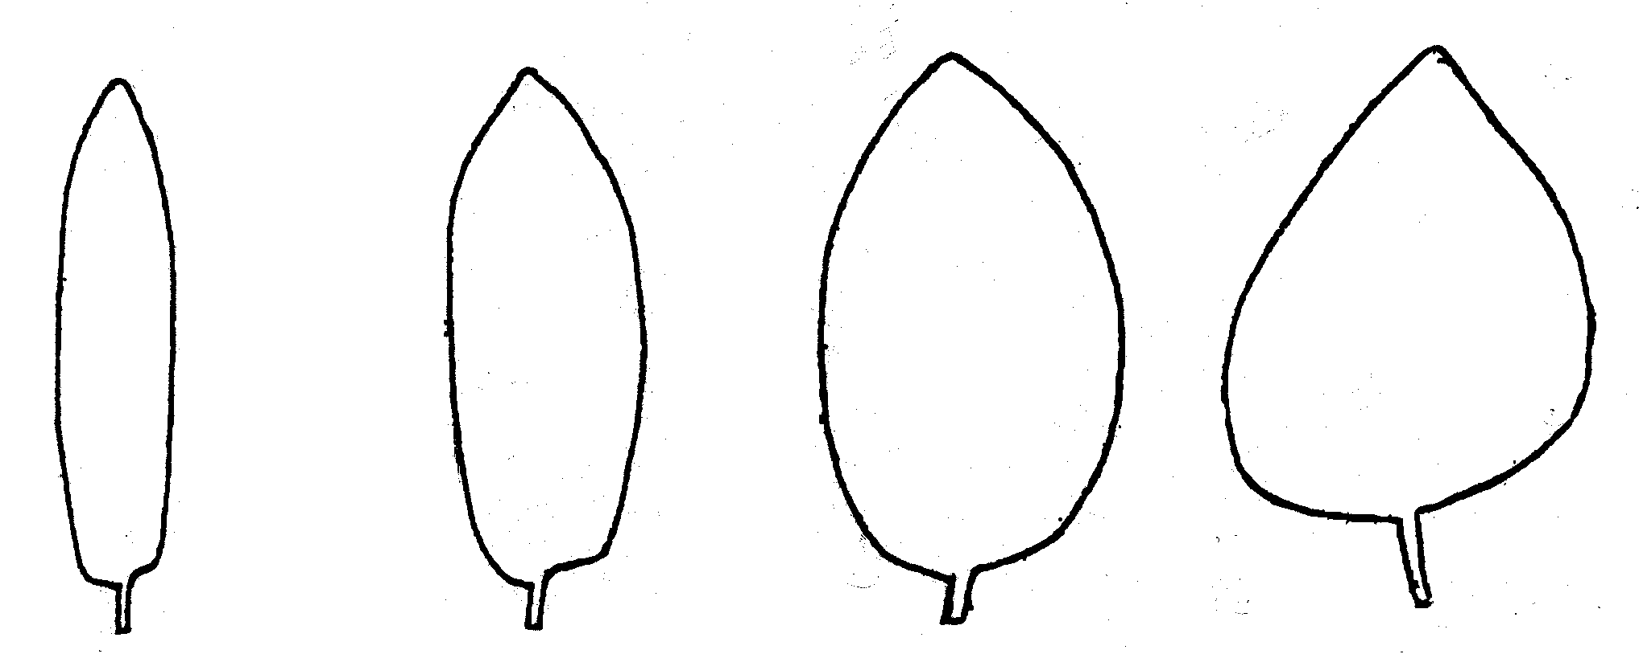

1 | 2 | 3 | 4
narrow elliptic | elliptic | broad elliptic | ovate

Ad. 17: Incised (secondary) leaf: incisions of the margin (observed on the upper third of the leaf blade)

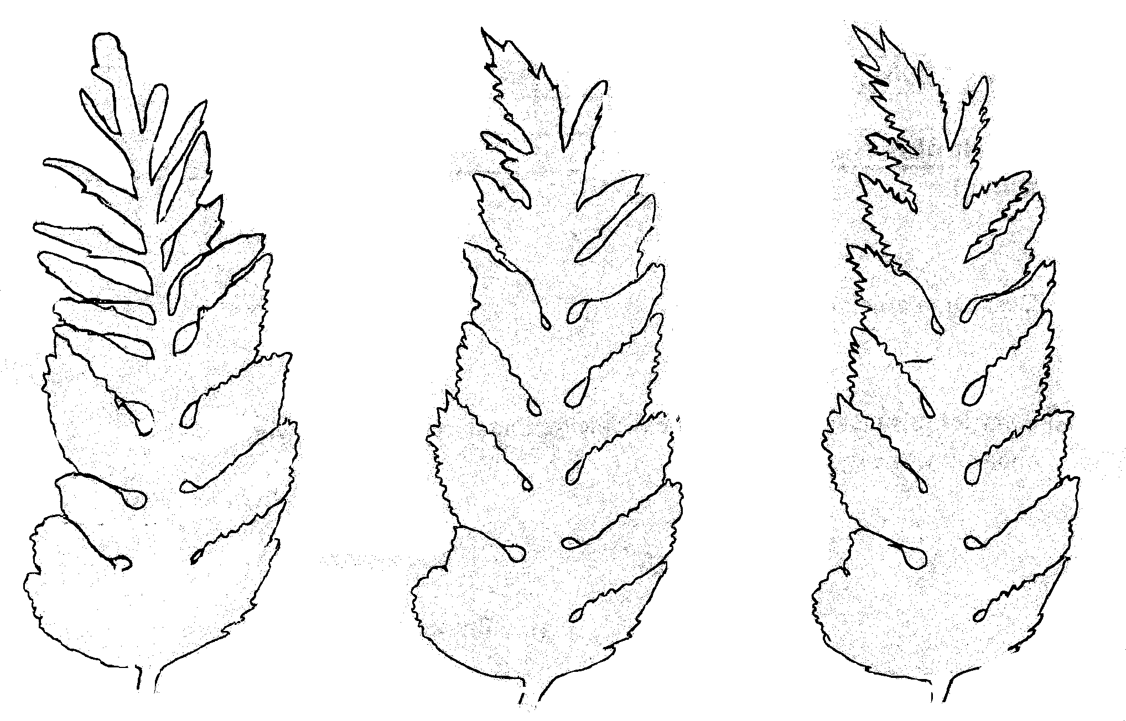

3 | 5 | 7
weak | medium | strong

Ad. 18, 20, 21: Rhizome: shape in longitudinal section (18), diameter at top (20) and diameter at base (21)

Shape in longitudinal section (18)
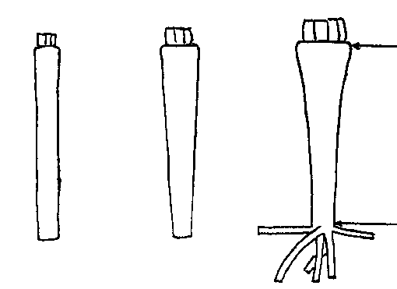 |  |  | Rhizome: diameter at top (20)  Rhizome: diameter at base (21)
1 | 2 | 3
narrow oblong | narrow obtriangular | obtriangular

Ad 28: Rhizome: predominant number of shoots on the crown

Twenty fully developed rhizomes should be put vertically in wet sand and kept at 15º-17ºC for two weeks. The shoots developed on the crown can be counted.

IX. Literature

Becker – Dillingen J., 1956: Handbuch des gesamten Gemüsebaues, Paul Parey in Berlin und Hamburg.

Géczi L., 1999: A torma Mezögazda Kiadó.

Nebel, H., 1987: Untersuchungen über Einflüsse von Herkunft, Anbau und Lagerung von Meerrettich. Dissertation TU München, Fak. f. Landw. u. Gartenbau.

Rhodes, A.M., Carmer, S.G., Courter, J.W., 1969: Measurement and classification of genetic variability in horseradish. Am. Soc. Hortic. Sci.J. 94, 98-102.

Wonneberger, C., 1978: Meerrettich, Anbau und Verwertung. Eigenverlag. Fürth/Osnabrück.

X. Technical Questionnaire

 |  |  |  | Reference Number
 |  |  |  | (not to be filled in by the applicant)
TECHNICAL QUESTIONNAIRE
to be completed in connection with an application for plant breeders’ rights

1. Species Armoratia rusticana Gaertn. Mey. et Scherb.

HORSE RADISH

2. Applicant (Name and address)

3. Proposed denomination or breeder’s reference

4. Information on origin, maintenance and reproduction of the variety

4.1 Origin and breeding method

- natural clone [ ]
- clone from in vitro culture [ ]
- clone from seedlings [ ]
- discovery (indicate where and when) [ ]
...............................................................................................................................

4.2 Other information

5. Characteristics of the variety to be indicated (the number in brackets refers to the corresponding characteristic in Test Guidelines; please mark the state of expression which best corresponds).

 | Characteristics |  |  |  | Example Varieties |  | Note
5.1  (1) | Leaf blade: shape
 | narrow elliptic |  |  |  | Brassói |  | 1[ ]
 | elliptic |  |  |  | Bagaméri 93/1 |  | 2[ ]
 | broad elliptic |  |  |  | Tel-Aviv |  | 3[ ]
 | ovate |  |  |  | Danvit |  | 4[ ]
5.2  (7) |  | Leaf blade: twisting of tip
 |  | absence or very weak |  |  |  | Danvit |  | 1[ ]
 |  | weak |  |  |  |  |  | 3[ ]
 |  | medium |  |  |  | Pózna |  | 5[ ]
 |  | strong |  |  |  |  |  | 7[ ]
 |  | very strong |  |  |  | Bagaméri 93/1 |  | 9[ ]

 | Characteristics |  |  |  | Example Varieties |  |  | Note
5.3  (10) |  | Leaf blade: serration
 |  | very weak |  |  |  | Grazi, Lucsonyi |  |  | 1[ ]
 |  | weak |  |  |  | Pózna |  |  | 3[ ]
 |  | medium |  |  |  | Bagaméri 93/1 |  |  | 5[ ]
 |  | strong |  |  |  |  |  |  | 7[ ]
 |  | very strong |  |  |  | Eperjesi |  |  | 9[ ]
5.4  (15) |  | Petiole: anthocyanin coloration at base
 |  | absent |  |  |  |  |  |  | 1[ ]
 |  | present |  |  |  | Rzezowi |  |  | 9[ ]
5.5  (18) |  | Rhizome: shape in longitudinal section
 |  | narrow oblong |  |  |  | Pózna |  |  | 1[ ]
 |  | narrow obtriangular |  |  |  |  |  |  | 2[ ]
 |  | obtriangular |  |  |  | Danvit |  |  | 3[ ]
5.6  (28) |  | Rhizome: predominant number of shoots on the crown
 |  | one |  |  |  | Bayerischer, Pózna |  |  | 1[ ]
 |  | two |  |  |  | Bagaméri 93/1 |  |  | 2[ ]
 |  | three or more |  |  |  | Brassói |  |  | 3[ ]
6. Similar varieties and differences between these varieties

Denomination of similar variety |  |  | Characteristic in which the similar variety is different ^{o)} | State of expression of similar variety |  |  | State of expression of candidate variety
______________
^{o)} In the case of identical states of expressions of both varieties, please indicate the size of the difference.

7. Additional information which may help to distinguish the variety

7.1 Resistance to pests and diseases
7.2 Special conditions for the examination of the variety

7.3 Other information

8. Authorization for release

- Does the variety require prior authorization for release under legislation concerning the protection of the environment, human and animal health?
Yes [ ] No [ ]

- Has such authorization been obtained?

Yes [ ] No [ ]

If the answer to that question is yes, please attach a copy of such an authorization.

[End of document]

