 |  | E  TG/188/1

INTERNATIONAL UNION FOR THE PROTECTION  OF NEW VARIETIES OF PLANTS | UNION INTERNATIONALE POUR LA PROTECTION  DES OBTENTIONS VÉGÉTALES | INTERNATIONALER VERBAND ZUM SCHUTZ VON PFLANZEN-ZÜCHTUNGEN | UNIÓN INTERNACIONAL PARA LA PROTECCIÓN  DE LAS OBTENCIONES VEGETALES

GUIDELINES

FOR THE CONDUCT OF TESTS

FOR DISTINCTNESS, UNIFORMITY AND STABILITY

CELOSIA

(Celosia L.)

GENEVA
2002

Copies of this document are available on request at the price of 10 Swiss francs each, including surface mail, from the Office of UPOV, 34, chemin des Colombettes, P.O. Box 18, 1211 Geneva 20, Switzerland

This document or parts of it may be reproduced, translated and published without obtaining the specific consent of UPOV, provided that the source is acknowledged.

* * * * * * *
E
TG/188/1
ORIGINAL: English
DATE: 2002-04-17

INTERNATIONAL UNION FOR THE PROTECTION  OF NEW VARIETIES OF PLANTS | UNION INTERNATIONALE POUR LA PROTECTION  DES OBTENTIONS VÉGÉTALES | INTERNATIONALER VERBAND ZUM SCHUTZ VON PFLANZEN-ZÜCHTUNGEN | UNIÓN INTERNACIONAL PARA LA PROTECCIÓN  DE LAS OBTENCIONES VEGETALES

GUIDELINES

FOR THE CONDUCT OF TESTS

FOR DISTINCTNESS, UNIFORMITY AND STABILITY

CELOSIA

(Celosia L.)

These Guidelines should be read in conjunction with document TG/1/2, which contains explanatory notes on the general principles on which the Guidelines have been established.
TABLE OF CONTENTS PAGE

I. | Subject of these Guidelines | 3
II. | Material Required | 3
III. | Conduct of Tests | 3
IV. | Methods and Observations | 5
V. | Grouping of Varieties | 5
VI. | Characteristics and Symbols | 6
VII. | Table of Characteristics | 7
VIII. | Explanations on the Table of Characteristics | 16
IX. | Literature | 18
X. | Technical Questionnaire | 19

I. Subject of these Guidelines

These Test Guidelines apply to all varieties of Celosia L. of the family Amaranthaceae.

II. Material Required

1. The competent authorities decide when, where and in what quantity and quality the plant material required for testing the variety is to be delivered. Applicants submitting material from a State other than that in which the testing takes place must make sure that all customs formalities are complied with. As a minimum, the following quantity of material is recommended:

vegetatively propagated varieties: 50 rooted cuttings;

seed propagated varieties: 2 grams of seed.

2. In the case of seed, the seed should meet the minimum requirements for germination, species and analytical purity, health and moisture content, specified by the competent authority. In cases where the seed is to be stored, the germination capacity should be as high as possible and should be stated by the applicant.

3. The material supplied should be visibly healthy, not lacking in vigor or affected by any important pests or diseases.

4. The plant material must not have undergone any treatment unless the competent authorities allow or request such treatment. If it has been treated, full details of the treatment must be given.

III. Conduct of Tests

1. The tests should normally be conducted over one growing cycle. If the examination cannot be completed in one growing cycle, the test should be extended for a second growing cycle.

2. The test should normally be conducted at one place. If any important characteristics of the variety cannot be seen at that place, the variety may be tested at an additional place.

3. The test should be carried out in the greenhouse under the following growing conditions:

Seed propagated varieties:

Sowing method: Preferably direct seeding (because of taproot)

For germination, seeds should be lightly covered with vermiculite.

Immediately after sowing:

Temperature: 22-24ºC.
Ventilation temperature: Day ca. 27ºC, night ca. 32ºC.

After ca. 1 week:

Temperature: Day ca. 20ºC, night ca. 17ºC.
Ventilation temperature during the day: Ca. 21-32ºC.
Ventilation temperature during the night: Ca. 18ºC.
Humidity: 90-95%.
The top layer of the soil must be kept moist.

After ca. 2 to 3 weeks:

Temperature: Day ca. 19ºC, night ca. 17ºC.
Ventilation temperature: Day ca. 20ºC, night ca. 18ºC.
Humidity: Ca. 80-85%.

6 to 8 weeks after sowing:

Temperature: Day ca. 16ºC, night ca. 15ºC.
Ventilation temperature: Day ca. 17ºC, night ca. 16ºC.
Humidity: Ca. 80-85%.

Vegetatively propagated varieties:

Temperature: Immediately after planting, ca. 20ºC to 25ºC, slowly decreasing to ca. 16ºC.
Humidity: Ca. 80-85%.

General:

Irrigation should be provided by overhead sprinkling until the flowers appear.

After appearance of the flowers, the soil should be kept drier and sprinkling should be stopped to reduce the risk of botrytis infection.

Base fertilization: None.
Fertilization during growth: None.

Substrate: Poor substrate, well drained.

Plant spacing: Ca. 32 pl/ m²,
max. 64 pl/m²

Shading: None, Celosia is very photo-sensitive.

Most Celosia varieties need to be supported by 2 to 3 layers of wire netting.

4. The size of the plots should be such that plants or parts of plants may be removed for measurement and counting without prejudice to the observations which must be made up to the end of the growing cycle. Each test should be designed to result in a total of at least 50 plants. Separate plots for observation and for measuring should only be used if they have been subject to similar environmental conditions.

5. Additional tests for special purposes may be established.

IV. Methods and Observations

1. All observations determined by measurement or counting should be made on 10 plants or parts taken from each of 10 plants.

2. Celosia is self-pollinating, and the rules for assessment of uniformity in seed propagated varieties are the same as for vegetatively propagated varieties. For the assessment of uniformity a population standard of 1% with an acceptance probability of at least 95% should be applied. In the case of a sample size of 50 plants, the maximum number of off-types allowed would be 2.

3. Unless otherwise indicated, all observations should be made on plants with a full-grown inflorescence. All observations on the leaf should be made on a full-grown leaf, located at the middle third of the stem and all observations on the flower should be made at the beginning of anther dehiscence.

4. Because daylight varies, color determinations made against a color chart should be made either in a suitable cabinet providing artificial daylight or in the middle of the day in a room without direct sunlight. The spectral distribution of the illuminant for artificial daylight should conform with the CIE Standard of Preferred Daylight D 6500 and should fall within the tolerance set out in British Standard 950, Part I. These determinations should be made with the plant part placed against a white background.

V. Grouping of Varieties

1. The collection of varieties to be grown should be divided into groups to facilitate the assessment of distinctness. Characteristics which are suitable for grouping purposes are those which are known from experience not to vary, or to vary only slightly, within a variety. Their various states of expression should be fairly evenly distributed throughout the collection.

2. It is recommended that the competent authorities use the following characteristics for grouping varieties:

(a) Inflorescence: color (characteristic 24)

VI. Characteristics and Symbols

1. To assess distinctness, uniformity and stability, the characteristics and their states as given in the Table of Characteristics should be used.

2. Notes (numbers), for the purposes of electronic data processing, are given opposite the states of expression for each characteristic.

3. Legend:

(*) Characteristics that should be used on all varieties in every growing cycle over which examinations are made and always be included in the variety descriptions, except when the state of expression of a preceding characteristic or regional environmental conditions render this impossible.

(+) See Explanations on the Table of Characteristics in Chapter VIII.

VII. Table of Characteristics/Tableau des caractères/Merkmalstabelle/Tabla de caracteres

 | English | français | deutsch | español | Example Varieties  Exemples  Beispielssorten  Variedades ejemplo | Note/  Nota
1.  (*) | Plant: height | Plante: hauteur | Pflanze: Höhe | Planta: altura
 | very short | très basse | sehr niedrig | muy baja | Super Dwarf Kimono Orange | 1
 | short | basse | niedrig | baja | Century Rose | 3
 | medium | moyenne | mittel | media | Martine | 5
 | tall | haute | hoch | alta | Bombay | 7
 | very tall | très haute | sehr hoch | muy alta |  | 9
2.  (*) | Stem: thickness | Tige: grosseur | Stiel: Dicke | Tallo: espesor
 | thin | fine | dünn | delgado | Yellow Flame | 3
 | medium | moyenne | mittel | medio | Bombay Gold | 5
 | thick | grosse | dick | grueso | Boscorsun | 7
3.  (*) | Stem: presence of anthocyanin coloration at base | Tige: présence de pigmentation anthocyanique à la base | Stiel: Vorhandensein von Anthocyanfärbung an der Basis | Tallo: presencia de pigmentación antociánica en la base
 | absent | absente | fehlend | ausente | Yellow Flame | 1
 | present | présente | vorhanden | presente | Bombay, Purple Martine | 9
4.  (*) | Stem: intensity of anthocyanin coloration at base | Tige: intensité de la pigmentation anthocyanique à la base | Stiel: Intensität der Anthocyanfärbung an der Basis | Tallo: intensidad de la pigmentación antociánica en la base
 | very weak | très faible | sehr gering | muy débil | Bombay Yellow,  Yellow Flame | 1
 | weak | faible | gering | débil | Bombay Gold | 3
 | medium | moyenne | mittel | media | Boscorcass | 5
 | strong | forte | stark | fuerte | Bombay, Bombay Purple | 7
 | very strong | très forte | sehr stark | muy fuerte | Enterprise Wine-red | 9
5.  (*) | Stem: color of basal part | Tige: couleur de la partie basale | Stiel: Farbe des basalen Teils | Tallo: color de la parte basal
 | light green | vert clair | hellgrün | verde claro | Enterprise White | 1
 | medium green | vert moyen | mittelgrün | verde medio |  | 2
 | dark green | vert foncé | dunkelgrün | verde oscuro |  | 3
 | yellow | jaune | gelb | amarillo | Celrayel, Martine Salmon | 4
 | orange | orange | orange | naranja | Bombay Salmon, Super Dwarf Kimono Orange | 5
 | pinkish red | rouge rosé | blaßrosarot | rojo rosáceo | Super Dwarf Kimono Cherry-red | 6
 | purple red | rouge pourpre | purpurrot | rojo púrpura | Celkopured,  Enterprise Wine-red | 7
6.  (*) | Stem: color of upper part | Tige: couleur de la partie supérieure | Stiel: Farbe des Oberteils | Tallo: color de la parte superior
 | light green | vert clair | hellgrün | verde claro | Bombay Rose, Celrayel | 1
 | medium green | vert moyen | mittelgrün | verde medio | Martine Salmon | 2
 | dark green | vert foncé | dunkelgrün | verde oscuro |  | 3
 | yellow | jaune | gelb | amarillo |  | 4
 | orange | orange | orange | naranja |  | 5
 | pinkish red | rouge rosé | blaßrosarot | rojo rosáceo | Celkopured | 6
 | purple red | rouge pourpre | purpurrot | rojo púrpura | Super Dwarf Kimono Red | 7
7.  (*) | Stem: shape in cross section | Tige: forme de la section transversale | Stiel: Form im Querschnitt | Tallo: forma de la sección transversal
 | circular | arrondie | rund | circular | Enterprise White | 1
 | flattened | aplatie | abgeflacht | aplanada | Boscorcass | 2
8.  (*) | Stem: ribs | Tige: côtes | Stiel: Rippen | Tallo: acostillado
 | absent | absentes | fehlend | ausente | Martine Pink,  Startrek lilac | 1
 | present | présentes | vorhanden | presente |  | 9
9.  (*) | Stem: flowering laterals | Tige: rameaux florifères latéraux | Haupttrieb: blühende Seitentriebe | Tallo: floración lateral
 | absent | absents | fehlend | ausente | Bombay Pink, Boscorsun | 1
 | present | présents | vorhanden | presente | Enterprise White,  Startrek Lilac | 9
10.  (*) | Petiole: length | Pétiole: longueur | Blattstiel: Länge | Pecíolo: longitud
 | short | court | kurz | corto | Celkopured | 3
 | medium | moyen | mittel | medio | Bombay | 5
 | long | long | lang | largo | Enterprise White | 7
11.  (*) | Petiole: presence of anthocyanin coloration | Pétiole: présence de pigmentation anthocyanique | Blattstiel: Vorhandensein von Anthocyanfärbung | Pecíolo: presencia de pigmentación antociánica
 | absent | absente | fehlend | ausente | Bombay Rose, Celrayel | 1
 | present | présente | vorhanden | presente | Caripe, Celkopured | 9
12.  (*) | Leaf blade: length | Limbe: longueur | Blattspreite: Länge | Limbo: longitud
 | short | court | kurz | corto | Bombay Fire | 3
 | medium | moyen | mittel | medio | Martine | 5
 | long | long | lang | largo | Bombay Rose, Caripe | 7
13.  (*) | Leaf blade: width | Limbe: largeur | Blattspreite: Breite | Limbo: anchura
 | narrow | étroit | schmal | estrecho | Bombay Fire | 3
 | medium | moyen | mittel | medio | Bombay, Caripe, Martine, Salmon | 5
 | broad | large | breit | ancho | Bombay Rose,  Enterprise White | 7
14.  (*) | Leaf blade: shape | Limbe: forme | Blattspreite: Form | Limbo: forma
 | narrow elliptic | elliptique étroit | schmal elliptisch | elíptico estrecho | Sharon | 1
 | elliptic | elliptique | elliptisch | elíptico | Bombay Rose | 2
 | ovate | ovale | eiförmig | oval | Bombay Purple | 3
 | broad ovate | ovale large | breit eiförmig | oval ancho |  | 4
15.  (*)  (+) | Leaf blade: shape of apex | Limbe: forme du sommet | Blattspreite: Form der Spitze | Limbo: forma del ápice
 | acute | aigu | spitz | agudo | Caripe, Sharon | 1
 | short acuminate | acuminé court | kurz zugespitzt | acuminado corto | Bombay Salmon | 2
 | long acuminate | acuminé long | lang zugespitzt | acuminado largo | Celkopured | 3
16.  (*) | Leaf blade: color | Limbe: couleur | Blattspreite: Farbe | Limbo: color
 | light green | vert clair | hellgrün | verde claro | Bombay Salmon,  Enterprise White | 1
 | medium green | vert moyen | mittelgrün | verde medio |  | 2
 | dark green | vert foncé | dunkelgrün | verde oscuro | Celkopured | 3
 | greenish red | rouge verdâtre | grünlichrot | rojo verdoso | Flamingo Feather | 4
 | red purple | pourpre rouge | rotpurpur | púrpura rojizo |  | 5
17.  (*) | Leaf blade: presence of anthocyanin coloration of main vein | Limbe: présence de pigmentation anthocyanique de la nervure principale | Blattspreite: Vorhandensein von Anthocyanfärbung der Hauptader | Limbo: presencia de pigmentación antociánica del nervio principal
 | absent | absente | fehlend | ausente | Enterprise White | 1
 | present | présente | vorhanden | presente | Celkopured | 9
18.  (*) | Leaf blade: blistering | Limbe: cloqûre | Blattspreite: Blasigkeit | Limbo: abullonado
 | absent or very weak | nulle ou très faible | fehlend oder sehr gering | ausente o muy débil | Bombay Pink | 1
 | weak | faible | gering | débil | Celrayel,  EnterpriseWine-red, Startrek Lilac | 3
 | medium | moyenne | mittel | medio | Bombay Rose, Celkopured | 5
 | strong | forte | stark | fuerte | Enterprise White | 7
 | very strong | très forte | sehr stark | muy fuerte |  | 9
19.  (*) | Leaf blade: undulation of margin | Limbe: ondulation du bord | Blattspreite: Randwellung | Limbo: ondulación del borde
 | absent | absente | fehlend | ausente | Bombay Rose,  Enterprise White | 1
 | present | présente | vorhanden | presente |  | 9
20.  (*) | Leaf blade: curvature of longitudinal axis | Limbe: courbure de l’axe longitudinal | Blattspreite: Biegung der Längsachse | Limbo: curvatura del eje longitudinal
 | upwards | vers le haut | nach oben | hacia arriba |  | 1
 | straight | droit | gerade | recto |  | 2
 | downwards | vers le bas | nach unten | hacia abajo |  | 3
21.  (*)  (+) | Inflorescence: main shape | Inflorescence: forme principale | Blütenstand: Hauptform | Inflorescencia: forma principal
 | spicate | spiciforme | ährenförmig | espiciforme | Enterprise Wine-red, Flamingo Feather | 1
 | plumose | plumeuse | federähnlich | plumosa | Hiryu no.2,  Kimono Cherry-red | 2
 | paniculate | paniculée | rispenartig | paniculada | Gerana Orange | 3
 | cristate | cristulée | kammförmig | en forma de cresta | Bombay Rose, Martine | 4
22.  (*) | Inflorescence: length of main inflorescence | Inflorescence: longueur de l’inflorescence principale | Blütenstand: Länge des Hauptblütenstandes | Inflorescencia: longitud de la inflorescencia principal
 | short | courte | kurz | corta | Enterprise Salmon, Martine Pink | 3
 | medium | moyenne | mittel | media | Bombay Salmon | 5
 | long | longue | lang | larga | Caripe | 7
23.  (*) | Inflorescence: width of main inflorescence | Inflorescence: largeur de l’inflorescence principale | Blütenstand: Breite des Hauptblütenstandes | Inflorescencia: anchura de la inflorescencia principal
 | narrow | étroite | schmal | estrecha | Caripe,  Enterprise Wine-red | 3
 | medium | moyenne | mittel | media | Bombay Fire,  Martine Pink | 5
 | broad | large | breit | ancha | Bombay Salmon, Boscorcur | 7
24.  (*) | Inflorescence: color | Inflorescence: couleur | Blütenstand: Farbe | Inflorescencia: color
 | white | blanche | weiß | blanca | Enterprise White | 1
 | green | verte | grün | verde |  | 2
 | yellow | jaune | gelb | amarilla | Martine Yellow | 3
 | orange | orange | orange | naranja | Super Dwarf Kimono Orange | 4
 | orange pink | rose orangé | orangerosa | rosa anaranjado |  | 5
 | pink | rose | rosa | rosa | Bombay Rose | 6
 | red | rouge | rot | roja | Red Chief | 7
 | purple | violette | purpur | púrpura |  | 8
25.  (*)  (+) | Cristate group only: inflorescence: color of prophylls on edge of top | Groupe des variétés à inflorescence cristulée seulement: inflorescence: couleur des prophylles sur le bord du sommet | Nur kammförmige Gruppe: Blütenstand: Farbe der Vorblätter am Rand der Spitze | Sólo para el grupo con cresta: inflorescencia: color de los profilos en el borde de la parte superior
 | white | blanches | weiß | blancos |  | 1
 | green | vertes | grün | verdes |  | 2
 | yellow | jaunes | gelb | amarillos | Bombay Gold,  Bombay Yellow | 3
 | orange | oranges | orange | naranjas | Bombay Orange | 4
 | orange pink | rose orangé | orangerosa | rosa anaranjado | Boscorora | 5
 | pink | roses | rosa | rosas | Bombay Rose | 6
 | red | rouges | rot | rojos | Bombay Fire | 7
 | purple | violettes | purpur | púrpura |  | 8
26.  (*)  (+) | Cristate group only: inflorescence: color of prophylls on distal part (excluding edge of top) | Groupe des variétés à inflorescence cristulée seulement: inflorescence: couleur des prophylles sur la partie distale (à l’exclusion du bord du sommet) | Nur kammförmige Gruppe: Blütenstand: Farbe der Vorblätter am unteren Teil (ohne Rand der Spitze) | Sólo para el grupo con cresta: inflorescencia: color de los profilos en la parte distal (excluído el borde de la parte superior)
 | white | blanches | weiß | blancos | Bombay Gold,  Bombay Yellow | 1
 | green | vertes | grün | verdes |  | 2
 | yellow | jaunes | gelb | amarillos |  | 3
 | orange | oranges | orange | naranjas |  | 4
 | orange pink | rose orangé | orangerosa | rosa anaranjado |  | 5
 | pink | roses | rosa | rosas | Bombay Orange,  Bombay Pink | 6
 | red | rouges | rot | rojos |  | 7
 | purple | violettes | purpur | púrpura | Bombay Fire | 8
27.  (*) | Cristate group only: inflorescence: degree of undulation (viewed from above) | Groupe des variétés à inflorescence cristulée seulement: inflorescence: degré d’ondulation (en vue de dessus) | Nur kammförmige Gruppe: Blütenstand: Ausprägung der Wellung (von oben gesehen) | Sólo para el grupo con cresta: inflorescencia: grado de ondulación (visto desde arriba)
 | weak | faible | gering | débil | Bombay Rose | 3
 | medium | moyen | mittel | medio | Bombay Fire, Celrayel | 5
 | strong | élevé | stark | fuerte | Bombay Dark-red, Boscorsun | 7
28.  (*) | Tepal: shape | Tépale: forme | Perigonblatt: Form | Tépalo: forma
 | elliptic | elliptique | elliptisch | elíptica | Enterprise White, Enterprise Wine-red | 1
 | ovate | ovale | eiförmig | oval | Martine,  Martine Scarlet | 2
29.  (*) | Tepal: color of median | Tépale: couleur de la partie médiane | Perigonblatt: Farbe des medianen Teiles | Tépalo: color de la parte media
 | RHS Colour Chart (indicate reference number) | Code RHS des couleurs (préciser le numéro de référence) | RHS-Farbkarte (Nummer angeben) | Carta de colores RHS (indíquese el número de referencia)
30.  (*) | Stamen: color of filament | Étamine: couleur du filament | Staubgefäß: Farbe des Staubfadens | Estambre: color del filamento
 | white | blanc | weiß | blanco | Enterprise White,  Martine Scarlet | 1
 | green | vert | grün | verde |  | 2
 | yellow | jaune | gelb | amarillo |  | 3
 | orange | orange | orange | naranja |  | 4
 | orange pink | rose orangé | orangerosa | rosa anaranjado | Boscorkir | 5
 | pink | rose | rosa | rosa | Bombay Orange,  Canaima | 6
 | red | rouge | rot | rojo |  | 7
 | purple | violet | purpur | púrpura | Bombay Purple, Boscorcass | 8
31.  (*) | Pistil: color of style | Pistil: couleur du style | Stempel: Farbe des Griffels | Pistilo: color del estilo
 | white | blanc | weiß | blanco |  | 1
 | green | vert | grün | verde |  | 2
 | yellow | jaune | gelb | amarillo | Martine Yellow,  Yellow Flame | 3
 | orange | orange | orange | naranja |  | 4
 | orange pink | rose orangé | orangerosa | rosa anaranjado | Bombay Salmon,  Bombay Velvet | 5
 | pink | rose | rosa | rosa | Martine Salmon,  Martine Scarlet | 6
 | red | rouge | rot | rojo |  | 7
 | purple | violet | purpur | púrpura | Bombay Purple | 8
32.  (*) | Pistil: color of stigma | Pistil: couleur du stigmate | Stempel: Farbe der Narbe | Pistilo: color del estigma
 | white | blanc | weiß | blanco |  | 1
 | green | vert | grün | verde |  | 2
 | yellow | jaune | gelb | amarillo |  | 3
 | orange | orange | orange | naranja |  | 4
 | orange pink | rose orangé | orangerosa | rosa anaranjado |  | 5
 | pink | rose | rosa | rosa |  | 6
 | red | rouge | rot | rojo |  | 7
 | purple | violet | purpur | púrpura |  | 8

VIII. Explanations on the Table of Characteristics

Ad. 15: Leaf blade: shape of apex
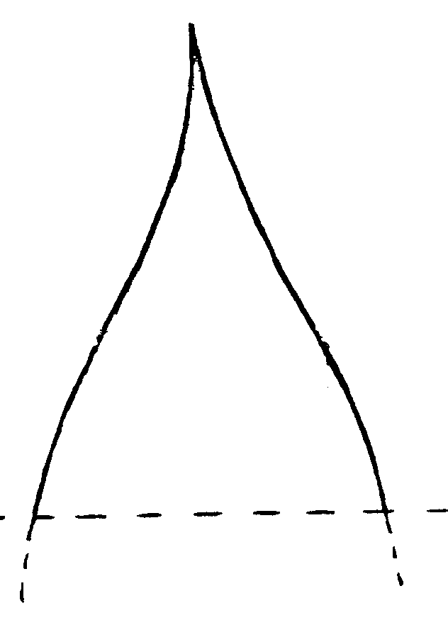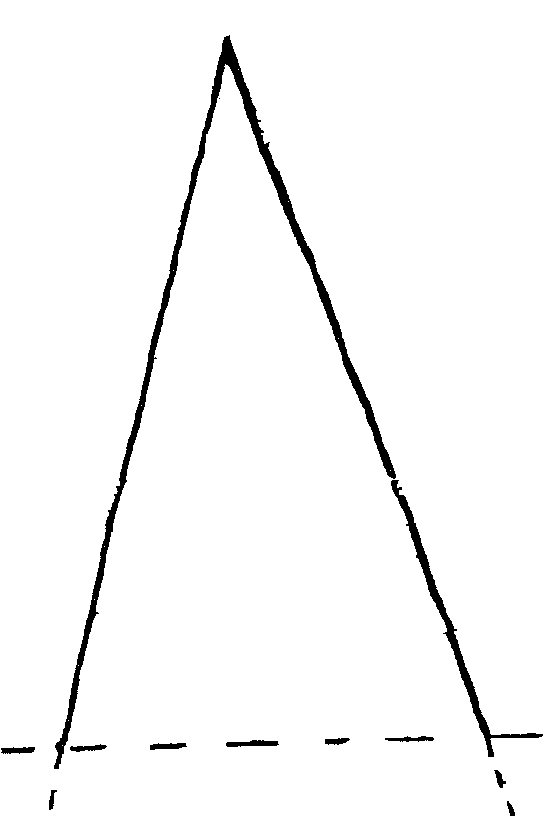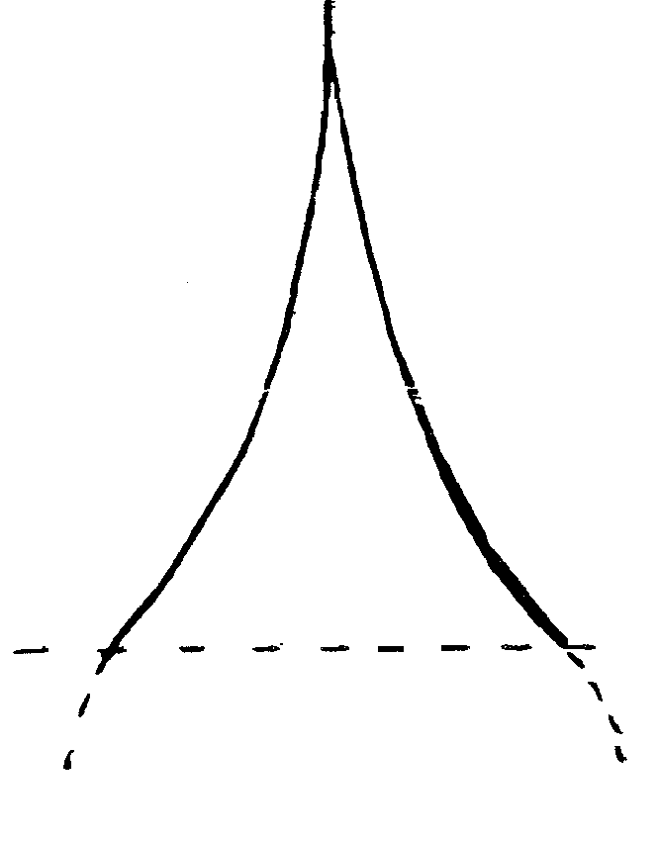

1 | 2 | 3
acute | short acuminate | long acuminate

Ad. 21: Inflorescence: main shape
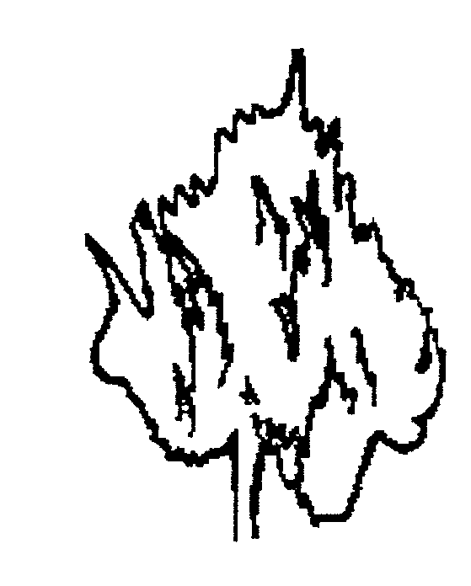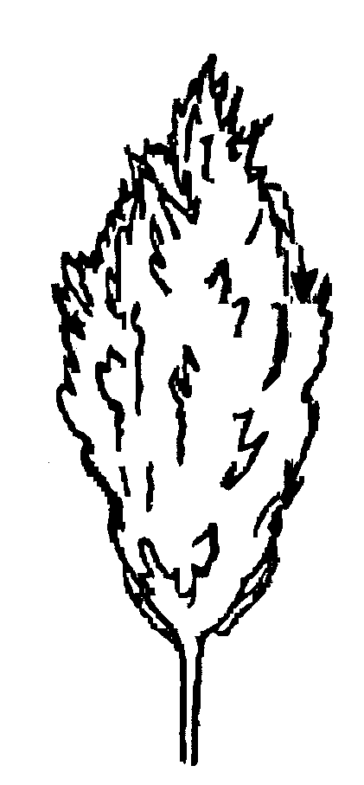
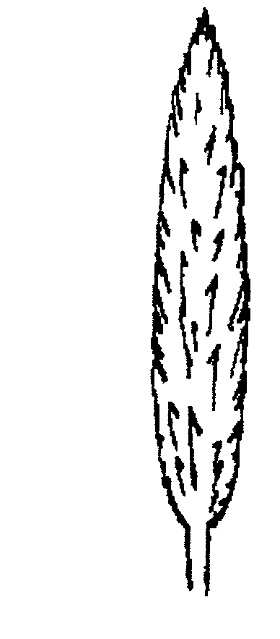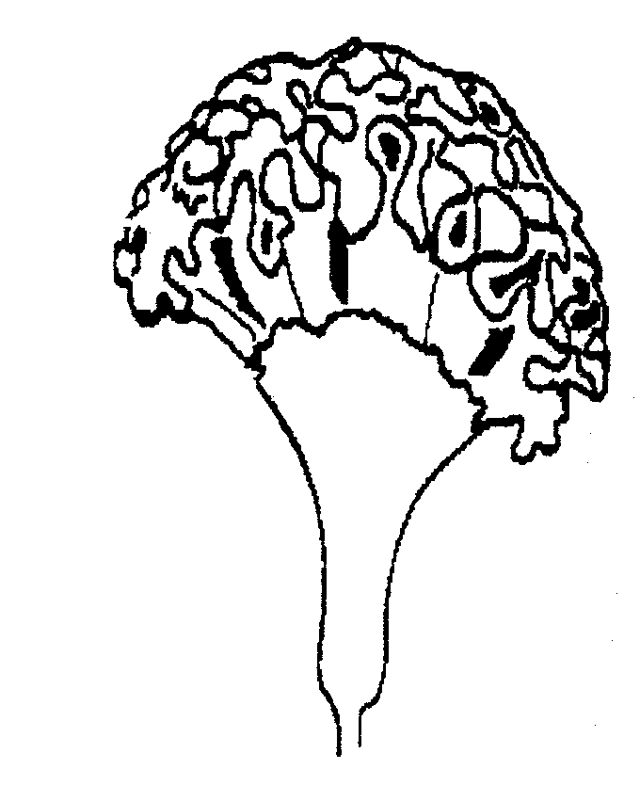1 | 2 | 3 | 4
spicate | plumose | paniculate | cristate

Ad. 25: Cristate group only: inflorescence: color of prophylls on edge of top

Ad. 26: Cristate group only: inflorescence: color of prophylls on distal part (excluding edge of top)
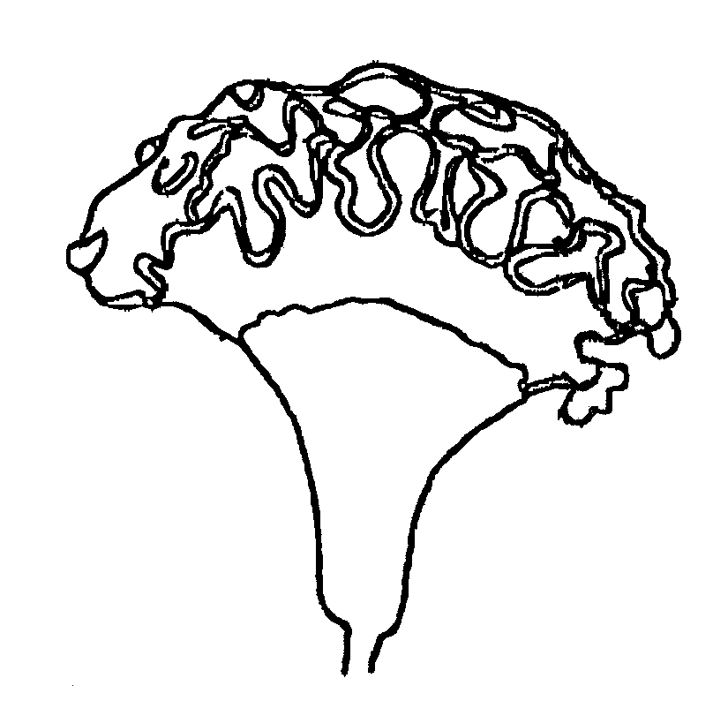
edge of top
distal part
IX. Literature

No specific literature.

X. Technical Questionnaire

Reference Number
(not to be filled in by the applicant)

TECHNICAL QUESTIONNAIRE
to be completed in connection with an application for plant breeders’ rights

1. Species Celosia L.

CELOSIA

2. Applicant (Name and address)

3. Proposed denomination or breeder’s reference

4. Information on origin, maintenance and reproduction of the variety

4.1 Origin

- Seedling (indicate parent varieties)

................................................................................................ [ ]

- Mutation (indicate parent variety)

................................................................................................ [ ]

- Discovery (indicate where and when)

................................................................................................ [ ]

- Other (specify)

................................................................................................ [ ]

4.2 Method of reproduction

- cuttings [ ]

- seed [ ]

- other (state method) [ ]

4.3 Other information

5. Characteristics of the variety to be indicated (the number in brackets refers to the corresponding characteristic in Test Guidelines; please mark the state of expression which best corresponds).

 | Characteristics | Example Varieties | Note
5.1  (1) | Plant: height
 | very short | Super Dwarf Kimono Orange | 1 [ ]
 | short | Century Rose | 3 [ ]
 | medium | Martine | 5 [ ]
 | tall | Bombay | 7 [ ]
 | very tall |  | 9 [ ]
5.2  (21) | Inflorescence: main shape
 | spicate | Enterprise Wine-red, Flamingo Feather | 1 [ ]
 | plumose | Hiryu no.2,  Kimono Cherry-red | 2 [ ]
 | paniculate | Gerana Orange | 3 [ ]
 | cristate | Bombay Rose, Martine | 4 [ ]
5.3  (24) | Inflorescence: color
 | white | Enterprise White | 1 [ ]
 | green |  | 2 [ ]
 | yellow | Martine Yellow | 3 [ ]
 | orange | Super Dwarf Kimono Orange | 4 [ ]
 | orange pink |  | 5 [ ]
 | pink | Bombay Rose | 6 [ ]
 | red | Red Chief | 7 [ ]
 | purple |  | 8 [ ]

6. Similar varieties and differences from these varieties

Denomination of similar variety | Characteristic in which the similar variety is different ^{o)} | State of expression of similar variety | State of expression of candidate variety
______________
^{o)} In the case of identical states of expressions of both varieties, please indicate the size of the difference.

7. Additional information which may help to distinguish the variety

7.1 Resistance to pests and diseases

7.2 Special conditions for the examination of the variety

cut flower [ ]

pot plant [ ]

bedding plant [ ]

other (specify) [ ]

7.3 Other information

A representative color photo of the variety should be added to the Technical Questionnaire.

8. Authorization for release

(a) Does the variety require prior authorization for release under legislation concerning the protection of the environment, human and animal health?

Yes [ ] No [ ]

(b) Has such authorization been obtained?

Yes [ ] No [ ]

If the answer to that question is yes, please attach a copy of such an authorization.

[End of document]

