 |  | TG/165/3 E

INTERNATIONAL UNION FOR THE PROTECTION  OF NEW VARIETIES OF PLANTS | UNION INTERNATIONALE POUR LA PROTECTION  DES OBTENTIONS VÉGÉTALES | INTERNATIONALER VERBAND ZUM SCHUTZ VON PFLANZEN-ZÜCHTUNGEN | UNIÓN INTERNACIONAL PARA LA PROTECCIÓN  DE LAS OBTENCIONES VEGETALES

GUIDELINES

FOR THE CONDUCT OF TESTS

FOR DISTINCTNESS, UNIFORMITY AND STABILITY

DILL

(Anethum graveolens L.)

GENEVA
1999

Copies of this document are available on request at the price of 10 Swiss francs each, including surface mail, from the Office of UPOV, 34, chemin des Colombettes, P.O. Box 18, 1211 Geneva 20, Switzerland

This document or parts of it may be reproduced, translated and published without obtaining the specific consent of UPOV, provided that the source is acknowledged.

* * * * * * *

TG/165/3
ORIGINAL: English
DATE: 1999-03-24

INTERNATIONAL UNION FOR THE PROTECTION  OF NEW VARIETIES OF PLANTS | UNION INTERNATIONALE POUR LA PROTECTION  DES OBTENTIONS VÉGÉTALES | INTERNATIONALER VERBAND ZUM SCHUTZ VON PFLANZEN-ZÜCHTUNGEN | UNIÓN INTERNACIONAL PARA LA PROTECCIÓN  DE LAS OBTENCIONES VEGETALES

GUIDELINES

FOR THE CONDUCT OF TESTS

FOR DISTINCTNESS, UNIFORMITY AND STABILITY

DILL

(Anethum graveolens L.)

These Guidelines should be read in conjunction with document TG/1/2, which contains explanatory notes on the general principles on which the Guidelines have been established.

TABLE OF CONTENTS PAGE

I. Subject of these Guidelines ........................................................................... 3

II. Material Required ........................................................................................ 3

III. Conduct of Tests .......................................................................................... 3

IV. Methods and Observations ............................................................................ 3

V. Grouping of Varieties ................................................................................... 4

VI. Characteristics and Symbols ........................................................................ 4

VII. Table of Characteristics ............................................................................... 5

VIII. Explanations on the Table of Characteristics .............................................. 10

IX. Literature ..................................................................................................... 13

X. Technical Questionnaire ............................................................................. 14

I. Subject of these Guidelines

These Test Guidelines apply to all varieties of Anethum graveolens L.

II. Material Required

1. The competent authorities decide when, where and in what quantity and quality the plant material required for testing the variety is to be delivered. Applicants submitting material from a State other than that in which the testing takes place must make sure that all customs formalities are complied with. The minimum quantity of seed to be supplied by the applicant in one or several samples should be:

100 g.

The seed should at least meet the minimum requirements for germination capacity, moisture content and purity for marketing seed in the country in which the application is made. The germination capacity should be as high as possible.

2. The plant material must not have undergone any treatment unless the competent authorities allow or request such treatment. If it has been treated, full details of the treatment must be given.

III. Conduct of Tests

1. The minimum duration of tests should normally be two similar growing periods.

2. The tests should normally be conducted at one place. If any important characteristics of the variety cannot be seen at that place, the variety may be tested at an additional place.

3. The tests should be carried out under conditions ensuring normal growth. The size of the plots should be such that plants or parts of plants may be removed for measurement and counting without prejudice to the observations which must be made up to the end of the growing period. Each test should include 100 single spaced plants which should be divided between 2 or more replicates. Separate plots for observation and for measuring can only be used if they have been subject to similar environmental conditions.

4. Additional tests for special purposes may be established.

IV. Methods and Observations

1. Unless otherwise indicated, all observations determined by measurement, weighting or counting should be made on 60 plants or parts taken from each of 60 plants.

2. All observations on the leaf and on the foliage, excluding those of young plant, should be made before the appearance of the main umbel. All observations on the leaf should be made in the middle of the stem.

3. All observations on the umbel, the color and waxiness of stem should be made when the umbel is fully developed.

4. The assessment of the height of the plant and the number of primary branches should be made at the time of full flowering.

V. Grouping of Varieties

If necessary, the collection of varieties to be grown should be divided into groups to facilitate the assessment of distinctness. Characteristics which are suitable for grouping purposes are those which are known from experience not to vary, or to vary only slightly, within a variety. Their various states of expression should be fairly evenly distributed throughout the collection.

VI. Characteristics and Symbols

1. To assess distinctness, uniformity and stability, the characteristics and their states as given in the Table of Characteristics should be used.

2. Notes (numbers), for the purposes of electronic data processing, are given opposite the states of the different characteristics.

3. Legend

(*) Characteristics that should be used on all varieties in every growing period over which the examinations are made and always be included in the variety descriptions, except when the state of expression of a preceding characteristic or regional environmental conditions render this impossible.

(+) See Explanations on the Table of Characteristics in Chapter VIII.

VII. Table of Characteristics/Tableau des caractères/Merkmalstabelle/Tabla de caracteres

 | English | Français | Deutsch | Espańol | Example Varieties  Exemples  Beispielssorten  Variedades ejemplo | Note/  Nota
1. | Young plant: anthocyanin coloration | Jeune plante: pigmentation anthocyanique | Jungpflanze: Anthocyanfärbung | Planta joven: pigmentación antociánica
 | absent | absente | fehlend | ausente |  | 1
 | present | présente | vorhanden | presente | Ambrozja | 9
2. | Young plant: attitude of leaves (3 to 5 leaves stage) | Jeune plante: port des feuilles (stade 3 à 5 feuilles) | Jungpflanze: Haltung der Blätter (3 bis 5 Blattstadium) | Planta joven: porte de las hojas (estado de 3 a 5 hojas)
 | erect | dressé | aufrecht | erecto | Indyjski | 1
 | semi-erect | demi-dressé | halbaufrecht | semierecto | Hanak | 3
 | horizontal | horizontal | waagerecht | horizontal | Kronos | 5
3.  (*) | Plant: density of foliage | Plante: densité du feuillage | Pflanze: Dichte des Laubes | Planta: densidad del follaje
 | loose | lâche | locker | laxa | Indyjski | 3
 | medium | moyenne | mittel | media | Sari | 5
 | dense | dense | dicht | densa | Hanak | 7
4. | Plant: number of primary branches | Plante: nombre de ramifications primaires | Pflanze: Anzahl Zweige erster Ordnung | Planta: número de ramificaciones primarias
 | few | petit | gering | bajo |  | 3
 | medium | moyen | mittel | media |  | 5
 | many | grand | groß | alto |  | 7
5.  (*)  (+) | Plant: height | Plante: hauteur | Pflanze: Höhe | Planta: altura
 | short | courte | niedrig | baja | Indyjski, Krezus | 3
 | medium | moyenne | mittel | media | Sari | 5
 | tall | haute | hoch | alta | Hanak, Szmaragd | 7
6.  (+) | Stem: length of main stem | Tige: longueur de la tige principale | Stengel: Länge des Hauptstengels | Tallo: longitud del tallo principal
 | short | courte | kurz | corta | Indyjski, Krezus | 3
 | medium | moyenne | mittel | media | Ambrozja | 5
 | long | longue | lang | larga | Szmaragd | 7
7. | Stem: diameter (at middle third) | Tige: diamètre (au tiers moyen) | Stengel: Durchmesser (im mittleren Drittel) | Tallo: diámetro (en el tercio central)
 | small | petit | klein | pequeño | Indyjski | 3
 | medium | moyen | mittel | medio | Amat | 5
 | large | grand | groß | grande | Hanak, Kronos | 7
8.  (*) | Stem: blue hue | Tige: teinte bleue | Stengel: Blauton | Tallo: matiz azul
 | absent | absente | fehlend | ausente | Hanak, Indyjski | 1
 | present | présente | vorhanden | presente | Ambrozja | 9
9. | Stem: intensity of green color | Tige: intensité de la couleur verte | Stengel: Intensität der Grünfärbung | Tallo: intensidad del color verde
 | light | claire | hell | claro | Hanak, Indyjski | 3
 | medium | moyenne | mittel | medio | Krezus | 5
 | dark | foncée | dunkel | oscuro | Lukullus | 7
10. | Stem: waxiness | Tige: pruine | Stengel: Wachsschicht | Tallo: cerosidad
 | absent or very weak | absente ou très faible | fehlend oder sehr gering | ausente o muy débil | Diwa | 1
 | weak | faible | gering | débil | Hanak | 3
 | medium | moyenne | mittel | media | Budakalaszi | 5
 | strong | forte | stark | fuerte | Szmaragd | 7
 | very strong | très forte | sehr stark | muy fuerte | Ambrozja | 9

 | English | Français | Deutsch | Espańol | Example Varieties  Exemples  Beispielssorten  Variedades ejemplo | Note/  Nota
11. | Leaf: shape | Feuille: forme | Blatt: Form | Hoja: forma
 | triangular | triangulaire | dreieckig | triangular | Ambrozja, Lukullus | 1
 | rhomboidal | losangequé | rhombisch | romboidal |  | 2
 | oblong | oblongue | rechteckig | oblonga |  | 3
12. (+) | Leaf: density of feathering | Feuille: densité des segmentes foliaires | Blatt: Dichte des Fiederblatts | Hoja: densidad del laciniado
 | loose | lâche | locker | laxa | Indyjski | 3
 | medium | moyenne | mittel | media | Lukullus | 5
 | dense | dense | dicht | densa | Hanak | 7
13. (h+) | Leaf: width of segments | Feuille: largeur des segments | Blatt: Breite der Fiedern | Hoja: anchura de las lacinias
 | narrow | étroite | schmal | estrecha | Indyjski | 3
 | medium | moyenne | mittel | media | Lukullus | 5
 | broad | large | breit | ancha | Krezus, Kronos | 7
14. (+) | Leaf: length | Feuille: longueur | Blatt: Länge | Hoja: longitud
 | short | courte | kurz | corta | Indyjski | 3
 | medium | moyenne | mittel | media | Amat | 5
 | long | longue | lang | larga | Hanak | 7
15. (+) | Leaf: width | Feuille: largeur | Blatt: Breite | Hoja: anchura
 | narrow | étroite | schmal | estrecha | Indyjski | 3
 | medium | moyenne | mittel | media | Ambrozja | 5
 | broad | large | breit | ancha | Sari | 7

 | English | Français | Deutsch | Espańol | Example Varieties  Exemples  Beispielssorten  Variedades ejemplo | Note/  Nota
16.  (*) | Leaf: blue hue | Feuille: teinte bleue | Blatt: Blauton | Hoja: matiz azul
 | absent | absente | fehlend | ausente | Hanak, Indyjski | 1
 | present | présente | vorhanden | presente | Amat, Ambrozja | 9
17. | Leaf: intensity of green color | Feuille: intensité de la couleur verte | Blatt: Intensität der Grünfärbung | Hoja: intensidad del color verde
 | light | claire | hell | claro | Hanak, Indyjski | 3
 | medium | moyenne | mittel | medio | Stella | 5
 | dark | foncée | dunkel | oscuro | Lukullus | 7
18. | Leaf: waxiness | Feuille: pruine | Blatt: Wachsschicht | Hoja: cerosidad
 | weak | faible | gering | débil | Hanak | 3
 | medium | moyenne | mittel | media | Budakalaszi | 5
 | strong | forte | stark | fuerte | Ambrozja | 7
19.  (*) | Main umbel: diameter | Ombelle principale: diamètre | Hauptdolde: Durchmesser | Umbela principal: diámetro
 | small | petit | klein | pequeño | Indyjski | 3
 | medium | moyen | mittel | media | Amat | 5
 | large | grand | groß | grande | Kronos | 7
20.  (+) | Main umbel: number of peduncles | Ombelle principale: nombre de pédoncules | Hauptdolde: Anzahl Doldenstrahlen | Umbela principal: número de pedúnculos
 | few | petit | gering | bajo | Indyjski | 3
 | medium | moyen | mittel | media | Sari | 5
 | many | grand | groß | alto | Szmaragd, Kronos | 7
21.  (*) | Time of appearance of main umbel | Époque d’appari-tion de l’ombelle principale | Zeitpunkt des Erscheinens der Hauptdolde | Época de aparición de la umbela principal
 | early | précoce | früh | temprana | Indyjski | 3
 | medium | moyenne | mittel | media | Ambrozja | 5
 | late | tardive | spät | tardía |  | 7
22. | Time of beginning of flowering | Époque du début de floraison | Zeitpunkt des Blühbeginns | Época del comienzo de la floración
 | early | précoce | früh | temprana | Indyjski | 3
 | medium | moyenne | mittel | media | Ambrozja | 5
 | late | tardive | spät | tardía |  | 7

VIII. Explanations on the Table of Characteristics

Ad. 5 and 6: Plant: height (5) and Stem: length of main stem (6)

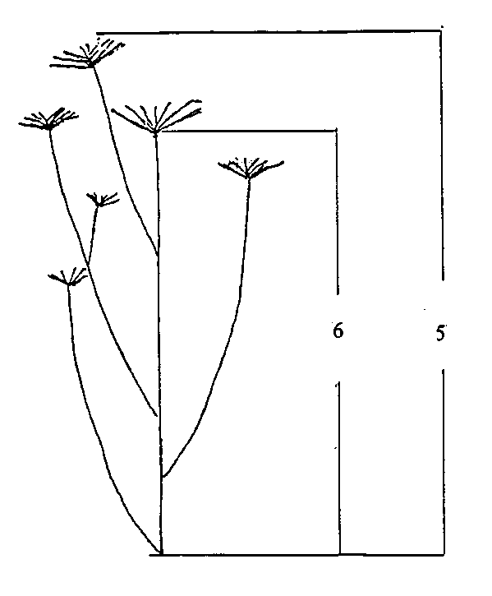

Ad. 12: Leaf: density of feathering

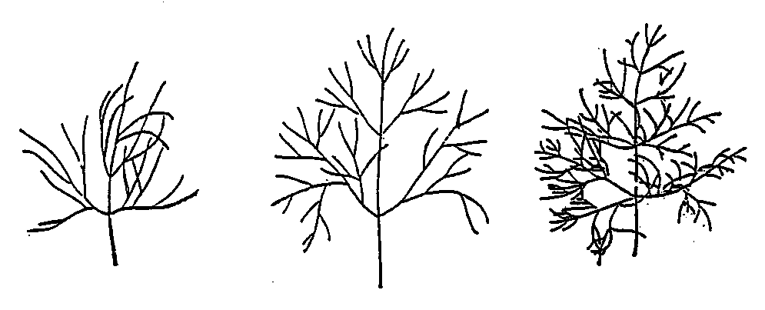

3 | 5 | 7
loose | medium | dense

Ad. 13: Leaf: width of segment

Segment
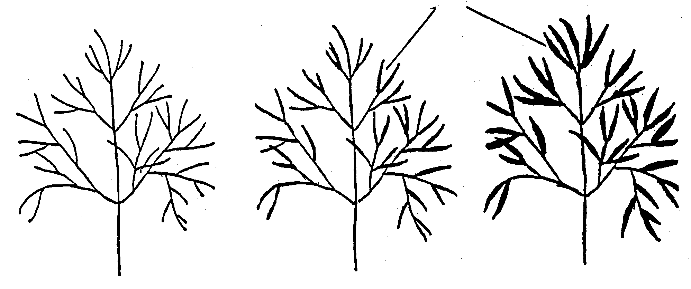

3 | 5 | 7
narrow | medium | broad

Ad. 14 and 15: Leaf: length (14) and width (15)

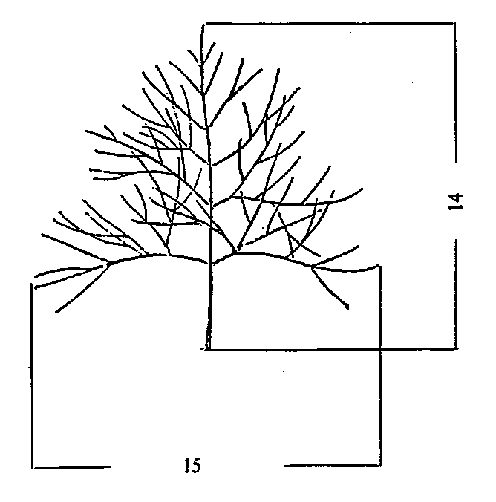

Ad. 20: Main umbel: number of peduncles

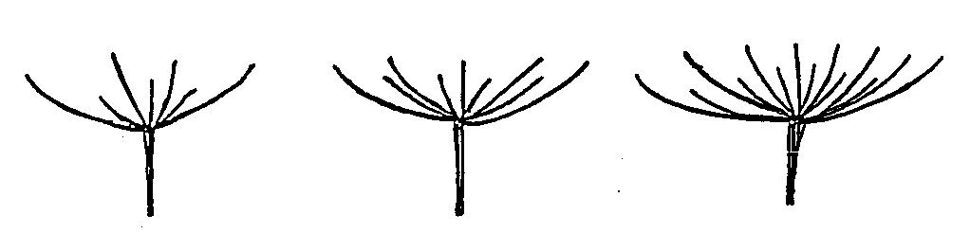

3 | 5 | 7
few | medium | many
IX. Literature

Chroboczek, E., 1977: “Odmianoznawstwo Roslin Warzywnych”, Panstwowe Wydawnictwo Rolnicze i Lesne, Warszawa

Dachler, M. and Pelzmann, H., 1989: “Heil- und Gewürzpflanzen, Anbau-Ernte-Aufbereitung”, Österreichischer Agrarverlag, Wien

Heeger, E. F., 1989: “Handbuch des Arznei- und Gewürzpflanzenbaues”, Dt. Bauernverlag, 2. Aufl.

Heeger, E. F. and Brüchner, K., 1950: “Heil- und Gewürzpflanzen, Arten- und Sortenkunde”,
Dt. Bauernverlag

Lizgunowa, T., 1948: “Ukrop. Owoszcznyje kultury i kormowyje korniepody. Rukowodstwo
po aprobacii sielsko-chozjastwiennych kultur”, Moskwa

Madaus, G., 1938: “Lehrbuch der biologischen Heilmittel”, Georg Thieme Verlag

X. Technical Questionnaire

Reference Number
(not to be filled in by the applicant)

TECHNICAL QUESTIONNAIRE
to be completed in connection with an application for plant breeders’ rights

1. Species Anethum graveolens L.

DILL

2. Applicant (Name and address)

3. Proposed denomination or breeder’s reference

4. Information on origin, maintenance and reproduction of the variety

5. Characteristics of the variety to be indicated (the number in brackets refers to the corresponding characteristic in the Test Guidelines; please mark the state of expression which best corresponds).

 |  | Characteristics |  | Example Varieties |  | Note
5.1  (5) | Plant: height
 | short |  | Indyjski, Krezus |  | 3[ ]
 | medium |  | Sari |  | 5[ ]
 | tall |  | Hanak, Szmaragd |  | 7[ ]
5.2  (16) | Leaf: blue hue
 |  | absent |  | Hanak, Indyjski |  | 1[ ]
 |  | present |  | Amat, Ambrozja |  | 9[ ]
5.3  (19) |  | Main umbel: diameter
 |  | small |  | Indyjski |  | 3[ ]
 |  | medium |  | Amat |  | 5[ ]
 |  | large |  | Kronos |  | 7[ ]
5.4  (21) |  | Time of appearance of main umbel
 |  | early |  | Indyjski |  | 3[ ]
 |  | medium |  | Ambrozja |  | 5[ ]
 |  | late |  |  |  | 7[ ]

6. Similar varieties and differences between these varieties

Denomination of similar variety | Characteristic in which the similar variety is different ^{o)} | State of expression of similar variety | State of expression of candidate variety
______________
^{o)} In the case of identical states of expressions of both varieties, please indicate the size of the difference.

7. Additional information which may help to distinguish the variety

7.1 Resistance to pests and diseases

7.2 Special conditions for the examination of the variety

7.3 Other information

8. Authorization for release

- Does the variety require prior authorization for release under legislation concerning the protection of the environment, human and animal health?
Yes [ ] No [ ]

- Has such authorization been obtained?

Yes [ ] No [ ]

If the answer to that question is yes, please attach a copy of such an authorization.

[End of document]

