 |  | E  TG/15/3

INTERNATIONAL UNION FOR THE PROTECTION  OF NEW VARIETIES OF PLANTS | UNION INTERNATIONALE POUR LA PROTECTION  DES OBTENTIONS VÉGÉTALES | INTERNATIONALER VERBAND ZUM SCHUTZ VON PFLANZEN-ZÜCHTUNGEN | UNIÓN INTERNACIONAL PARA LA PROTECCIÓN  DE LAS OBTENCIONES VEGETALES

GUIDELINES

FOR THE CONDUCT OF TESTS

FOR DISTINCTNESS, UNIFORMITY AND STABILITY

PEAR

(Pyrus communis L.)

GENEVA
2000

Copies of this document are available on request at the price of 10 Swiss francs each, including surface mail, from the Office of UPOV, 34, chemin des Colombettes, P.O. Box 18, 1211 Geneva 20, Switzerland

This document or parts of it may be reproduced, translated and published without obtaining the specific consent of UPOV, provided that the source is acknowledged.

* * * * * * *
TG/15/3
ORIGINAL: English
DATE: 2000-04-05

INTERNATIONAL UNION FOR THE PROTECTION  OF NEW VARIETIES OF PLANTS | UNION INTERNATIONALE POUR LA PROTECTION  DES OBTENTIONS VÉGÉTALES | INTERNATIONALER VERBAND ZUM SCHUTZ VON PFLANZEN-ZÜCHTUNGEN | UNIÓN INTERNACIONAL PARA LA PROTECCIÓN  DE LAS OBTENCIONES VEGETALES

GUIDELINES

FOR THE CONDUCT OF TESTS

FOR DISTINCTNESS, UNIFORMITY AND STABILITY

PEAR

(Pyrus communis L.)

These Guidelines should be read in conjunction with document TG/1/2, which contains explanatory notes on the general principles on which the Guidelines have been established.

TABLE OF CONTENTS PAGE

I. Subject of these Guidelines 3

II. Material Required 3

III. Conduct of Tests 3

IV. Methods and Observations 4

V. Grouping of Varieties 4

VI. Characteristics and Symbols 5

VII. Table of Characteristics 6

VIII. Explanations on the Table of Characteristics 24

IX. Literature 33

X. Technical Questionnaire 35

I. Subject of these Guidelines

These Test Guidelines apply to all vegetatively propagated varieties for fruit production of Pyrus communis L.

II. Material Required

1. The competent authorities decide when, where and in what quantity and quality the plant material required for testing the variety is to be delivered. Applicants submitting material from a state other than that where the testing takes place must make sure that all customs formalities are complied with. As a minimum, the following quantity of plant material is recommended:

5 trees for varieties resulting from crossing
10 trees for varieties obtained from mutation
or
3 budsticks or
3 (from crossing) or 10 (from mutation) dormant shoots for grafting;
sufficient to propagate 5 (10) trees.

It is recommended that the competent authority prescribes either the rootstock quince ‘East Malling A’ with the intergrafting ‘Beurré Hardy’ or ‘Doyenné du Comice’ or specifies another rootstock. If the applicant intends to use another rootstock he has to ask the competent authority for permission.

2. The plant material supplied should be virusfree and visibly healthy, not lacking in vigor or affected by any important pests or diseases. It should preferably not be obtained from in vitro propagation.

3. The plant material must not have undergone any treatment unless the competent authorities allow or request such treatment. If it has been treated, full details of the treatment must be given.

III. Conduct of Tests

- To assess distinctness, it is essential that the trees under test should produce at least two satisfactory crops of fruit.

2. The tests should normally be conducted at one place. If any important characteristics of the variety cannot be seen at that place, the variety may be tested at an additional place.

3. The tests should be carried out under conditions ensuring normal growth. Each test should include a total of 5 trees for varieties resulting from crossing and 10 trees for varieties obtained from mutations. Separate plots for observation and for measuring can only be used if they have been subject to similar environmental conditions.

4. Additional tests for special purposes may be established.

IV. Methods and Observations

1. Unless otherwise stated, all observations should be made on 5 plants or parts taken from each of 5 plants in the case of varieties resulting from crossing, and on 10 plants or parts taken from each of 10 plants in the case of mutants. All observations on the fruit should be made in minimum on 10 typical fruits, selected from 5 or 10 trees, respectively.

2. For assessment of uniformity, a population standard of 1% and an acceptance probability of at least 95% should be applied for varieties resulting from crossing, and a population standard of 2% with the same acceptance probability for mutants. In the case of a sample size of 5 plants no off-types should be allowed, in the case of 10 plants the maximum number of off-types allowed would be 1.

3. Unless otherwise stated, all observations on the tree and on the one-year-old shoot should be made during winter on trees that have fruited at least once. The length of the internodes should be observed in the middle of the shoot.

4. Unless otherwise stated, all observations on the flower should be made on fully developed flowers at the beginning of anther dehiscence.

5. Unless otherwise stated, all observations on the leaf should be made in summer on fully developed leaves from the middle third of a well developed current season shoot.

- Unless otherwise stated, all observations on the fruit should be made on fruits at the time of maturity for consumption.

V. Grouping of Varieties

1. The collection of varieties to be grown should be divided into groups to facilitate the assessment of distinctness. Characteristics which are suitable for grouping purposes are those which are known from experience not to vary, or to vary only slightly within the variety. Their various states of expression should be fairly evenly distributed throughout the collection.

2. It is recommended that the competent authorities use the following characteristics for grouping varieties:

- Fruit: position of maximum diameter (characteristic 40)
- Fruit: size (characteristic 41)
- Fruit: ground color of skin (characteristic 44)
- Time of beginning of flowering (characteristic 64)
- Time of maturity for consumption (characteristic 65).

VI. Characteristics and Symbols

1. To assess distinctness, uniformity and stability, the characteristics and their states as given in the Table of Characteristics should be used.

2. Notes (numbers), for the purposes of electronic data processing, are given opposite the states of expression for each characteristic.

3. Legend

(*) Characteristics that should be used on all varieties in every growing period over which examinations are made and always be included in the variety descriptions, except when the state of expression of a preceding characteristic or regional environmental conditions render this impossible.

(+) See Explanations on the Table of Characteristics in Chapter VIII.

VII. Table of Characteristics/Tableau des caractères/Merkmalstabelle/Tabla de caracteres

 | English | français | deutsch | español | Example Varieties  Exemples  Beispielssorten  Variedades ejemplo | Note/  Nota
1. | Tree: vigor | Arbre: vigueur | Baum: Wuchsstärke | Árbol: vigor
 | weak | faible | gering | débil | Précoce de Trévoux | 3
 | medium | moyenne | mittel | medio | Williams’ Bon Chrétien | 5
 | strong | forte | stark | fuerte | Beurré d’Amanlis | 7
2.  (*) | Tree: branching | Arbre: ramification | Baum: Verzweigung | Árbol: ramificación
 | absent or  very weak | nulle ou très faible | fehlend oder  sehr gering | ausente o  muy débil | Jeanne d’Arc | 1
 | weak | faible | gering | débil | Louise Bonne d’Avranches | 3
 | medium | moyenne | mittel | media | Conference, Pitmaston  Duchesse d’Angoulême | 5
 | strong | forte | stark | fuerte | Alexandrine Douillard,  Packham’s Triumph | 7
 | very strong | très forte | sehr stark | muy fuerte | Oliver de Serres | 9
3.  (*)  (+) | Tree: habit | Arbre: port | Baum: Wuchsform | Árbol: porte
 | fastigiate | très dressé | sehr aufrecht | fastigiado | Jeanne d’Arc | 1
 | upright | dressé | aufrecht | erecto | Beurré Clairgeau,  Doyenné du Comice | 2
 | semi-upright | demi-dressé | halbaufrecht | semierecto | Colorée de Juillet,  Nojabrskaja | 3
 | spreading | divergent | breitwüchsig | rastrero | Madame Ballet | 4
 | drooping | retombant | überhängend | colgante | Beurré Diel,  Beurré Six | 5
 | weeping | pleureur | lang überhängend | llorón | Armida,  Beurré d’Amanlis | 6

 | English | français | deutsch | español | Example Varieties  Exemples  Beispielssorten  Variedades ejemplo | Note/  Nota
4. | One-year-old shoot: growth | Rameau d’un an:  forme | Einjähriger Trieb:  Wuchs | Rama de un año: crecimiento
 | straight | droit | gerade | recto | Passe Crassane | 1
 | wavy | ondulé | gewellt | ondulado | Beurré Bosc,  Épine du Mas | 2
 | zig-zag | en zigzag | zickzackförmig | en zig zag | Laxton’s Superb | 3
5. | One-year-old shoot: length of internode | Rameau d’un an:  longueur des entrenœuds | Einjähriger Trieb: Internodienlänge | Rama de un año: longitud del entrenudo
 | short | courts | kurz | corta | Conference | 3
 | medium | moyens | mittel | media | Beurré Hardy,  Jeanne d’Arc | 5
 | long | longs | lang | larga | Pitmaston Duchesse d’Angoulême,  Santa Maria | 7
6. | One-year-old shoot: predominant color on sunny side | Rameau d’un an: couleur prédo- minante sur la face exposée au soleil | Einjähriger Trieb: Vorherrschende Farbe auf der Son-nenseite | Rama de un año: color predominante en la cara expuesta al sol
 | grey green | vert-gris | graugrün | verde–gris | Mirandino rosso,  Nojabrskaja | 1
 | grey brown | brun-gris | graubraun | marrón grisáceo | Concorde | 2
 | medium brown | brun moyen | mittelbraun | marrón medio | Beurré Superfin,  Précoce de Trévoux | 3
 | orange brown | brun orangé | orangebraun | marrón anaranjado | Eva Baltet | 4
 | brown red | brun-rouge | braunrot | marrón rojizo | Beurré Hardy,  Louise Bonne d’Avranches | 5
 | brown purple | brun-violet | braunpurpur | marrón púrpura | Nordhäuser Winterforelle | 6
 | dark brown | brun foncé | dunkelbraun | marrón oscuro | Jeanne d’Arc | 7

 | English | français | deutsch | español | Example Varieties  Exemples  Beispielssorten  Variedades ejemplo | Note/  Nota
7. | One-year-old shoot: number of lenticels | Rameau d’un an: nombre de lenticelles | Einjähriger Trieb: Anzahl der Lenti-zellen | Rama de un año: número de lenticelas
 | few | petit | gering | escaso | Triomphe de Vienne | 3
 | medium | moyen | mittel | medio | Williams’ Bon Chrétien | 5
 | many | grand | groß | muchos | Beurré d’Amanlis,  Doyenné d’Alencon | 7
8.  (*) | One-year-old shoot:  shape of apex of vegetative bud | Rameau d’un an: forme du sommet de l’œil à bois | Einjähriger Trieb: Form der Spitze der vegetativen Knospe | Rama de un año: forma del ápice de la yema de madera
 | acute | pointu | spitz | agudo | Conference | 1
 | obtuse | obtus | stumpf | obtuso | Passe Crassane | 2
 | rounded | arrondi | abgerundet | redondeado | Jeanne d’Arc | 3
9.  (*) | One-year-old shoot: position of vegetative bud in relation to shoot | Rameau d’un an: position de l’œil à bois par rapport à la tige | Einjähriger Trieb: Stellung der vegetativen Knospe zum Trieb | Rama de un año: posición de la yema de madera en relación con la rama
 | adpressed | appliqué | anliegend | alineada | Williams’ Bon Chrétien | 1
 | slightly held out | légèrement divergent | leicht abstehend | ligeramente divergente | Passe Crassane | 2
 | markedly held out | fortement divergent | deutlich abstehend | claramente divergente | Conference, Épine du Mas | 3
10.  (+) | One-year-old shoot: size of bud support | Rameau d’un an: taille du support de l’œil | Einjähriger Trieb: Größe des Knospenwulstes | Rama de un año: tamaño del soporte de la yema
 | small | petit | klein | pequeño | Nordhäuser Winter-forelle, Santa Maria | 3
 | medium | moyen | mittel | medio | Beurré Alexandre Lucas,  Comtesse de Paris | 5
 | large | grand | groß | grande | Beurré Hardy,  Jeanne d’Arc | 7

 | English | français | deutsch | español | Example Varieties  Exemples  Beispielssorten  Variedades ejemplo | Note/  Nota
11.  (*) | Young shoot: anthocyanin colo-ration of growing tip (during rapid growth) | Jeune rameau: pigmentation anthocyanique du sommet en croissance (pendant la croissance rapide) | Junger Trieb: An-thocyanfärbung der Triebspitze (wäh-rend des schnellen Wachstums) | Rama joven: pigmentación antociánica del ápice de crecimiento (durante el crecimiento rápido)
 | absent or  very weak | nulle ou très faible | fehlend oder  sehr gering | ausente o muy débil | Clapp’s Favourite,  Poire de Charneu | 1
 | weak | faible | gering | débil | Doyenné du Comice | 3
 | medium | moyenne | mittel | media | Beurré Hardy | 5
 | strong | forte | stark | fuerte | Red Bartlett | 7
 | very strong | très forte | sehr stark | muy fuerte | Liegels Winterbutterbirne | 9
12.  (*) | Young shoot: intensity of pubes-cence (upper third) | Jeune rameau: intensité de la pubescence (tiers supérieur) | Junger Trieb: Stär-ke der Behaarung (oberes Drittel) | Rama joven: intensidad de la pubescencia (en el tercio superior)
 | weak | faible | gering | débil | Concorde | 3
 | medium | moyenne | mittel | media | Beurré Giffard,  Williams’ Bon Chrétien | 5
 | strong | forte | stark | fuerte | Beurré Hardy,  Comtesse de Paris | 7
13.  (*)  (+) | Leaf blade: attitude  in relation to shoot | Limbe: port par rapport à la tige | Blattspreite: Haltung im Verhältnis zum Trieb | Limbo: porte en relación con la rama
 | upwards | dressé | aufwärts | ascendente | Citron des Carmes,  Précoce de Trévoux | 1
 | outwards | horizontal | abstehend | perpendicular | Curé,  Doyenné du Comice | 2
 | downwards | retombant | abwärts | descendente | Beurré Giffard, Pitmaston Duchesse d’Angoulême | 3

 | English | français | deutsch | español | Example Varieties  Exemples  Beispielssorten  Variedades ejemplo | Note/  Nota
14.  (*) | Leaf blade: length | Limbe: longueur | Blattspreite: Länge | Limbo: longitud
 | short | court | kurz | corta | Joséphine de Malines,  Pierre Corneille | 3
 | medium | moyen | mittel | media | Beurré Hardy,  Conference | 5
 | long | long | lang | larga | Passe Crassane,  Triomphe de Vienne | 7
15.  (*) | Leaf blade: width | Limbe: largeur | Blattspreite: Breite | Limbo: anchura
 | narrow | étroit | schmal | estrecha | Olivier de Serres | 3
 | medium | moyen | mittel | media | Williams’ Bon Chrétien | 5
 | broad | large | breit | ancha | Curé | 7
16.  (*) | Leaf blade: ratio length/width | Limbe: rapport longueur/largeur | Blattspreite: Verhältnis Länge/Breite | Limbo: relación entre la longitud y la anchura
 | very small | très faible | sehr klein | muy pequeña | Curé | 1
 | small | faible | klein | pequeña | Président Drouard | 3
 | medium | moyen | mittel | media | Conference,  Williams’ Bon Chrétien | 5
 | large | élevé | groß | grande | Louise Bonne d’Avranches,  Triomphe de Vienne | 7
 | very large | très élevé | sehr groß | muy grande | Beurré Lebrun,  Monchallard | 9
17.  (+) | Leaf blade: shape  of base | Limbe: forme de la base | Blattspreite: Form der Basis | Limbo: forma de la base
 | acute | pointue | spitz | aguda | Beurré Giffard | 1
 | right-angled | à angle droit | rechtwinklig | en ángulo recto | Santa Maria,  Grand Champion | 2
 | obtuse | obtuse | stumpf | obtusa | Général Leclerc | 3
 | truncate | tronquée | gerade | truncada | Doyenné du Comice | 4
 | cordate | cordiforme | herzförmig | cordiforme | Président Drouard | 5

 | English | français | deutsch | español | Example Varieties  Exemples  Beispielssorten  Variedades ejemplo | Note/  Nota
18.  (+) | Leaf blade: shape of apex (excluding pointed tip) | Limbe: forme du sommet (pointe exclue) | Blattspreite: Form der Spitze (ohne aufgesetzte Spitze) | Limbo: forma del ápice (excluyendo la punta)
 | acute | aigu | spitz | aguda | Conference | 1
 | right-angled | en angle droit | rechtwinklig | en ángulo recto | Williams’ Bon Chrétien | 2
 | obtuse | obtus | stumpf | obtusa | Beurré Clairgeau | 3
 | rounded | arrondi | abgerundet | redondeada | Curé, Pitmaston  Duchesse d’Angoulême | 4
19. | Leaf blade: length of pointed tip | Limbe: longueur de la pointe | Blattspreite: Länge der aufgesetzten Spitze | Limbo: longitud de la punta
 | absent or very short | nulle ou très courte | fehlend oder sehr kurz | ausente o muy corta |  | 1
 | short | courte | kurz | corta | Curé | 3
 | medium | moyenne | mittel | media | Comtesse de Paris | 5
 | long | longue | lang | larga | Beurré Giffard | 7
 | very long | très longue | sehr lang | muy larga | Santa Maria | 9
20.  (+) | Leaf blade: incisions of margin (upper half) | Limbe: incisions du bord (moitié supérieure) | Blattspreite: Randeinschnitte (obere Hälfte) | Limbo: incisiones del borde (mitad superior)
 | absent | absente | fehlend | ausente | Beurré Giffard | 1
 | crenate | crénelées | gekerbt | crenadas | Beurré d’Amanlis | 2
 | bluntly serrate | à dents obtuses | stumpf gesägt | aserradas obtusas | Alexandrine Douillard | 3
 | sharply serrate | à dents pointues | spitz gesägt | aserradas agudas | General Leclerc | 4
21. | Leaf blade: depth of incisions of margin | Limbe: profondeur des incisions du bord | Blattspreite: Tiefe der Randeinschnitte | Limbo: profundidad de las incisiones del borde
 | shallow | peu profondes | flach | poco profunda | Précoce de Trevoux, Williams’ Bon Chrétien | 3
 | medium | moyennement profondes | mittel | media | Beurré Diel,  Oliver de Serres | 5
 | deep | profondes | tief | profunda | Pitmaston Duchesse d'Angoulême | 7

 | English | français | deutsch | español | Example Varieties  Exemples  Beispielssorten  Variedades ejemplo | Note/  Nota
22.  (*) | Leaf blade: curvature of longitudinal axis | Limbe: courbure de l’axe longitudinal | Blattspreite: Krüm-mung der Längs-achse | Limbo: curvatura del eje longitudinal
 | weak | faible | gering | débil | Précoce de Trévoux | 3
 | medium | moyenne | mittel | media | Beurré Giffard,  Épine du Mas | 5
 | strong | forte | stark | fuerte | Comtesse de Paris,  Doyenné d’Alencon | 7
23.  (*) | Petiole: length | Pétiole: longueur | Blattstiel: Länge | Peciolo: longitud
 | short | courte | kurz | corta | Épine du Mas | 3
 | medium | moyenne | mittel | media | Beurré Hardy, Louise Bonne d’Avranches | 5
 | long | longue | lang | larga | Beurré Lebrun,  Triomphe de Vienne | 7
24.  (*) | Petiole: presence of  stipules | Pétiole: présence de stipules | Blattstiel: Vorhan-  densein von Neben-  blättern | Peciolo: presencia de estípulas
 | absent | absentes | fehlend | ausentes | Monchallard | 1
 | present | présentes | vorhanden | presentes | Doyenné du Comice | 9
25.  (*)  (+) | Petiole: distance of  stipules from basal  attachment of  petiole | Pétiole: distance entre les stipules et la base | Blattstiel: Abstand  des Nebenblattes von der Ansatz- stelle des Blattstieles | Peciolo: distancia entre las estípulas y la inserción basal del peciolo
 | short | courte | kurz | pequeña | Doyenné du Comice,  Pitmaston Duchesse d’Angoulême,  Oliver de Serres | 3
 | medium | moyenne | mittel | media | Beurré Bosc, Beurré Diel | 5
 | long | longue | lang | grande | Conference, Beurré Giffard | 7

 | English | français | deutsch | español | Example Varieties  Exemples  Beispielssorten  Variedades ejemplo | Note/  Nota
26. | Shoot: location of flower bud | Rameau: position du bourgeon à fleur | Trieb: Anordnung der Blütenknospe | Rama: situación de la yema floral
 | mainly on spurs | principalement sur lambourdes | vorwiegend an kurzen Fruchtspießen | principalmente en las lamburdas | Beurré d’Anjou,  Beurré Hardy | 1
 | mainly on long  shoots | principalement sur les longs rameaux | vorwiegend an  langen Trieben | principalmente en las ramas largas | Curé,  Williams’ Bon Chrétien | 2
27.  (*) | Flower bud: length | Bourgeon à fleur: longueur | Blütenknospe: Länge | Yema floral: longitud
 | short | courte | kurz | corta | Beurré Alexandre Lucas,  Williams’ Bon Chrétien | 3
 | medium | moyenne | mittel | media | Louise Bonne d’Avranches | 5
 | long | longue | lang | larga | Beurré Bosc, Beurré Hardy | 7
28. | Flower: sepal: length | Fleur : longueur du sépale | Blüte: Länge des Kelchblattes | Flor: longitud del sépalo
 | short | court | kurz | corta | Triomphe de Vienne,  Olivier de Serres | 3
 | medium | moyen | mittel | media | Beurré Hardy,  Doyenné du Comice | 5
 | long | long | lang | larga | Curé, Pitmaston Duchesse d’Angoulême | 7
29. | Flower: attitude of  sepals in relation to corolla | Fleur: port des sépales par rapport à la corolle | Blüte: Haltung der Kelchblätter im Verhältnis zur Blütenkrone | Flor: porte de los sépalos en relación con la corola
 | adpressed | appliqués | anliegend | alineado | Président Drouard | 1
 | spreading | étalés | abstehend | rastrero | Doyenne du Comice,  Pitmaston Duchesse d’Angoulême | 2
 | recurved | retombants | zurückgeschlagen | recurvado | Beurré d’Anjou,  Beurré Giffard | 3

 | English | français | deutsch | español | Example Varieties  Exemples  Beispielssorten  Variedades ejemplo | Note/  Nota
30.  (*) | Flower: position of margins of petals | Fleur: position des bords des pétales | Blüte: Stellung der Blütenblätter | Flor: posición de los bordes de los pétalos
 | apart | libres | freistehend | libres | Beurré Bosc,  Passe Crassane | 1
 | touching | tangents | sich berührend | tocándose | Doyenné du Comice,  Jeanne d’Arc | 2
 | overlapping | chevauchants | überlappend | solapándose | Conference,  Docteur Jules Guyot | 3
31. | Flower: position of stigma in relation  to stamens | Fleur: position du stigmate par rapport aux étamines | Blüte: Position der Narbe im Verhältnis zu den Staubblät-tern | Flor: posición del estigma en relación con los estambres
 | below | au-dessous | unterhalb | por encima | Bergamotte Esperen,  Jeanne d’Arc | 1
 | same level | au même niveau | in gleicher Höhe | al mismo nivel | Alexandrine Doulliard,  Beurré Hardy | 2
 | above | au-dessus | oberhalb | por debajo | Beurré d’Amanlis,  Beurré Giffard | 3
32. | Flower: size of petal | Fleur : taille du pétale | Blüte: Größe des Blütenblattes | Flor: tamaño del pétalo
 | small | petit | klein | pequeño | Sierra, Highland | 3
 | medium | moyen | mittel | medio | Williams’ Bon Chrétien | 5
 | large | grand | groß | grande | Concorde, Dita | 7
33.  (*) | Flower: shape of petal (excluding the claw) | Fleur : forme du pétale (sauf l’onglet) | Blüte: Form des Blütenblattes (ohne Nagel) | Flor: forma del pétalo (excluida la uña)
 | circular | rond | kreisförmig | circular | Comtesse de Paris | 1
 | broad ovate | ovale large | breit eiförmig | ovalados anchos | Beurré Hardy,  Doyenné du Comice | 2
 | ovate | ovale | eiförmig | ovalados | Beurré Bosc | 3

 | English | français | deutsch | español | Example Varieties  Exemples  Beispielssorten  Variedades ejemplo | Note/  Nota
34. | Flower: shape of base of petal (excluding the claw) | Fleur: forme de la base (sauf l’onglet) du pétale | Blüte: Form der Basis des Blüten- blattes (ohne Nagel) | Flor: forma de la base del pétalo (excluida la uña)
 | cuneate | cunéiforme | keilförmig | cuneiforme | Beurré Bosc, Beurré Hardy | 1
 | rounded | arrondie | abgerundet | redondeada | Comtesse de Paris,  Doyenné d’Hiver | 2
 | truncate | tronquée | gerade | truncada | Beurré Diel,  Précoce de Trévoux | 3
 | cordate | cordiforme | herzförmig | cordiforme | Delfrap | 4
35. | Flower: length of claw of petal | Fleur: longueur de l’onglet du pétale | Blüte: Länge des Nagels des Blütenblattes | Flor: longitud de la uña del pétalo
 | short | court | kurz | corta | Williams’ Bon Chrétien, Madame Verté | 3
 | medium | moyen | mittel | media | Triomphe de Vienne, Madame Favre | 5
 | long | long | lang | larga | Beurré d'Anjou,  Louise Bonne d’Avranches | 7
36. | Immature fruit: color of sepals (early summer) | Fruit immature: couleur des sépales (début de l’été) | Unreife Frucht: Farbe der Kelchblätter (Frühsommer) | Frutos no maduros: color de los sépalos (a principios del verano)
 | green | vert | grün | verde | Beurré Hardy, Dessertnaja | 1
 | green-brown | brun-vert | grünbraun | marrón-verde | Pitmaston Duchesse d'Angoulême,  Poire de Charneu | 2
 | brown | brun | braun | marrón | Comtesse de Paris,  Olivier de Serres | 3
 | red-brown | rouge-brun | rotbraun | marrón rojizo | Concorde,  Doyenné du Comice | 4
 | red | rouge | rot | rojo | Conference, Nordhäuser Winterforelle, Santa Maria | 5

 | English | français | deutsch | español | Example Varieties  Exemples  Beispielssorten  Variedades ejemplo | Note/  Nota
37. | Fruit: length | Fruit: longueur | Frucht: Länge | Fruto: longitud
 | short | court | kurz | corto | Oliver de Serres | 3
 | medium | moyen | mittel | medio | Williams’ Bon Chrétien | 5
 | long | long | lang | largo | Abbé Fétel | 7
38. | Fruit: maximum diameter | Fruit: diamètre maximum | Frucht: maximaler Durchmesser | Fruto: diámetro máximo
 | small | petit | klein | pequeño | Abbé Fétel | 3
 | medium | moyen | mittel | medio | Williams’ Bon Chrétien | 5
 | large | grand | groß | grande | Jeanne d’Arc | 7
39.  (*) | Fruit: ratio length/ diameter | Fruit: rapport longueur/diamètre | Frucht: Verhältnis  Länge/Durchmesser | Fruto: relación longitud/diámetro
 | very small | très petit | sehr klein | muy pequeña | Oliver de Serres,  Passe Crassane | 1
 | small | petit | klein | pequeña | Beurré d’Ahrenberg, | 3
 | medium | moyen | mittel | mediana | Beurré Clairgeau,  Williams’ Bon Chrétien | 5
 | large | grand | groß | grande | Conference | 7
 | very large | très grand | sehr groß | muy grande | Abbé Fétel | 9
40.  (*)  (+) | Fruit: position of maximum diameter | Fruit: emplacement du plus grand diamètre | Frucht: Position des  maximalen Durch-messers | Fruto: posición del diámetro máximo
 | in middle | au milieu | in der Mitte | en el medio | Bergamotte Esperen | 1
 | slightly towards  calyx | légèrement vers le calice | etwas zum  Kelch hin | ligeramente hacia el cáliz | Beurré Alexandre Lucas,  Doyenné du Comice | 2
 | clearly towards  calyx | nettement vers le calice | deutlich zum  Kelch hin | claramente hacia el cáliz | Conference | 3

 | English | français | deutsch | español | Example Varieties  Exemples  Beispielssorten  Variedades ejemplo | Note/  Nota
41.  (*) | Fruit: size | Fruit: taille | Frucht: Größe | Fruto: tamaño
 | very small | très petit | sehr klein | muy pequeño | Petit Muscat,  Précoce de Cassano | 1
 | small | petit | klein | pequeño | Citron des Carmes,  Doyenné de Juillet | 3
 | medium | moyen | mittel | medio | Docteur Jules Guyot,  Épine du Mas | 5
 | large | grand | groß | grande | Doyenné du Comice,  Passe Crassane | 7
 | very large | très grand | sehr groß | muy grande | Margarete Marillat | 9
42. | Fruit: symmetry (in longitudinal section) | Fruit: symétrie (dans la section longitudinale) | Frucht: Symmetrie (im Längsschnitt) | Fruto: simetría (en sección logitudinal)
 | symmetric | symétrique | symmetrisch | simétrico | Passe Crassane | 1
 | slightly asymmetric | légèrement dissymétrique | leicht asymmetrisch | ligeramente asimétrico | Beurré Bosc, | 2
 | strongly asymmetric | fortement dissymétrique | stark asymmetrisch | claramente asimétrico | Beurré Clairgeau, Nouveau Poiteau | 3
43.  (*)  (+) | Fruit: profile of sides | Fruit: profil latéral | Frucht: Seitenform | Fruto: perfil lateral
 | concave | concave | konkav | cóncavo | Abbé Fétel, Beurré Bosc | 1
 | straight | droit | gerade | recto | Beurré Giffard | 2
 | convex | convexe | konvex | convexo | Doyenné d’Hiver,  Olivier de Serres | 3
44.  (*) | Fruit: ground color of skin | Fruit: couleur du fond de l’épiderme | Frucht: Grundfarbe der Schale | Fruto: color de fondo de la epidermis
 | not visible | non visible | nicht sichtbar | no visible | Grand Champion, Uta | 1
 | green | vert | grün | verde | Nouveau Poiteau | 2
 | yellow green | vert-jaune | gelbgrün | verde amarillento | Beurré Giffard, Beurré Hardy | 3
 | yellow | jaune | gelb | amarillo | Président Drouard,  Williams’ Bon Chrétien | 4

 | English | français | deutsch | español | Example Varieties  Exemples  Beispielssorten  Variedades ejemplo | Note/  Nota
45.  (*) | Fruit: relative area of over color | Fruit: proportion de lavis | Frucht: Deckfar-benanteil | Fruto: zona relativa de color superficial
 | absent or very small | nulle ou très petite | fehlend oder sehr klein | ausente o muy pequeña | Passe Crassane,  Président Drouard | 1
 | small | petite | klein | pequeña | Précoce de Trévoux | 3
 | medium | moyenne | mittel | media | Nordhäuser Winterforelle | 5
 | large | grande | groß | grande | Beurré Clairgeau | 7
 | very large | très grande | sehr groß | muy grande | Starkrimson | 9
46. | Fruit: hue of over  color | Fruit: teinte du lavis | Frucht: Ton der Deckfarbe | Fruto: tono del color superficial
 | orange | orange | orange | naranja | Précoce de Trévoux | 1
 | orange red | rouge orangé | orangerot | rojo anaranjado | Duchesse Elsa | 2
 | pink red | rouge-rose | rosarot | rojo rosado | Belle Angevine | 3
 | light red | rouge clair | hellrot | rojo claro | Nordhäuser Winterforelle | 4
 | dark red | rouge foncé | dunkelrot | rojo obscuro | Starkrimson | 5
47. | Fruit: relative area of russet around eye basin | Fruit: proportion de liège autour de la cuvette de l’œil | Frucht: anteilige  Fläche der Beros-  tung im Bereich  der Kelchgrube | Fruto: zona relativa de russeting en la cavidad del ojo
 | absent or  very small | nulle ou très petite | fehlend oder  sehr klein | ausente o muy pequeña | Liegels Winterbutterbirne | 1
 | small | petite | klein | pequeña | Nordhäuser Winterforelle | 3
 | medium | moyenne | mittel | media | Packham’s Triumph | 5
 | large | grande | groß | grande | Conference | 7
 | very large | très grande | sehr groß | muy grande | General Leclerc,  Madame Verté | 9

 | English | français | deutsch | español | Example Varieties  Exemples  Beispielssorten  Variedades ejemplo |  | Note/  Nota
48. | Fruit: relative area of russet on cheeks | Fruit: proportion de liège sur les joues | Frucht: anteilige Fläche der Beros-  tung auf den Wangen | Fruto: zona relativa de russeting en las caras
 | absent or  very small | nulle ou très petite | fehlend oder  sehr klein | ausente o muy pequeña |  | Liegels Winterbutterbirne |  | 1
 | small | petite | klein | pequeña |  | Beurré Alexandre Lucas |  | 3
 | medium | moyenne | mittel | media |  | Comtesse de Paris |  | 5
 | large | grande | groß | grande |  | General Leclerc |  | 7
 | very large | très grande | sehr groß | muy grande |  | Madame Verté |  | 9
49. | Fruit: relative area of russet around stalk attachment | Fruit: proportion de liège autour du pédoncule | Frucht: anteilige Fläche der Berostung im Bereich des Stiel-ansatzes | Fruto: zona relativa de russeting en torno a la base peduncular
 | absent or  very small | nulle ou très petite | fehlend oder  sehr klein | ausente o muy pequeña |  | Curé |  | 1
 | small | petite | klein | pequeña |  | Nordhäuser Winterforelle |  | 3
 | medium | moyenne | mittel | media |  | Packham’s Triumph |  | 5
 | large | grande | groß | grande |  | Beurré Hardy |  | 7
 | very large | très grande | sehr groß | muy grande |  | Madame Verté |  | 9
50.  (*) | Fruit: length of stalk | Fruit: longueur du pédoncule | Frucht: Länge des Stiels | Fruto: longitud del pedúnculo
 | short | court | kurz | corta |  | Beurré d’Anjou,  Beurré des Enfants |  | 3
 | medium | moyen | mittel | media |  | Alexandrine Douillard,  Beurré Hardy |  | 5
 | long | long | lang | larga |  | Beurré Bosc, Curé |  | 7

 | English | français | deutsch | español | Example Varieties  Exemples  Beispielssorten  Variedades ejemplo | Note/  Nota
51.  (*) | Fruit: thickness of stalk | Fruit: grosseur du pédoncule | Frucht: Dicke des Stiels | Fruto: grosor del pedúnculo
 | thin | fin | dünn | fino | Beurré Bosc, Concorde | 3
 | medium | moyen | mittel | medio | Beurré Hardy,  Williams’ Bon Chrétien | 5
 | thick | gros | dick | grueso | Beurré d’Anjou,  Clapp’s Favourite | 7
52. | Fruit: curvature of stalk | Fruit: courbure du pédoncule | Frucht: Krümmung des Stiels | Fruto: curvatura del pedúnculo
 | absent or  very weak | nulle ou très faible | fehlend oder  sehr gering | ausente o muy débil | Président Drouard | 1
 | weak | faible | gering | débil | Curé | 3
 | medium | moyenne | mittel | media | Conference | 5
 | strong | forte | stark | fuerte | Beurré Bosc | 7
53.  (*) | Fruit: attitude of stalk in relation to axis of fruit | Fruit: port du pédoncule par rapport à l’axe du fruit | Frucht: Haltung des Stiels zur Frucht-achse | Fruto: porte del pedúnculo en relación con el eje del fruto
 | straight | droit | gerade | recto | Bonne de Beugny,  Doyenné de Juillet | 1
 | oblique | demi-dressé | schräg | oblicuo | Beurré Clairgeau,  Doyenné du Comice | 2
 | right-angled | à angle droit | rechtwinklig | en ángulo recto | Abbé Fétel,  Margarete Marillat | 3
54.  (*)  (+) | Fruit: depth of stalk cavity | Fruit: profondeur de la cavité du pédoncule | Frucht: Tiefe der Stielgrube | Fruto: profundidad de la cavidad peduncular
 | absent or  very shallow | nulle ou très peu profonde | fehlend oder  sehr flach | ausente o muy poco profunda | Beurré Giffard,  Conference | 1
 | shallow | peu profonde | flach | poco profunda | Louise Bonne d'Avranches | 3
 | medium | moyenne | mittel | media | Épine du Mas,  Précoce de Trévoux | 5
 | deep | profonde | tief | profunda | Doyenné d’Hiver,  Passe Crassane | 7
 | very deep | très profonde | sehr tief | muy profunda | Oliver de Serres | 9
 | English | français | deutsch | español | Example Varieties  Exemples  Beispielssorten  Variedades ejemplo | Note/  Nota
55.  (+) | Fruit: attitude of sepals (at harvest) | Fruit: position des sépales (à la récolte) | Frucht: Haltung der Kelchblätter (zur Ernte) | Fruto: porte de los sépalos (en la madurez de cosecha)
 | converging | convergents | zusammenlaufend | convergentes | Beurré Alexandre Lucas,  Le Lectier | 1
 | erect | dressés | aufrechtstehend | erectos | Conference,  Passe Crassane | 2
 | spreading | étalés | abstehend | divergentes | Comtesse de Paris, Curé | 3
56.  (*) | Fruit: eye basin (at harvest) | Fruit: cuvette de l’œil (à la récolte) | Frucht: Kelchgrube (zur Ernte) | Fruto: cavidad del ojo (en la madurez de cosecha)
 | absent | absente | fehlend | ausente | Espargne,  Sommer-Eierbirne | 1
 | present | présente | vorhanden | presente | Olivier de Serres,  Passe Crassane | 9
57.  (*)  (+) | Fruit: depth of eye basin (at harvest) | Fruit: profondeur de la cuvette de l’œil (à la récolte) | Frucht: Tiefe der Kelchgrube (zur Ernte) | Fruto: profundidad de la cavidad del ojo (en la madurez de cosecha)
 | shallow | peu profonde | flach | poco profunda | Précoce de Trévoux,  Comtesse de Paris | 3
 | medium | moyenne | mittel | media | Beurré Giffard,  Beurré Hardy | 5
 | deep | profonde | tief | profunda | Doyenné du Comice,  Passe Crassane | 7
58.  (*)  (+) | Fruit: width of eye basin (at harvest) | Fruit: largeur de la cuvette de l’œil (à la récolte) | Frucht: Breite der Kelchgrube (zur Ernte) | Fruto: anchura de la cavidad del ojo (en la madurez de cosecha)
 | narrow | étroite | schmal | estrecho | Épine du Mas,  Williams’ Bon Chrétien | 3
 | medium | moyenne | mittel | medio | Beurré Clairgeau,  Beurré Hardy | 5
 | broad | large | breit | ancho | Doyenné du Comice,  Passe Crassane | 7

 | English | français | deutsch | español | Example Varieties  Exemples  Beispielssorten  Variedades ejemplo | Note/  Nota
59.  (*) | Fruit: relief of area around eye (at harvest) | Fruit: rugosité de la zone autour de l’œil (à la récolte) | Frucht: Relief im Bereich des Kelches (zur Ernte) | Fruto: relieve de la zona en torno al ojo (en la madurez de cosecha)
 | smooth | lisse | eben | liso | Passe Crassane,  Président Drouard | 1
 | slightly ribbed | légèrement côtelée | leicht gerippt | ligeramente acanalado | Alexandrine Douillard,  Williams’ Bon Chrétien | 2
 | embossed | bosselée | höckerig | con protuberancias irregulares | Beurré Clairgeau,  Le Lectier | 3
60. | Fruit: texture of flesh | Fruit: texture de la chair | Frucht: Textur des Fruchtfleisches | Fruto: textura de la pulpa
 | fine | fine | fein | fina | Beurré Hardy,  Grand Champion | 3
 | medium | moyenne | mittel | media | Beurrè Bosc  Président Drouard | 5
 | coarse | grossière | grob | grosera | Curé,  Tongre | 7
61. | Fruit: firmness of flesh | Fruit: fermeté de la chair | Frucht: Festigkeit des Fruchtfleisches | Fruto: firmeza de la pulpa
 | soft | molle | weich | blanda | Jeanne d'Arc | 3
 | medium | moyenne | mittel | media | Beurré Hardy,  Poire de Charneu | 5
 | firm | ferme | fest | firme | Comtesse de Paris, Nordhäuser Winterforelle | 7
62. | Fruit: juiciness of flesh | Fruit: succulence de la chair | Frucht: Saftigkeit des Fruchtfleisches | Fruto: suculencia de la pulpa
 | dry | sèche | trocken | seca | Mirandino rosso,  Timpurri de Voinesti | 3
 | medium | moyenne | mittel | media | Williams' Bon Chrétien | 5
 | juicy | juteuse | saftig | jugosa | Conference,  Grand Champion | 7
 | very juicy | très juteuse | sehr saftig | muy jugosa | Doyenné du Comice, Robert de Neufville | 9

 |  | English |  |  | français |  |  | deutsch |  |  | español |  | Example Varieties  Exemples  Beispielssorten  Variedades ejemplo |  |  | Note/  Nota
63.  (*) |  |  | Seed: shape |  |  | Pépin: forme |  |  | Samen: Form |  |  | Semilla: forma
 | round |  |  | arrondie |  |  | rund |  |  | redonda |  |  |  | Madame Favre,  Jeanne d’Arc |  |  | 1
 | ovate |  |  | ovale |  |  | eiförmig |  |  | ovalada |  |  |  | Beurré Giffard,  Williams’ Bon Chrétien |  |  | 2
 | elliptic |  |  | elliptique |  |  | elliptisch |  |  | elíptica |  |  |  | Alexandrine Douillard,  Épine du Mas |  |  | 3
 | narrow elliptic |  |  | elliptique étroite |  |  | schmal elliptisch |  |  | elíptica estrecha |  |  |  | Docteur Jules Guyot,  Curé |  |  | 4
64.  (*) | Time of beginning  of flowering |  |  | Époque de début de floraison |  |  | Zeitpunkt des Blühbeginns |  |  | Época del inicio de la floración
 | very early |  |  | très précoce |  |  | sehr früh |  |  | muy precoz |  |  |  | Beurré Alexandre Lucas,  Pitmaston Duchesse d’Angoulême |  |  | 1
 | early |  |  | précoce |  |  | früh |  |  | precoz |  |  |  | Delfrap, Louise Bonne d’Avranches |  |  | 3
 | medium |  |  | moyenne |  |  | mittel |  |  | media |  |  |  | Packham's Triumph, Williams’ Bon Chrétien |  |  | 5
 | late |  |  | tardive |  |  | spät |  |  | tardía |  |  |  | Doyenné du Comice, Jeanne d'Arc |  |  | 7
 | very late |  |  | très tardive |  |  | sehr spät |  |  | muy tardía |  |  |  | Frangipane |  |  | 9
65.  (*) | Time of maturity for consumption |  |  | Époque de maturité pour la consommation |  |  | Zeitpunkt der Genussreife |  |  | Época de madurez para el consumo
 | very early |  |  | très précoce |  |  | sehr früh |  |  | muy precoz |  |  |  | Mirandino rosso,  Doyenné de Juillet |  |  | 1
 | early |  |  | précoce |  |  | früh |  |  | precoz |  |  |  | Précoce de Trevoux |  |  | 3
 | medium |  |  | moyenne |  |  | mittel |  |  | media |  |  |  | Coscia |  |  | 5
 | late |  |  | tardive |  |  | spät |  |  | tardía |  |  |  | Beurré Hardy,  Doyenné du Comice,  Jeanne d'Arc |  |  | 7
 | very late |  |  | très tardive |  |  | sehr spät |  |  | muy tardía |  |  |  | Doyenné d'Hiver, Nord-häuser Winterforelle, Président Drouard |  |  | 9

VIII. Explanations on the Table of Characteristics

Ad 3: Tree: habit

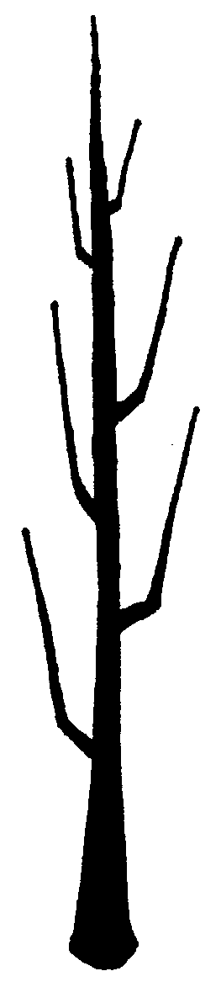 | 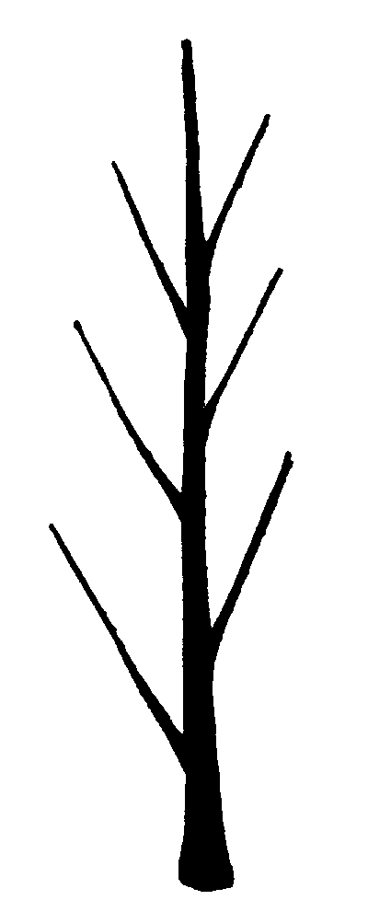 | 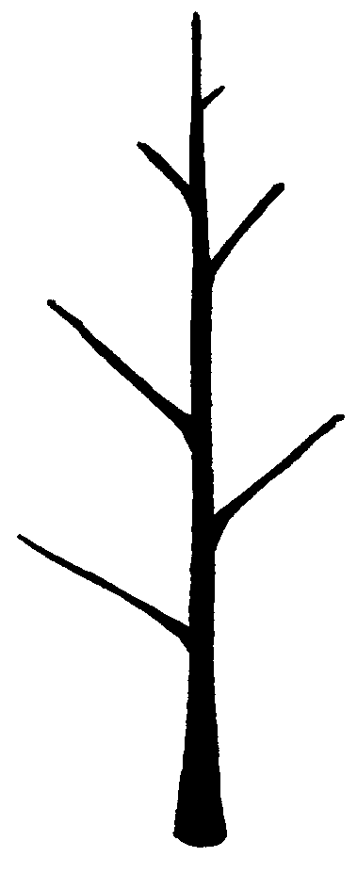

1 | 2 | 3
fastigiate | upright | semi upright

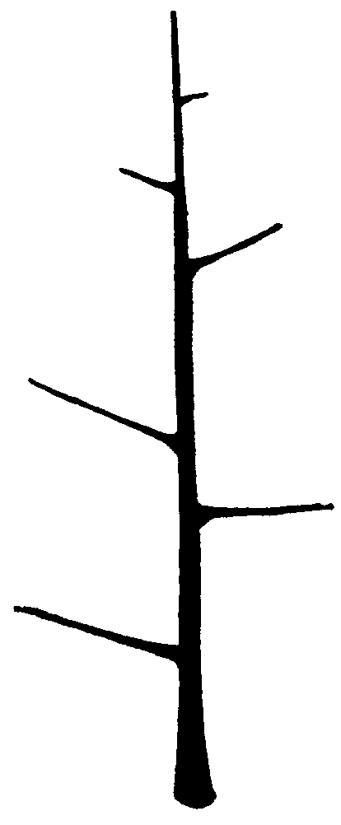 | 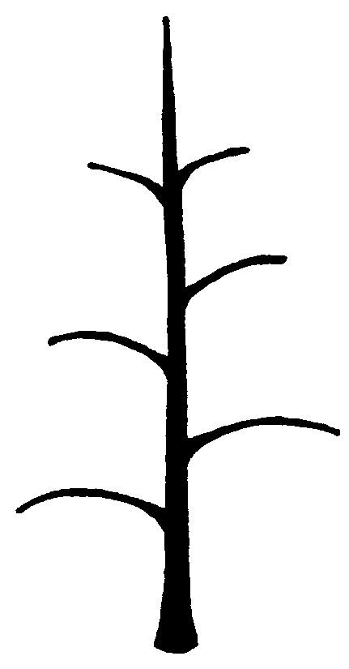 | 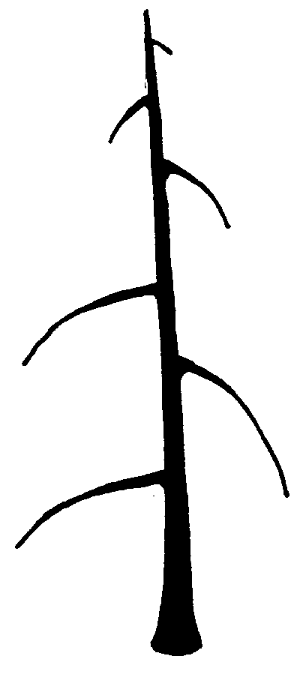

4 | 5 | 6
spreading | drooping | weeping

Ad.10: One-year-old shoot: size of bud support

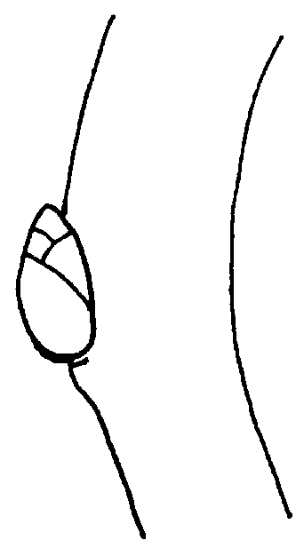 | 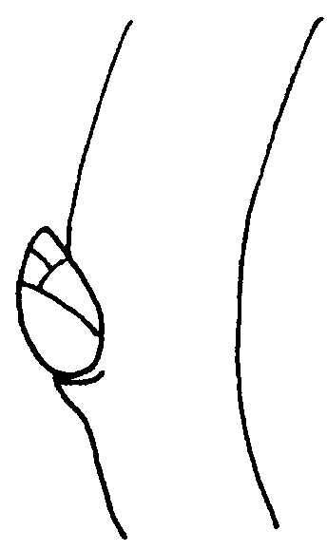 | 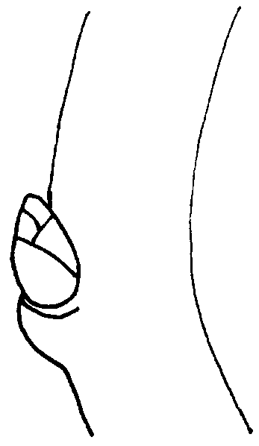

3 | 5 | 7
small | medium | large

Ad.13: Leaf blade: attitude in relation to shoot

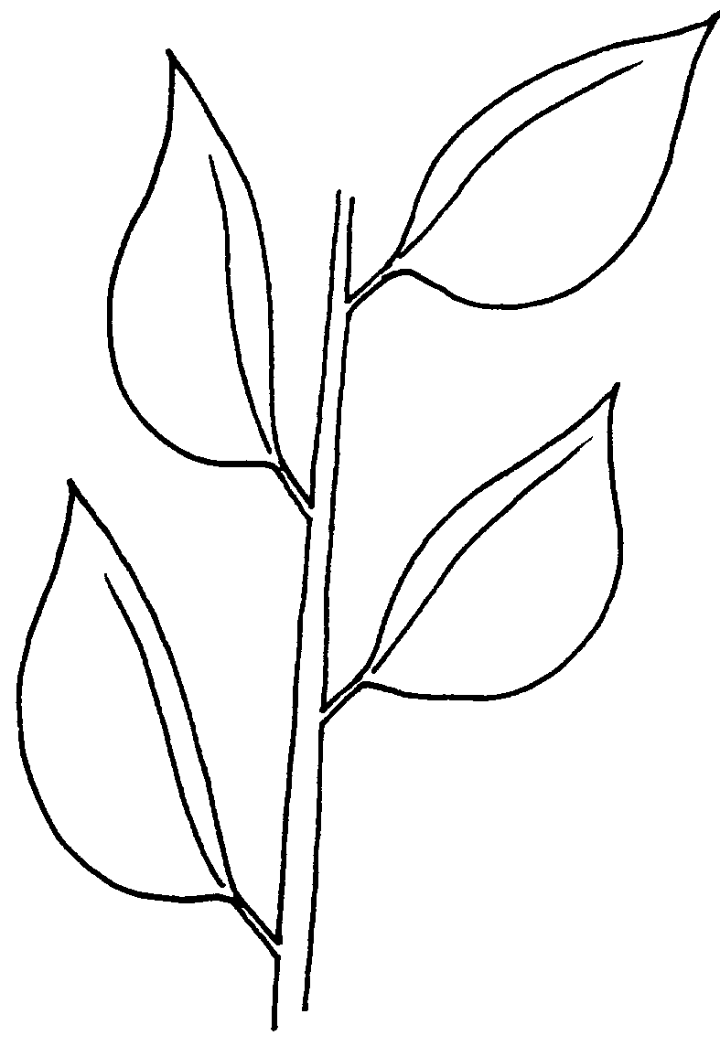 | 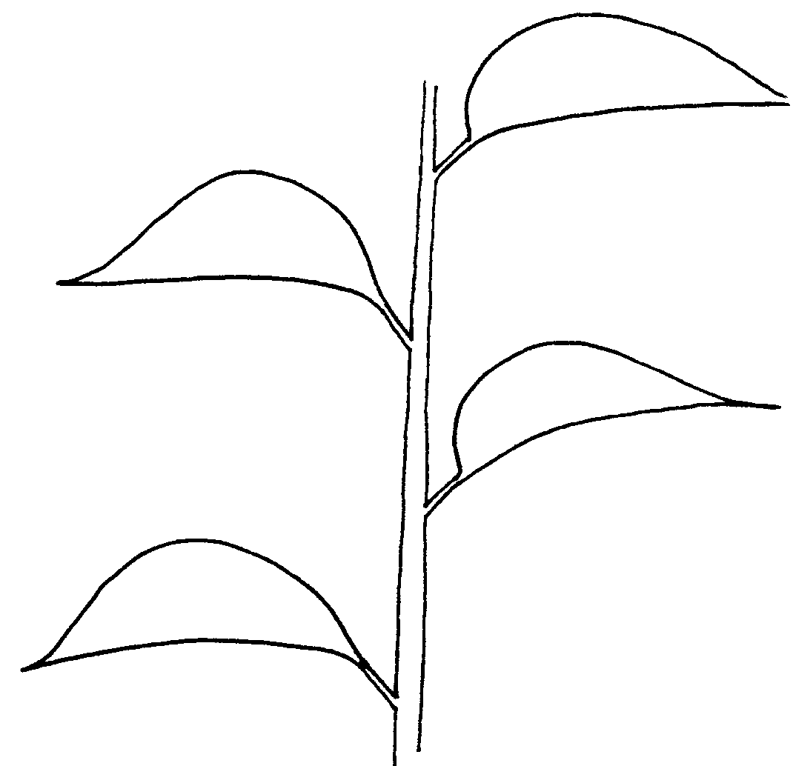 | 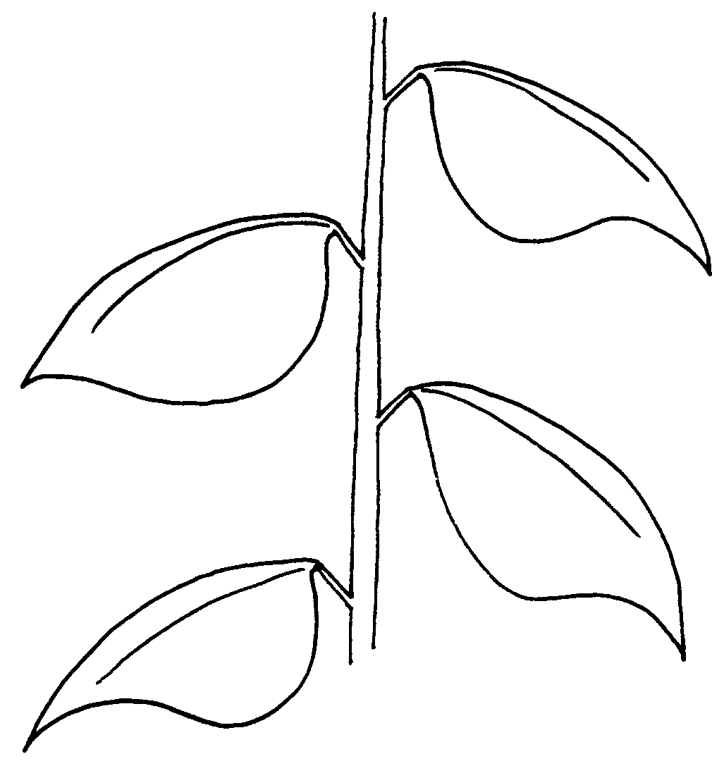

1 | 2 | 3
upwards | outwards | downwards

Ad.17: Leaf blade: shape of base

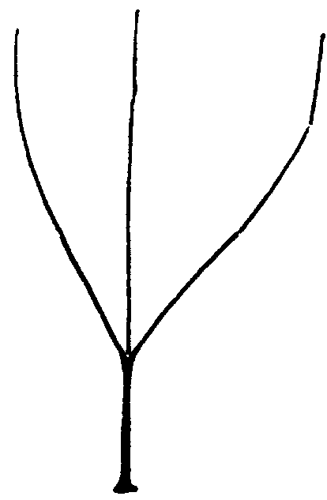 | 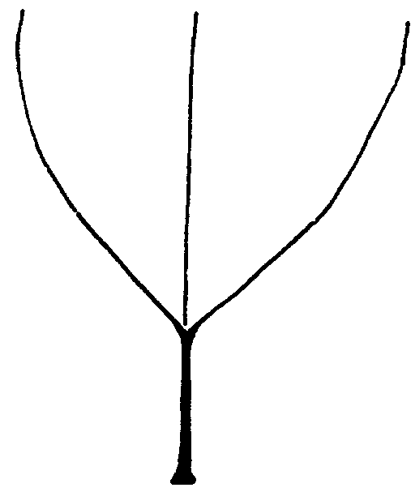 | 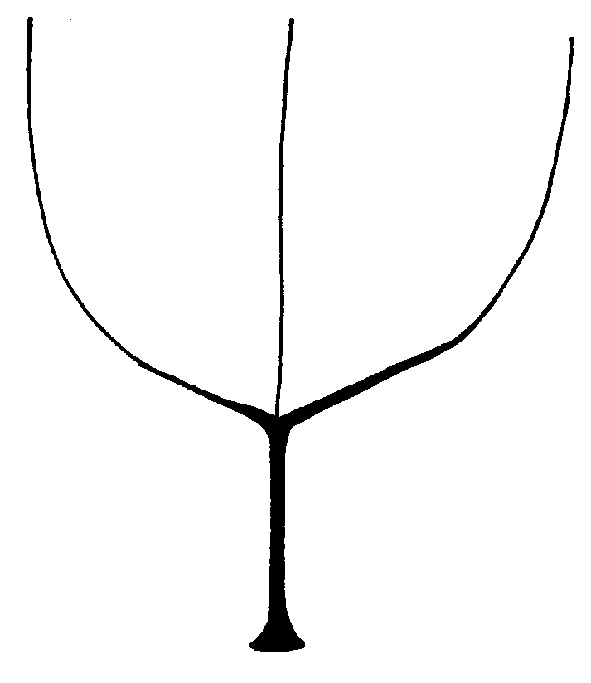

1 | 2 | 3
acute | right-angled | obtuse

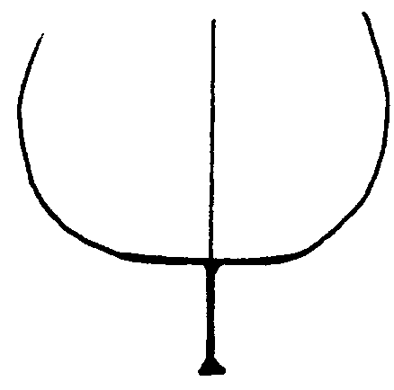 | 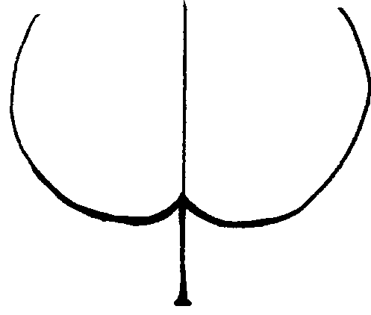

4 | 5
truncate | cordate

Ad.18: Leaf blade: shape of apex (excluding pointed tip)

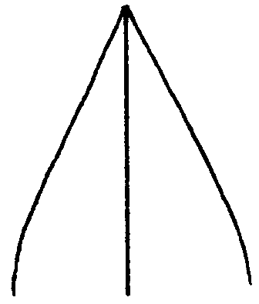 | 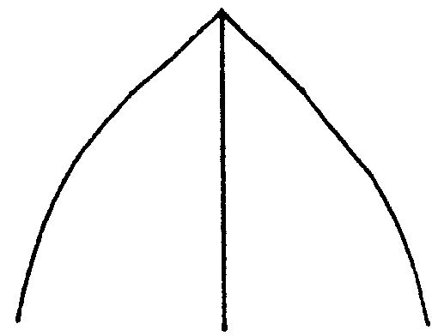 | 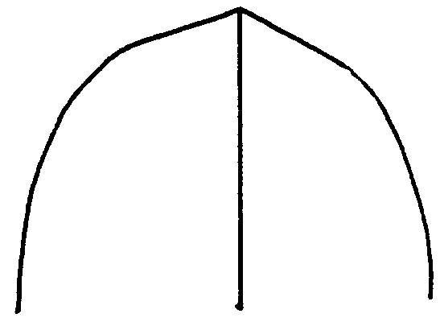 | 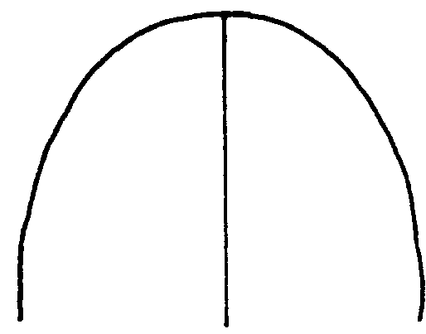

1 | 2 | 3 | 4
acute | right-angled | obtuse | rounded

Ad. 20: Leaf blade: incisions of margin (upper half)

 |  | 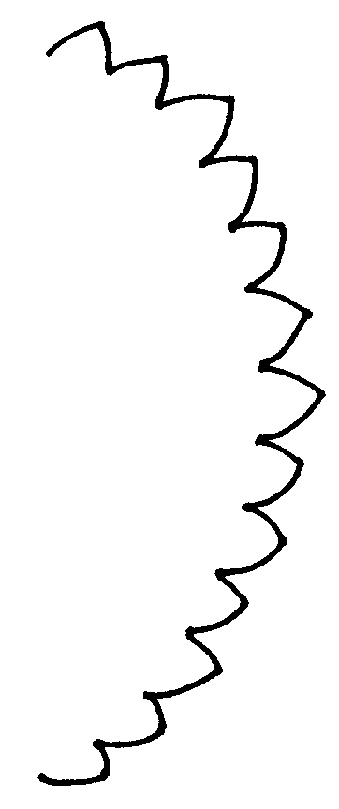 | 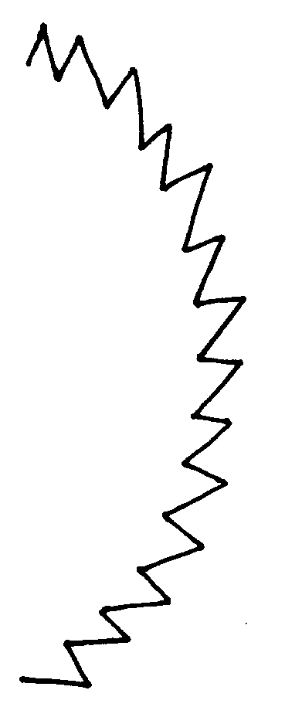

1 | 2 | 3 | 4
absent | crenate | bluntly serrate | sharply serrate

Ad. 25: Petiole: distance of stipules from basal attachment of petiole

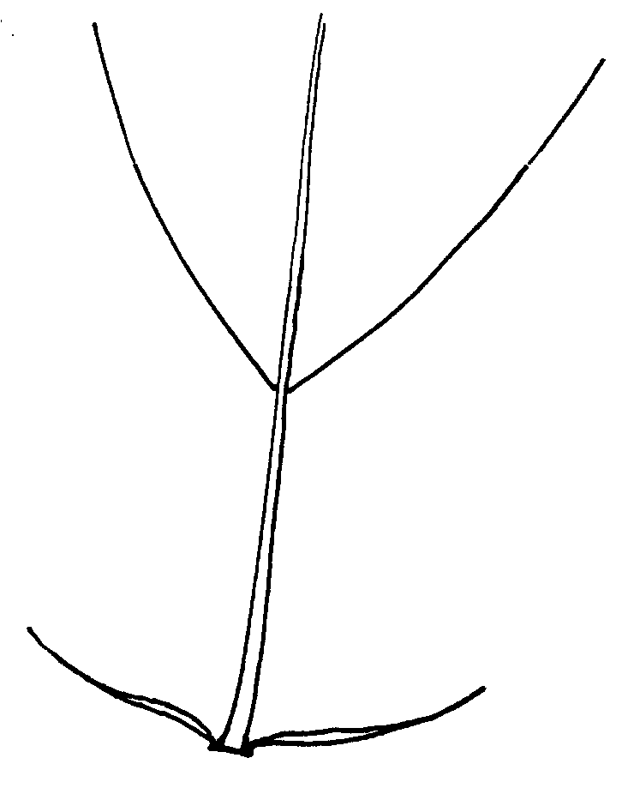 | 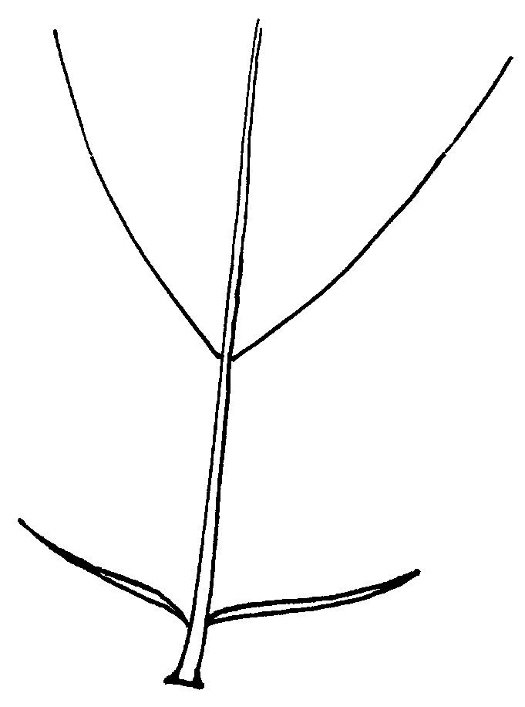 | 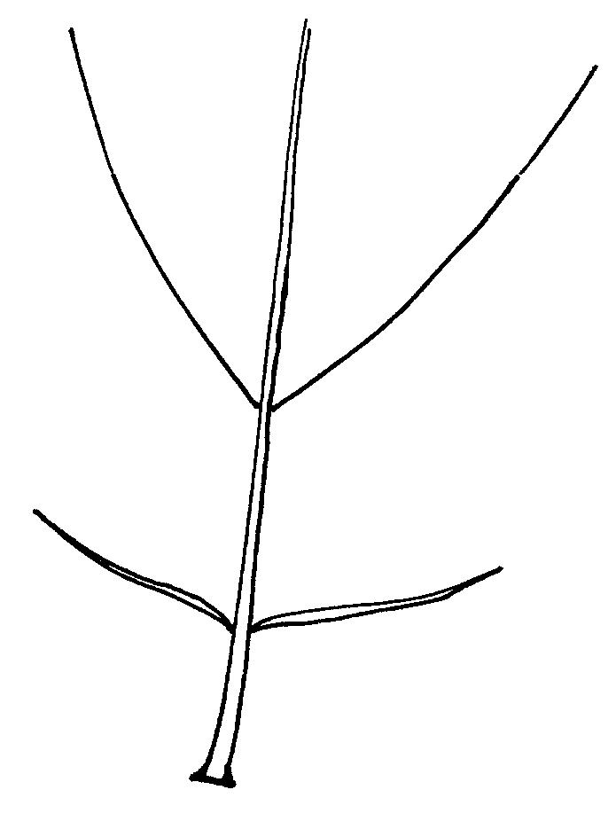

3 | 5 | 7
short | medium | long

Ad. 40: Fruit: position of the maximum diameter

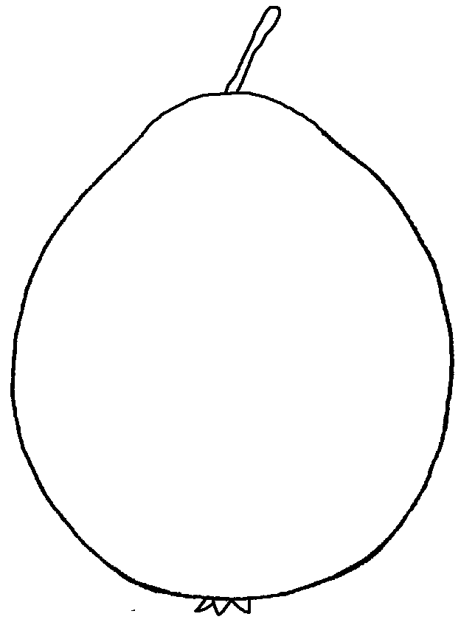 | 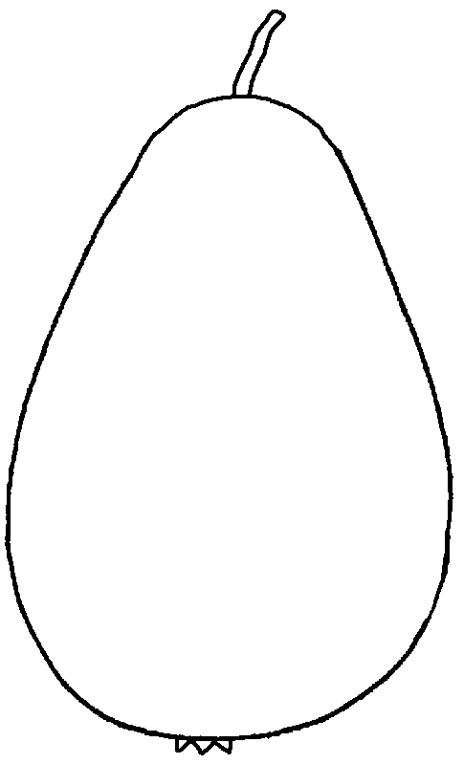 | 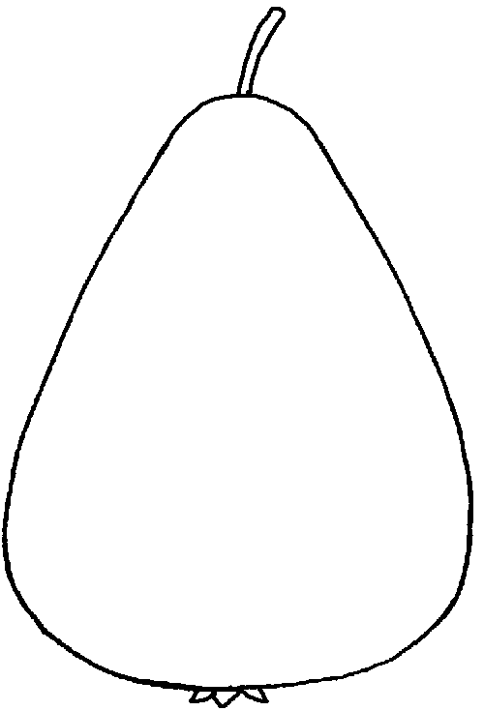

1 | 2 | 3
in middle | slightly towards calyx | clearly towards calyx

Ad. 43: Fruit: profile of sides

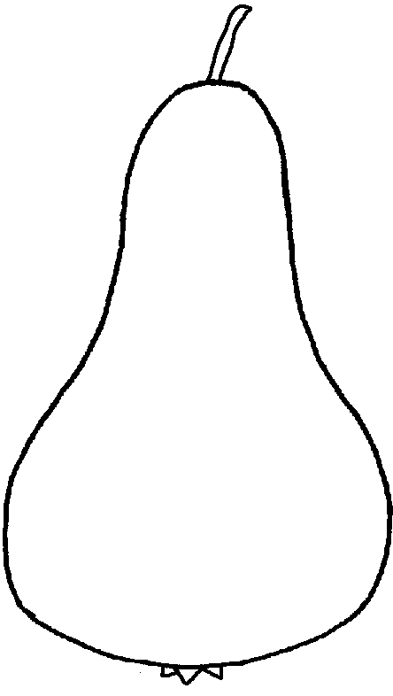 | 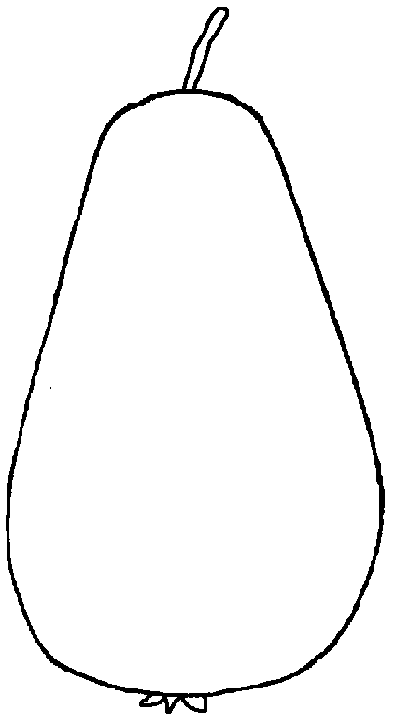 | 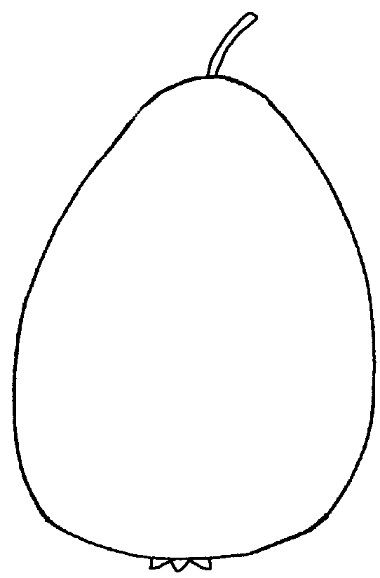

1 | 2 | 3
concave | straight | convex

Ad. 54: Fruit: depth of stalk cavity

57: Fruit: depth of eye basin (at harvest)

58: Fruit: width of eye basin (at harvest)

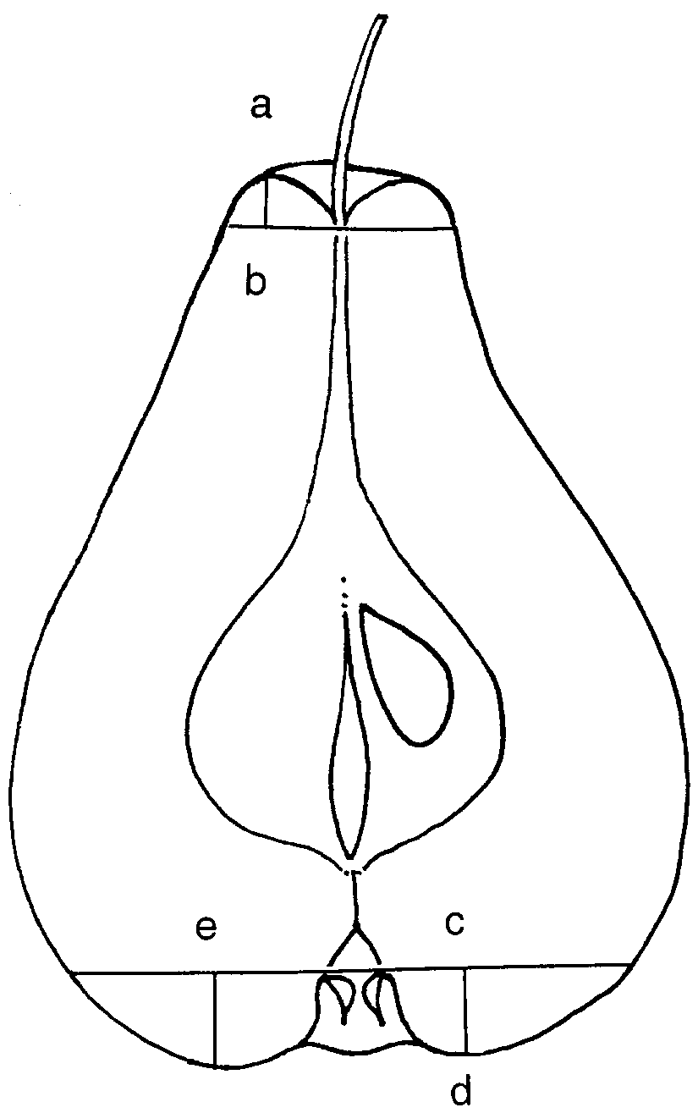 | ab = depth of stalk cavity  (characteristic 54)  cd = depth of eye basin  (characteristic 57)  ce = width of eye basin  (characteristic 58)
Ad. 55: Fruit: attitude of sepals (at harvest)

 | 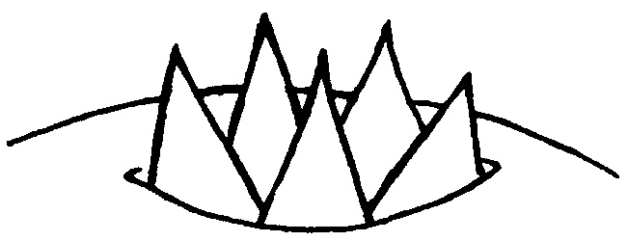

1 | 2
converging | erect

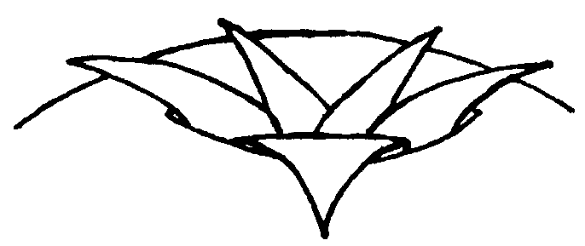

3
spreading

Synonyms of the example varieties:

Example Varieties | Synonym(s)
Abbé Fétel | Abate Fétel
Belle Angevine | Schöne Angevine
Bergamotte Esperen | Esperens Bergamotte
Beurré Alexandre Lucas | Alexander Lucas, Mantecosa Alexandre Lucas
Beurré Bosc | Bosc's Flaschenbirne, Kaiser Alexander, Mantecosa Bosc
Beurré Clairgeau | Clairgeaus Butterbirne
Beurré d’Amanlis | Amanlis Butterbirne
Beurré Diel | Diels Butterbirne
Beurré Giffard | Giffards Butterbirne, Mantecosa Giffard, Cañella
Beurré Hardy | Butirra Hardy, Gellerts Butterbirne
Beurré Lebrun | Lebruns Butterbirne
Beurré Six | Six Butterbirne
Beurré Superfin | Conseiller de la Cour, Hochfeine Butterbirne
Citron des Carmes | Sommermagdalene
Clapp's Favourite | Clapps’ Liebling
Colorée de Juillet | Bunte Julibirne
Comtesse de Paris | Gräfin von Paris
Conference | Konferenzbirne
Curé | Espadón de Invierno, Pastorenbirne, Vicar of Winkfield
Docteur Jules Guyot | Jules Guyot, Limonera
Doyenné d’Alençon | Alencons Dechantsbirne
Doyenné d’Hiver | Decana d'Inverno, Pastorale, Winterdechantsbirne
Doyenné de Juillet | Doyenné d’Été, Julidechantsbirne
Doyenné du Comice | Decana del Comizio, Decana del Congreso, Vereinsdechantsbirne
Duchesse d’Angoulême | Herzogin von Angoulême
Duchesse Elsa | Herzogin Elsa
Épine du Mas | Colmar, Herbstdorn
Espargne | Sparbirne
Jeanne d’Arc | Jungfrau von Orleans
Joséphine de Malines | Josephine von Mecheln
Liegels Winterbutterbirne | Beurré d'Hiver de Liegel
Louise Bonne d’Avranches | Buona Luisa, Gute Luise, Louise Bonne of Jersey
Mirandino rosso | Bella di Giugno
Monchallard | Belle Epine Fondante, Epine d'Eté de Bordeaux
Nouveau Poiteau | Neue Poiteau
Passe Crassane | Edelcrassane, Passa Crassana
Example Varieties | Synonym(s)
Pitmaston Duchesse d’Angoulême | Pitmaston Duchesse, Williams’ Duchesse
Poire de Charneu | Bürgermeisterbirne, Köstliche von Charneu, Légipont
Précoce de Cassano | Frühe von Cassano
Précoce de Trevoux | Frühe von Trevoux
Red Bartlett | Max Red Bartlett, Rote Williams, Williams Roja, Williams Rouge
Santa Maria | Marienbirne
Starkrimson | Red Clapp's Favourite, Rote Clapps Liebling, Super Red
Tongre | Beurré Durandeau, Durondeau, Tongern
Williams’ Bon Chrétien | Bartlett, Buen Cristiano Williams, Williams Christbirne

IX. Literature

Arbury, J., 1997: “Pears.” Wells & Winter, Mereworth, Maidstone, GB

Bocek, O., 1954: “Pomologie.” Statni Zemedelske Hakladatelstvi, Praha, CZ

Bordeianu, T., et. al., 1963: “Pomologia Republicii Socialiste Romania.” Vol. 1-8, Editura Academiei Republicii Socialiste, Bucaresti, RO

Brozik, S., Regius, J., 1957: “Termeszett gyümölcsfajtaink. Almastermesuek, Körte es birs.” Mezögazdasagi Kiado, Budapest, HU

Cifranic, P., et al., 1978: “Pomologia.” Priroda, Bratislava, CZ

Dahl, C.G., 1943: “Pomologia del II – Päron och Plommon.” Albert Bonniers Förlag, Stockholm, SE

Hedrick, U.P., 1921: “The pears of New York – Report of the New York Experimental Station for the year 1921.” J.B. Lyon Company, Albany, US

Kessler, H., 1948: “Birnensorten der Schweiz.” Verlag Verbandsdruckerei AG, Bern, CH

Krümmel, H., Groh, W., Friedrich, G., 1964: “Deutsche Obstsorten.” Bd. 1-3. Deutscher Landwirtschaftsverlag, Berlin, DE

Leroy, A., 1867: “Dictionnaire de pomologie I,II – Poires.” Principales Librairies Agricoles et Horticoles, Angers, FR

Morettini, A., Baldini, E., Scaramuzzi, F., Mittempergher L., 1967: “Monografia delle principali cultivar di pero.” Consiglio nazionale delle ricerche, Centro Miglioramento Piante da Frutto, Firenze, IT

Nicotra, A., Cobianchi, D., Faedi, W., Manzo, P., 1979: “Monografia di cultivar di pero.” Ministero Agricoltura e Foreste, Roma, IT

Nilsson, A., 1989: “Våra päron-, plommon- och körsbärssorter.” Karlebo Forlag AB, SE

Petzold, H., 1989: “Birnensorten.” Verlag J. Neumann, Neudamm, Melsungen, Berlin, Basel, Wien, DE

Seitzer, J., Schüle, H., Wenck, F., 1957: “Farbtafeln der Birnensorten.” Verlag Eugen Ulmer, Stuttgart, DE

Tomcsanyi, P., et al., 1979: “Gyümölcsfajtaink, Gyakorlati pomologia.” Mezögazdasagi Kiado, Budapest, HU

Van der Zwet, T., 1982: “The Pear.” Horticultural Publishing, US

Votteler, W., 1993: “Verzeichnis der Apfel- und Birnensorten.” Obst- und Gartenbauverlag, 3. Auflage, München, DE

Yamagata-ken, 1980: “The report on the characterization and classification of pear varieties.” Yamagata Horticultural Experiment Station, JP

X. Technical Questionnaire

Reference Number
(not to be filled in by the applicant)
TECHNICAL QUESTIONNAIRE
to be completed in connection with an application for Plant Breeders’ Rights

1. Species Pyrus communis L.

PEAR (Fruit varieties)

2. Applicant (name and address)

3. Proposed denomination or breeder’s reference

4. Information on origin, maintenance and reproduction of the variety

4.1 Origin

(a) Seedling of unknown parentage [ ]

(b) Produced by controlled pollination (indicate parent varieties) [ ]

− Seed bearing parent (indicate parent) [ ]

................................................................................................

− Pollen parent (indicate parent) [ ]

................................................................................................

(c) Produced by open pollination of (indicate seed bearing parent plant) [ ]

................................................................................................

(d) Mutation or sport from (indicate original parent variety) [ ]

................................................................................................

(e) Discovery (indicate where and when) [ ]

................................................................................................

4.2 In vitro propagation

The plant material of the candidate variety has been obtained
by in vitro propagation yes [ ]
no [ ]
4.3 Virus status

(a) The variety is free from all known virus as follows (indicate from which viruses) [ ]

....................................................................................................................................

(b) The plant material is virus tested (indicate against which virus) [ ]

....................................................................................................................................

(c) The virus status is unknown [ ]

4.4 Other information

5. |  | Characteristics of the variety to be indicated (the number in brackets refers to the corresponding  characteristic in Test Guidelines; please mark the state of expression which best corresponds).
 | Characteristics |  |  | Example Varieties | Note
5.1  (40) |  |  | Fruit: position of maximum diameter
 |  |  | in middle | Bergamotte Esperen | 1[ ]
 |  |  | slightly towards calyx | Beurré Alexandre Lucas,  Doyenné du Comice | 2[ ]
 |  |  | clearly towards calyx | Conference | 3[ ]
5.2  (41) |  |  | Fruit: size
 |  | very small |  | Petit Muscat,  Précoce de Cassano | 1[ ]
 |  | small |  | Citron des Carmes,  Doyenné de Juillet | 3[ ]
 |  | medium |  | Docteur Jules Guyot,  Épine du Mas | 5[ ]
 |  | large |  | Doyenné du Comice,  Passe Crassane | 7[ ]
 |  | very large |  | Margarete Marillat | 9[ ]

 | Characteristics |  | Example Varieties |  | Note
5.3  (44) |  | Fruit: ground color of the skin
 |  | not visible | Grand Champion, Uta |  | 1[ ]
 |  | green | Nouveau Poiteau |  | 2[ ]
 |  | yellow green | Beurré Giffard,  Beurré Hardy |  | 3[ ]
 |  | yellow | Président Drouard,  Williams’ Bon Chrétien |  | 4[ ]
5.4  (64) |  | Time of beginning of flowering
 |  | very early | Beurré Alexandre Lucas, Pitmaston Duchesse d’Angoulême |  | 1[ ]
 |  | early | Delfrap, Louise Bonne d’Avranches |  | 3[ ]
 |  | medium | Packham's Triumph, Williams’ Bon Chrétien |  | 5[ ]
 |  | late | Doyenné du Comice, Jeanne d'Arc |  | 7[ ]
 |  | very late | Frangipane |  | 9[ ]
5.5  (65) |  | Time of maturity for consumption
 |  | very early | Mirandino rosso,  Doyenné de Juillet | 1[ ]
 |  | early | Précoce de Trévoux | 3[ ]
 |  | medium | Coscia | 5[ ]
 |  | late | Beurré Hardy, Doyenné du Comice, Jeanne d'Arc | 7[ ]
 |  | very late | Doyenné d'Hiver, Nordhäuser Winterforelle,  Président Drouard | 9[ ]

6. Similar varieties and differences from these varieties
Denomination of similar variety | Characteristic in which the similar variety is different ^{o)} | State of expression of similar variety | State of expression of candidate variety
______________
^{o)} In the case of identical states of expressions of both varieties, please indicate the size of the difference.
7. Additional information which may help to distinguish the variety

7.1 Resistance to pests and diseases

7.2 Special conditions for the examination of the variety

7.3 Other information

A representative color photo of the variety should be included in the Technical Questionnaire.

- Authorization for release
(a) Does the variety require prior authorization for release under legislation concerning the protection of the environment, human and animal health?
Yes [ ] No [ ]
(b) Has such authorization been obtained?
Yes [ ] No [ ]
If the answer to that question is yes, please attach a copy of such an authorization.

[End of document]

